Lesson 13 Practice Problems
- Write each number in scientific notation.
  - 14,700
  - 0.00083
  - 760,000,000
  - 0.038
  - 0.38
  - 3.8
  - 3,800,000,000,000
  - 0.0000000009
- Perform the following calculations. Express your answers in scientific notation.
  - $\left(2×{10}^{5}\right)+\left(6×{10}^{5}\right)$
  - $\left(4.1×{10}^{7}\right)⋅2$
  - $\left(1.5×{10}^{11}\right)⋅3$
  - ${\left(3×{10}^{3}\right)}^{2}$
  - $\left(9×{10}^{6}\right)⋅\left(3×{10}^{6}\right)$
- Jada is making a scale model of the solar system. The distance from Earth to the Moon is about $2.389×{10}^{5}$ miles. The distance from Earth to the Sun is about $9.296×{10}^{7}$ miles. She decides to put Earth on one corner of her dresser and the Moon on another corner, about a foot away. Where should she put the sun?
  - On a windowsill in the same room?
  - In her kitchen, which is down the hallway?
  - A city block away?
- Explain your reasoning.
- Here is the graph for one equation in a system of equations.
- 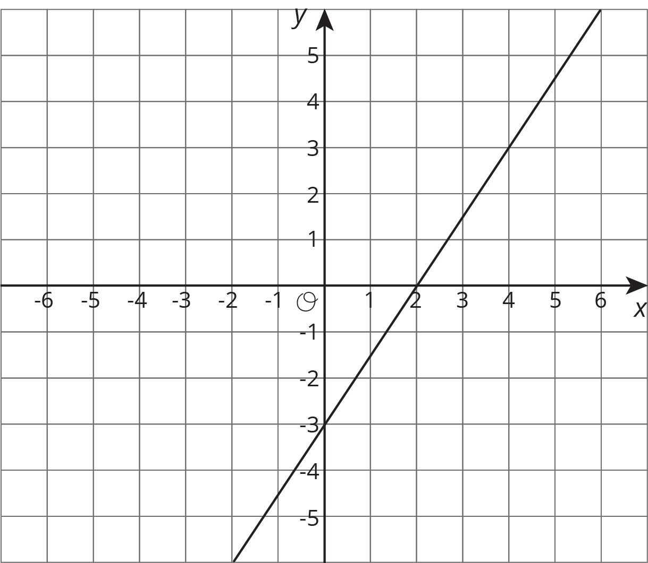
  - Write a second equation for the system so it has infinitely many solutions.
  - Write a second equation whose graph goes through $\left(0,2\right)$ so that the system has no solutions.
  - Write a second equation whose graph goes through $\left(2,2\right)$ so that the system has one solution at $\left(4,3\right)$.
- (From Unit 4, Lesson 12.)
© CC BY Open Up Resources. Adaptations CC BY IM.

