Lesson 11: Side-Side-Angle (Sometimes) Congruence
- Let’s explore triangle congruence criteria that are ambiguous.

11.1: Notice and Wonder: Congruence Fail
What do you notice? What do you wonder?
In triangles $GBD$ and $KHI$:
- Angle $GBD$ is congruent to angle $KHI$.
- Segment $BD$ is congruent to segment $HI$.
- Segment $DG$ is congruent to segment $IK$.

11.2: Dare to Be (Even More) Different
Copy these segments and use them to make a triangle using the given angle so that the given angle is not between the 2 given sides. Draw your triangle on tracing paper. Try to make your triangle different from the triangles drawn by the other people in your group.

11.3: Ambiguously Ambiguous?
Your teacher will give you some sets of information.
- For each set of information, make a triangle using that information.
- If you think you can make more than one triangle, make more than one triangle.
- If you think you can’t make any triangle, note that.
When you are confident they are accurate, create a visual display.

Are you ready for more?
Triangle $ABC$ is shown. Use your straightedge and compass to construct a new point $D$ on line $AC$ so that the length of segment $BD$ is the same as the length of segment $BC$.
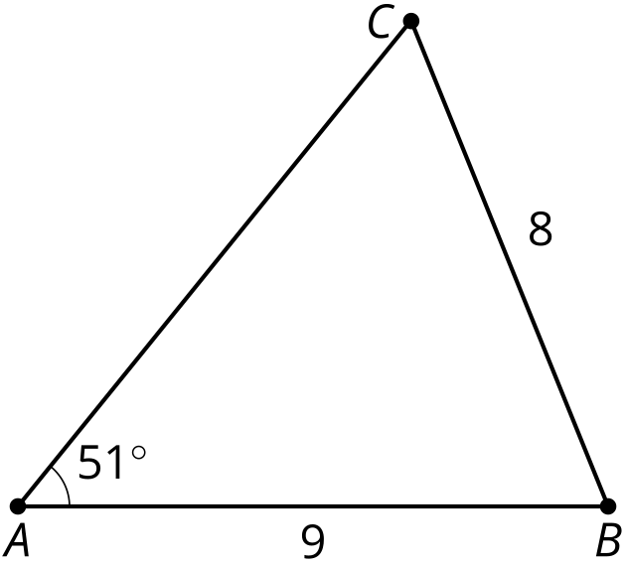
Now use the straightedge and compass to construct the midpoint of $CD$. Label that midpoint $M$.
- Explain why triangle $ABM$ is a right triangle.
- Explain why knowing the angle at $A$ and the side lengths of $AB$ and $BC$ was not enough to define a unique triangle, but knowing the angle at $A$ and the side lengths of $AB$ and $BM$ would be enough to define a unique triangle.

Lesson 11 Summary
Imagine we know triangles have 2 pairs of corresponding, congruent side lengths, and a pair of corresponding, congruent angles that is not between the given sides. What can we conclude?
Sometimes this is not enough information to determine that the triangles made with those measurements are congruent. These triangles have 2 pairs of congruent sides and a pair of congruent angles, but they are not congruent triangles.
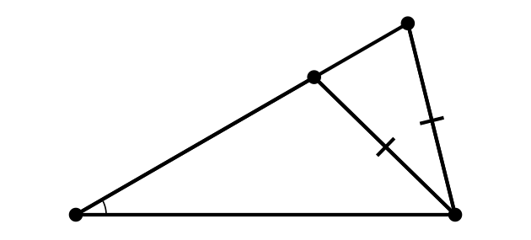
If the longer of the 2 given sides is opposite the given angle though, that does guarantee congruent triangles. In a right triangle, the longest side is always the hypotenuse. If we know the hypotenuse and the leg of a right triangle, we can be confident they are congruent.
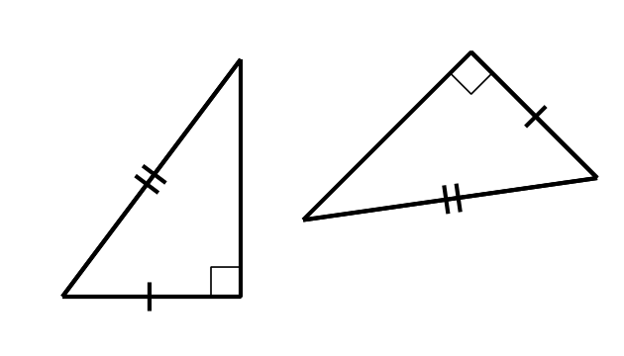
© CC BY 2019 by Illustrative Mathematics®

