Lesson 7: Hagamos medios, tercios y cuartos

Standards Alignments
Addressing | 2.G.A.3

Teacher-facing Learning Goals
- Partition circles and rectangles into halves, thirds, and fourths, and describe the pieces.

Student-facing Learning Goals
- Hagamos medios, tercios y cuartos o cuartas partes.

Lesson Purpose
The purpose of this lesson is for students to recognize halves, thirds, and fourths, understanding that these terms describe equal pieces of the same whole.
In grade 1, students learned that when a shape is partitioned into 2 equal pieces, the pieces are called halves. They learned that when a shape is partitioned into 4 equal pieces, each piece is called a fourth or a quarter.
In this lesson, students learn that when a shape is partitioned into 3 equal pieces, the pieces are called thirds. They partition shapes into halves, thirds, and fourths. Fourths and quarters should be used interchangeably when discussing 4 equal pieces, so that students are comfortable with both terms.

Access for:

Students with Disabilities
- Engagement (Activity 1)

English Learners
- MLR8 (Activity 2)

Instructional Routines
Which One Doesn’t Belong? (Warm-up)

Materials to Gather
- Construction paper: Activity 1
- Rulers: Activity 1, Activity 2
- Scissors: Activity 1

Lesson Timeline
Warm-up | 10 min
Activity 1 | 20 min
Activity 2 | 15 min
Lesson Synthesis | 10 min
Cool-down | 5 min

Teacher Reflection Question
In grade 2, students used halves, fourths, and quarters to describe equal pieces of a shape. How did you see students use this vocabulary in today’s lesson? What support can you offer to students to help them use math vocabulary to describe equal pieces of a shape.

Cool-down
(to be completed at the end of the lesson) 5min
Nombra partes iguales

Standards Alignments
Addressing | 2.G.A.3

Student-facing Task Statement
- Parte el rectángulo en 3 partes iguales. Colorea una parte.
- Cada parte del rectángulo se llama un ________________________.
- Un _________________________ del rectángulo está coloreado.

Student Responses
- Answers vary. Sample response:
- 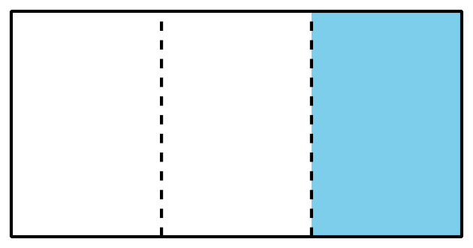
- Each piece of the rectangle is called a third.
- A third of the rectangle is shaded.

