Unit 2 Lesson 14: Solving Systems by Elimination (Part 1)

1 Notice and Wonder: Hanger Diagrams (Warm up)

Student Task Statement
What do you notice? What do you wonder?
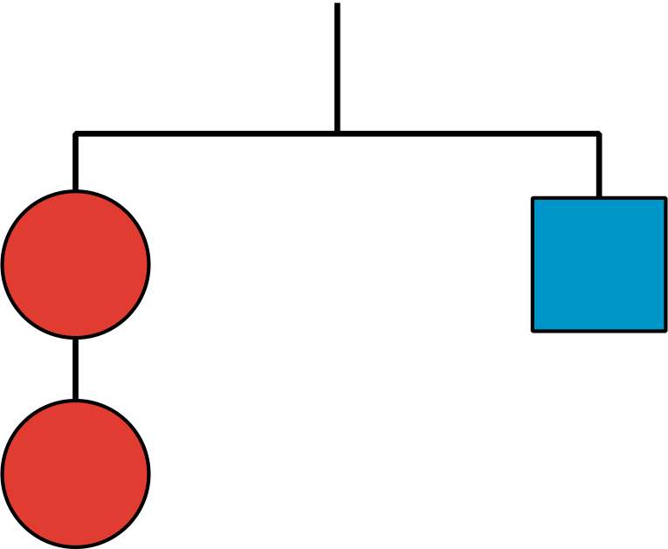
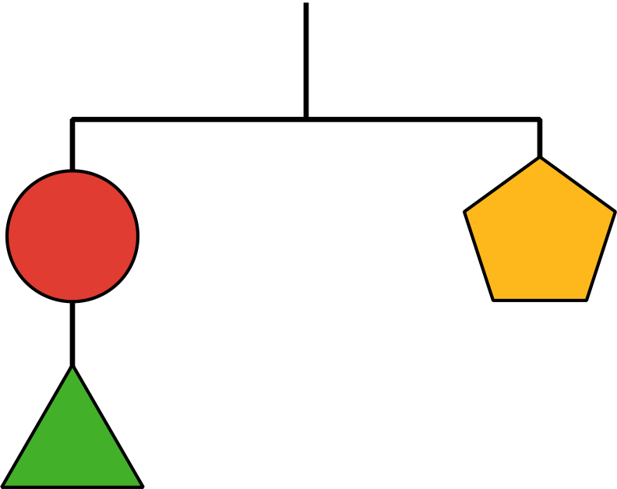
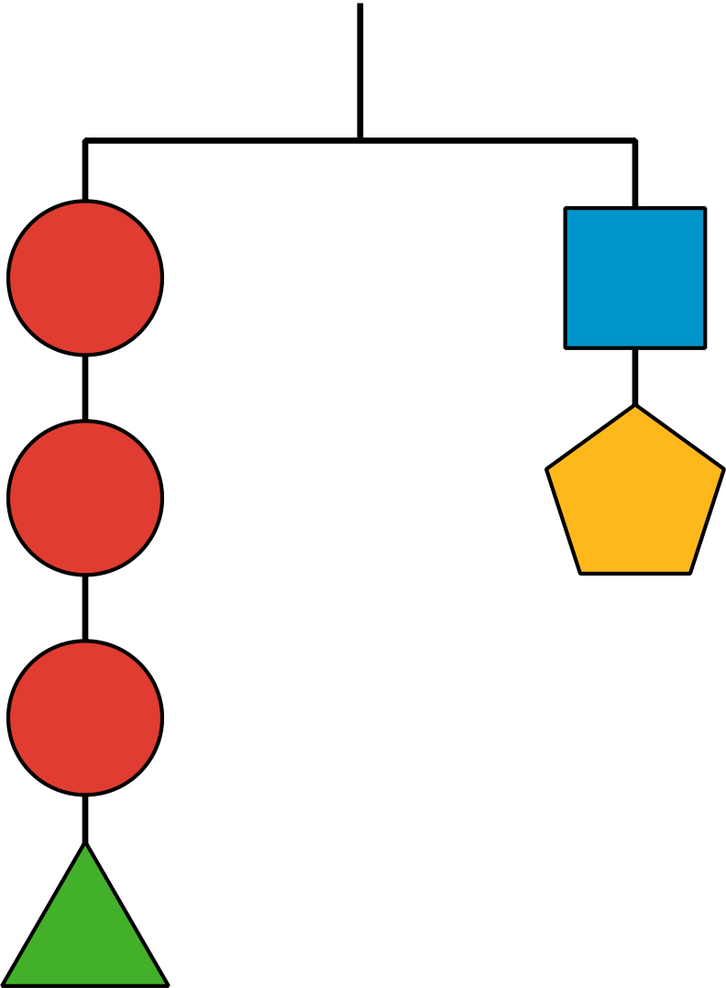

2 Adding Equations

Student Task Statement
Diego is solving this system of equations:
$\left\{\begin{matrix}\begin{matrix}4x+3y & =10 \\ \text{-}4x+5y & =6\end{matrix}\end{matrix}\right.$
Here is his work:
$\begin{matrix}4x+3y & =10 \\ \text{-}4x+5y & = 6 + \\ \overset{¯}{ 0+8y} & \overset{¯}{ =16 } \\ y & =2\end{matrix}$
$\begin{matrix}4x+3\left(2\right) & =10 \\ 4x+6 & =10 \\ 4x & =4 \\ x & =1\end{matrix}$
- Make sense of Diego’s work and discuss with a partner:
  - What did Diego do to solve the system?
  - Is the pair of $x$ and $y$ values that Diego found actually a solution to the system? How do you know?
- Does Diego’s method work for solving these systems? Be prepared to explain or show your reasoning.
- a. $\left\{\begin{matrix}\begin{matrix}2x+y & =4 \\ x−y & =11\end{matrix}\end{matrix}\right.$
- b. $\left\{\begin{matrix}\begin{matrix}8x+11y & =37 \\ 8x+ y & = 7\end{matrix}\end{matrix}\right.$

3 Adding and Subtracting Equations to Solve Systems

Student Task Statement
Here are three systems of equations you saw earlier.
System A
$\left\{\begin{matrix}\begin{matrix}4x+3y & =10 \\ \text{-}4x+5y & = 6\end{matrix}\end{matrix}\right.$
System B
$\left\{\begin{matrix}\begin{matrix}2x+y & =4 \\ x−y & =11\end{matrix}\end{matrix}\right.$
System C
$\left\{\begin{matrix}\begin{matrix}8x+11y & =37 \\ 8x+ y & = 7\end{matrix}\end{matrix}\right.$

For each system:
- Use graphing technology to graph the original two equations in the system. Then, identify the coordinates of the solution.
- Find the sum or difference of the two original equations that would enable the system to be solved.
- Graph the third equation on the same coordinate plane. Make an observation about the graph.
© CC BY 2019 by Illustrative Mathematics®

