Lesson 11 Practice Problems
- Select all the expressions that are equal to $4⋅{10}^{\text{-}3}$:
  - $4⋅\left(\frac{1}{10}\right)⋅\left(\frac{1}{10}\right)⋅\left(\frac{1}{10}\right)$
  - $4⋅\left(\text{-}10\right)⋅\left(\text{-}10\right)⋅\left(\text{-}10\right)$
  - $4⋅0.001$
  - $4⋅0.0001$
  - $0.004$
  - $0.0004$
- Write each expression as a multiple of a power of 10:
  - 0.04
  - 0.072
  - 0.0000325
  - Three thousandths
  - 23 hundredths
  - 729 thousandths
  - 41 millionths
- A family sets out on a road trip to visit their cousins. They travel at a steady rate. The graph shows the distance remaining to their cousins' house for each hour of the trip.
  - How fast are they traveling?
  - Is the slope positive or negative? Explain how you know and why that fits the situation.
  - How far is the trip and how long did it take? Explain how you know.
- 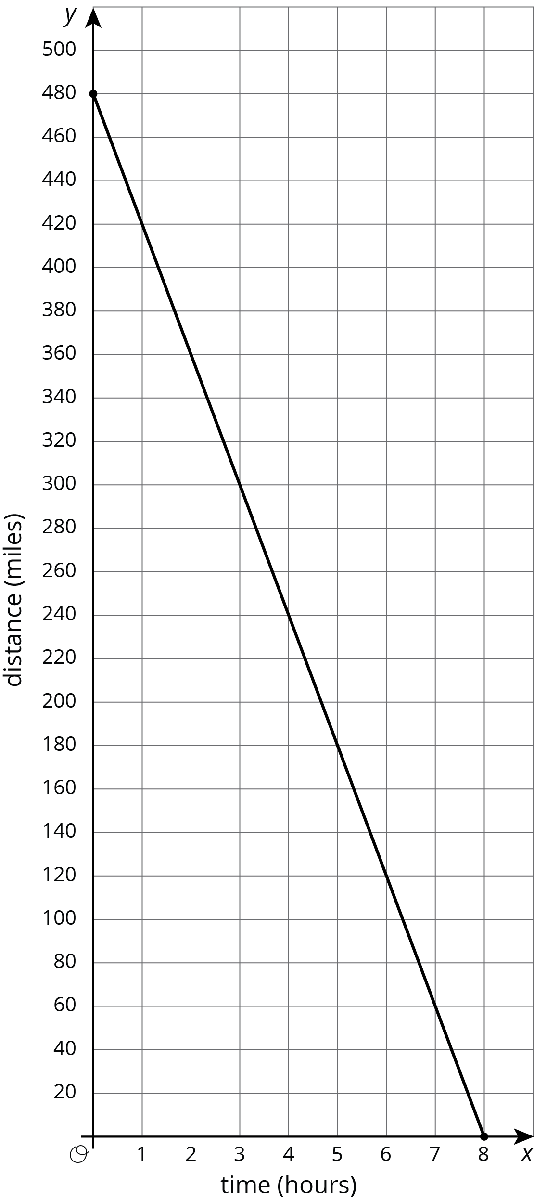
- (From Unit 3, Lesson 9.)
© CC BY Open Up Resources. Adaptations CC BY IM.

