Unit 6 Lesson 9: Linear Models

1 Candlelight (Warm up)

Student Task Statement
A candle is burning. It starts out 12 inches long. After 1 hour, it is 10 inches long. After 3 hours, it is 5.5 inches long.
- When do you think the candle will burn out completely?
- Is the height of the candle a function of time? If yes, is it a linear function? Explain your thinking.

2 Shadows

Student Task Statement
When the Sun was directly overhead, the stick had no shadow. After 20 minutes, the shadow was 10.5 cm long. After 60 minutes, it was 26 cm long.
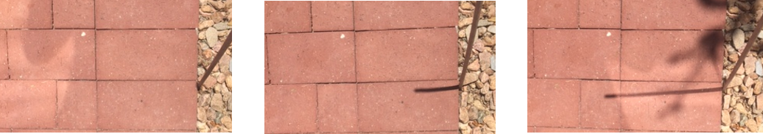
- Based on this information, estimate how long it will be after 95 minutes.
- After 95 minutes, the shadow measured 38.5 cm. How does this compare to your estimate?
- Is the length of the shadow a function of time? If so, is it linear? Explain your reasoning.

3 Recycling

Student Task Statement
In an earlier lesson, we saw this graph that shows the percentage of all garbage in the U.S. that was recycled between 1991 and 2013.
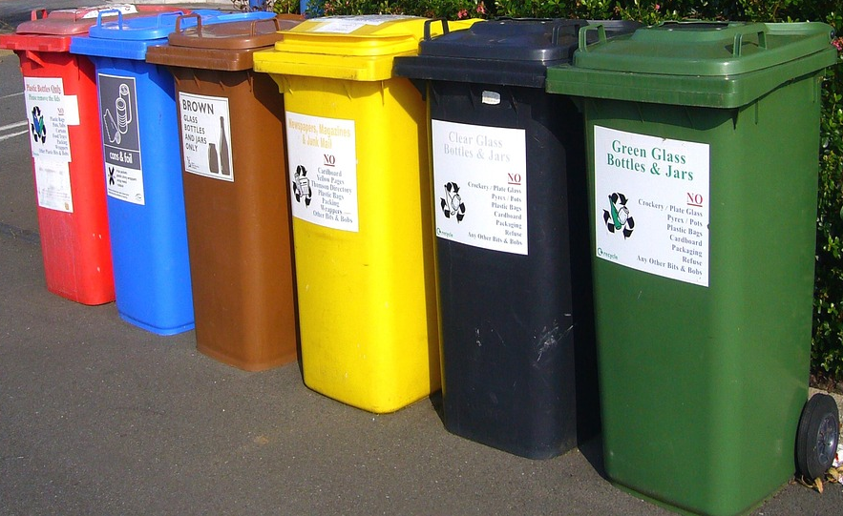
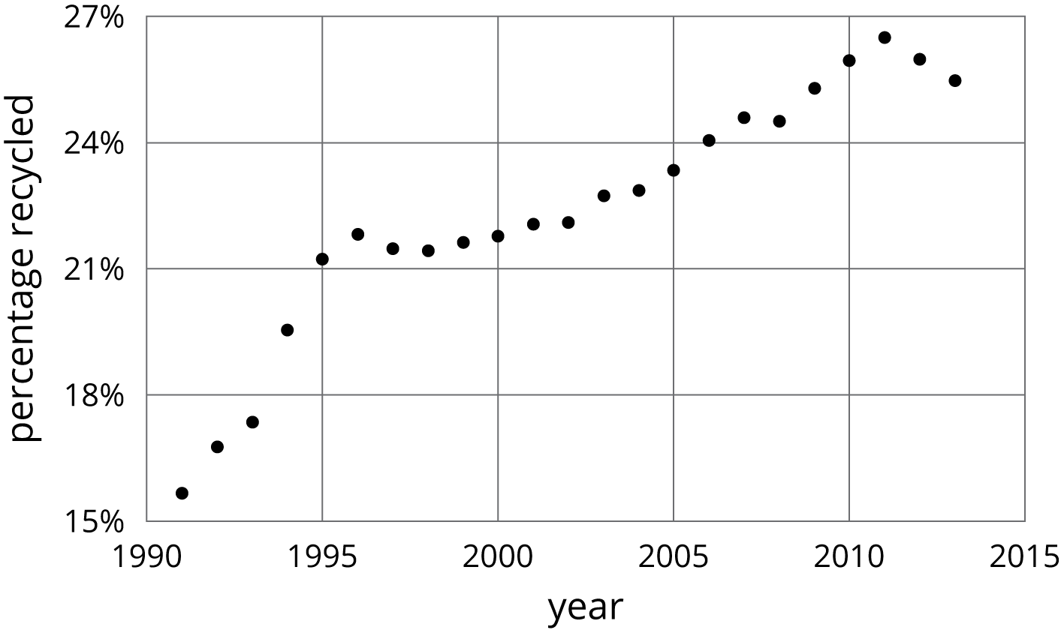
- Sketch a linear function that models the change in the percentage of garbage that was recycled between 1991 and 1995. For which years is the model good at predicting the percentage of garbage that is produced? For which years is it not as good?
- Pick another time period to model with a sketch of a linear function. For which years is the model good at making predictions? For which years is it not very good?
© CC BY Open Up Resources. Adaptations CC BY IM.

