Unit 6 Lesson 8: Linear Functions

1 Bigger and Smaller (Warm up)

Student Task Statement
Diego said that these graphs are ordered from smallest to largest. Mai said they are ordered from largest to smallest. But these are graphs, not numbers! What do you think Diego and Mai are thinking?
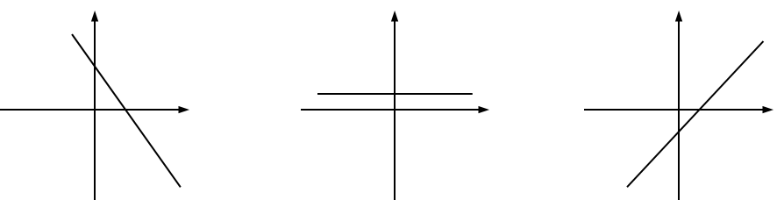

2 Proportional Relationships Define Linear Functions

Student Task Statement
- Jada earns $7 per hour mowing her neighbors’ lawns.
  - Name the two quantities in this situation that are in a functional relationship. Which did you choose to be the independent variable? What is the variable that depends on it?
  - Write an equation that represents the function.
  - Here is a graph of the function. Label the axes. Label at least two points with input-output pairs.
  - 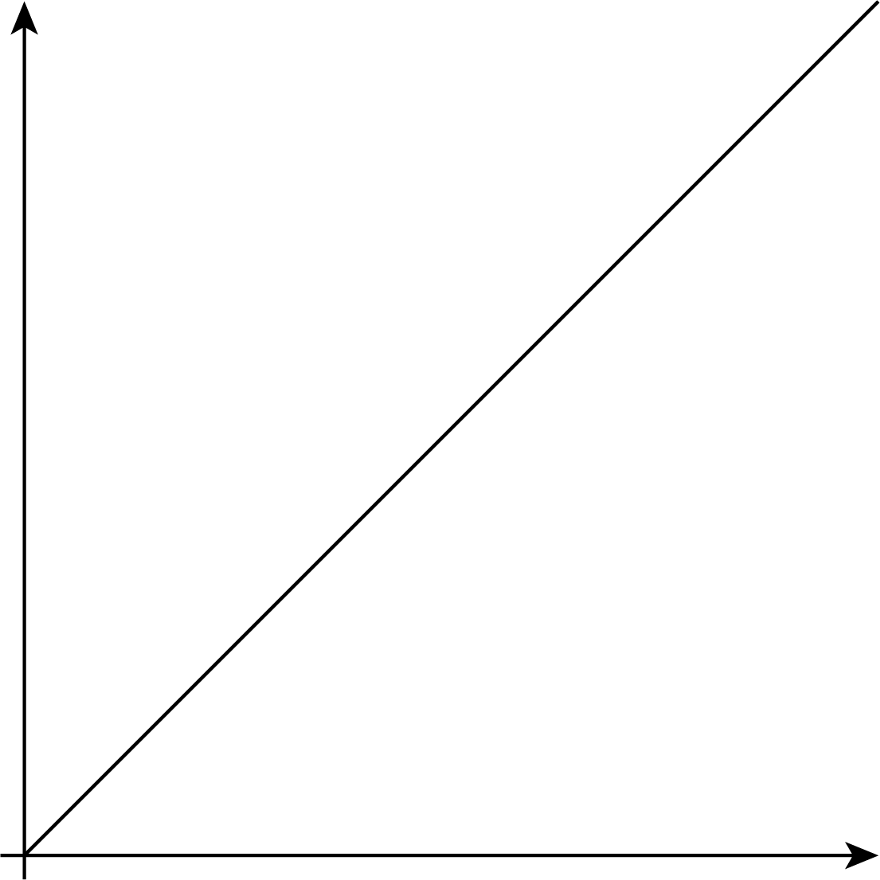
- To convert feet to yards, you multiply the number of feet by $\frac{1}{3}$.
  - Name the two quantities in this situation that are in a functional relationship. Which did you choose to be the independent variable? What is the variable that depends on it?
  - Write an equation that represents the function.
  - Draw the graph of the function. Label at least two points with input-output pairs.

3 Is it Filling Up or Draining Out?

Student Task Statement
There are four tanks of water.
- The amount of water in gallons, $A$, in Tank A is given by the function $A=200+8t$, where $t$ is in minutes.
- The amount of water in gallons, $B$, in Tank B starts at 400 gallons and is decreasing at 5 gallons per minute. These functions work when $t≥0$ and $t≤80$.
- Which tank started out with more water?
- Write an equation representing the relationship between $B$ and $t$.
- One tank is filling up. The other is draining out. Which is which? How can you tell?
- The amount of water in gallons, $C$, in Tank C is given by the function $C=800−7t$. Is it filling up or draining out? Can you tell just by looking at the equation?
- The graph of the function for the amount of water in gallons, $D$, in Tank D at time $t$ is shown. Is it filling up or draining out? How do you know?
- 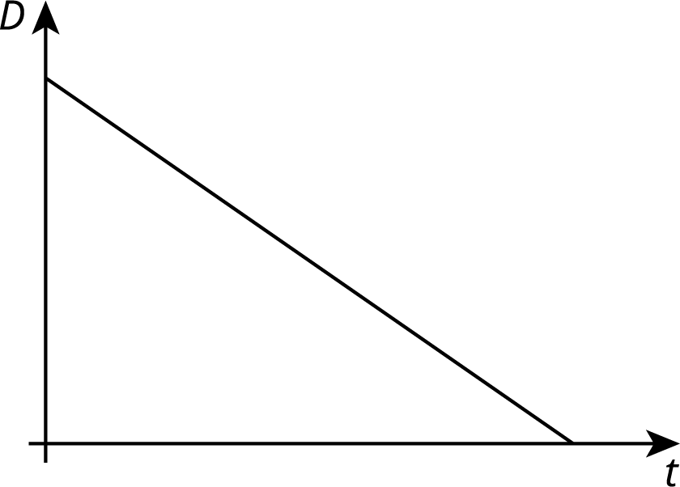

4 Which is Growing Faster? (Optional)

Student Task Statement
Noah is depositing money in his account every week to save money. The graph shows the amount he has saved as a function of time since he opened his account.
Elena opened an account the same day as Noah. The amount of money $E$ in her account is given by the function $E=8w+60$, where $w$ is the number of weeks since the account was opened.
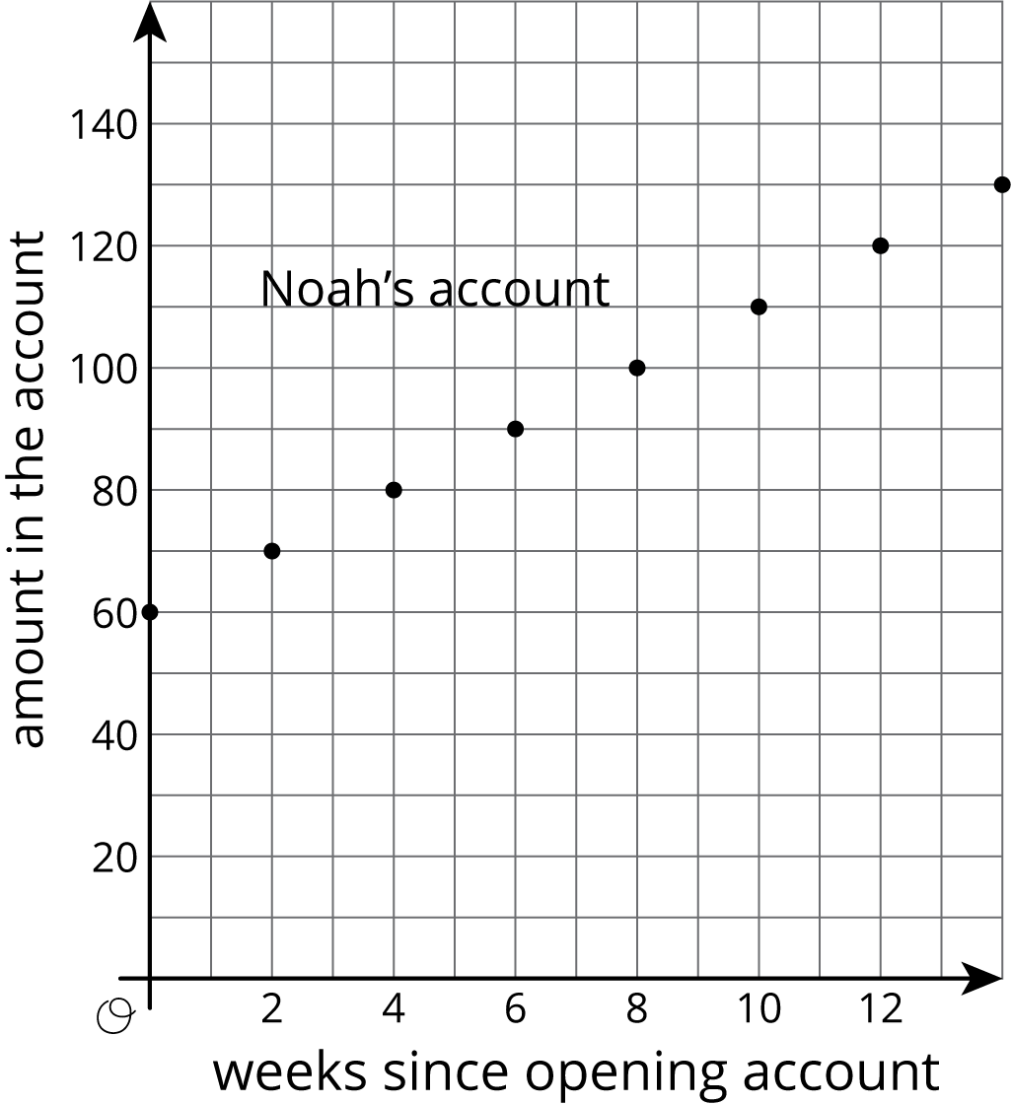
- Who started out with more money in their account? Explain how you know.
- Who is saving money at a faster rate? Explain how you know.
- How much will Noah save over the course of a year if he does not make any withdrawals? How long will it take Elena to save that much?
© CC BY Open Up Resources. Adaptations CC BY IM.

