Lesson 8 Practice Problems
- Select all the true statements:
  - $2^{8}⋅2^{9}=2^{17}$
  - $8^{2}⋅9^{2}={72}^{2}$
  - $8^{2}⋅9^{2}={72}^{4}$
  - $2^{8}⋅2^{9}=4^{17}$
- Find $x$, $y$, and $z$ if ${\left(3⋅5\right)}^{4}⋅{\left(2⋅3\right)}^{5}⋅{\left(2⋅5\right)}^{7}=2^{x}⋅3^{y}⋅5^{z}$.

- Han found a way to compute complicated expressions more easily. Since $2⋅5=10$, he looks for pairings of 2s and 5s that he knows equal 10. For example, $3⋅2^{4}⋅5^{5}=3⋅2^{4}⋅5^{4}⋅5=\left(3⋅5\right)⋅{\left(2⋅5\right)}^{4}=15⋅{10}^{4}=150,​000.$ Use Han's technique to compute the following:
  - $2^{4}⋅5⋅{\left(3⋅5\right)}^{3}$
  - $\frac{2^{3}⋅5^{2}⋅{\left(2⋅3\right)}^{2}⋅{\left(3⋅5\right)}^{2}}{3^{2}}$
- The cost of cheese at three stores is a function of the weight of the cheese. The cheese is not prepackaged, so a customer can buy any amount of cheese.
  - Store A sells the cheese for $a$ dollars per pound.
  - Store B sells the same cheese for $b$ dollars per pound and a customer has a coupon for $5 off the total purchase at that store.
  - Store C is an online store, selling the same cheese at $c$ dollar per pound, but with a $10 delivery fee.
- This graph shows the price functions for stores A, B, and C.
- 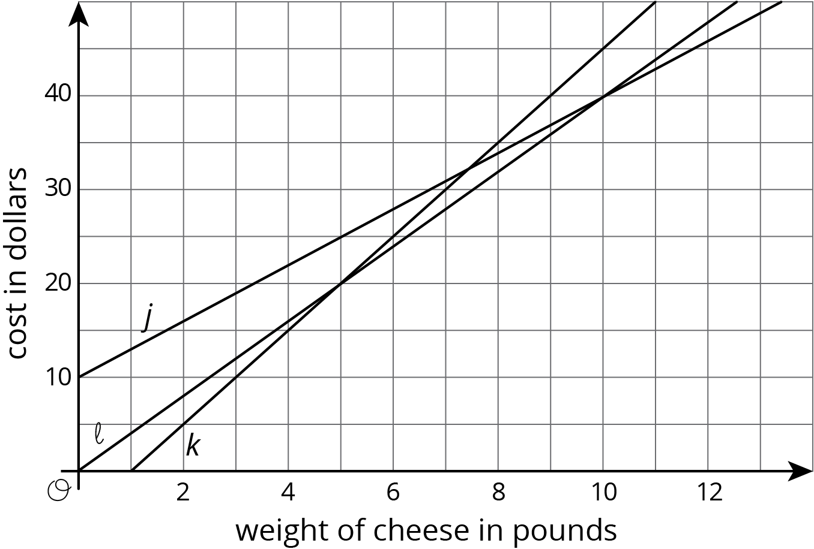
  - Match Stores A, B, and C with Graphs $j$, $k$, and $ℓ$.
  - How much does each store charge for the cheese per pound?
  - How many pounds of cheese does the coupon for Store B pay for?
  - Which store has the lowest price for a half a pound of cheese?
  - If a customer wants to buy 5 pounds of cheese for a party, which store has the lowest price?
  - How many pounds would a customer need to order to make Store C a good option?
- (From Unit 5, Lesson 8.)
© CC BY Open Up Resources. Adaptations CC BY IM.

