Lesson 6: Side-Angle-Side Triangle Congruence
- Let’s use definitions and theorems to figure out what must be true about shapes, without having to measure all parts of the shapes.

6.1: Information Overload?
Highlight each piece of given information that is used in the proof, and each line in the proof where that piece of information is used.
Given:
- $\overset{¯}{AB}≅\overset{¯}{DE}$
- $\overset{¯}{AC}≅\overset{¯}{DF}$
- $\overset{¯}{BC}≅\overset{¯}{EF}$
- $∠A≅∠D$
- $∠B≅∠E$
- $∠C≅∠F$
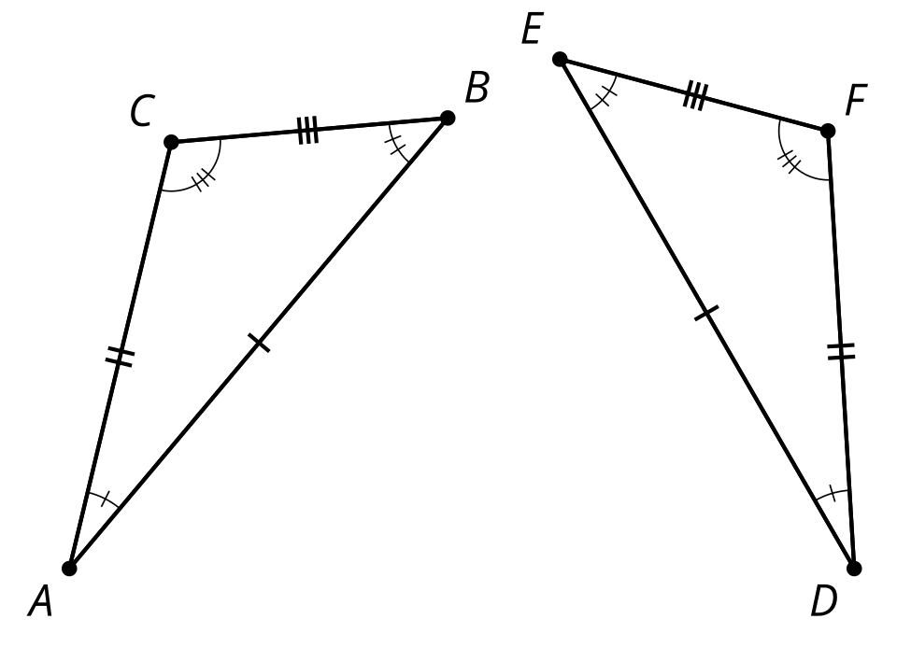
Proof:
- Segments $AB$ and $DE$ are the same length so they are congruent. Therefore, there is a rigid motion that takes $AB$ to $DE$.
- Apply that rigid motion to triangle $ABC$. The image of $A$ will coincide with $D$, and the image of $B$ will coincide with $E$.
- We cannot be sure that the image of $C$ coincides with $F$ yet. If necessary, reflect the image of triangle $ABC$ across $DE$ to be sure the image of $C$, which we will call $C^{′}$, is on the same side of $DE$ as $F$. (This reflection does not change the image of $A$ or $B$.)
- We know the image of angle $A$ is congruent to angle $D$ because rigid motions don’t change the size of angles.
- $C^{′}$ must be on ray $DF$ since both $C^{′}$ and $F$ are on the same side of $DE$, and make the same angle with it at $D$.
- Segment $DC^{′}$ is the image of $AC$ and rigid motions preserve distance, so they must have the same length.
- We also know $AC$ has the same length as $DF$. So $DC^{′}$ and $DF$ must be the same length.
- Since $C^{′}$ and $F$ are the same distance along the same ray from $D$, they have to be in the same place.
- We have shown that a rigid motion takes $A$ to $D$, $B$ to $E$, and $C$ to $F$; therefore, triangle $ABC$ is congruent to triangle $DEF$.

6.2: Proving the Side-Angle-Side Triangle Congruence Theorem
- Two triangles have 2 pairs of corresponding sides congruent, and the corresponding angles between those sides are congruent. Sketch 2 triangles that fit this description and label them $LMN$ and $PQR$, so that:
  - Segment $LM$ is congruent to segment $PQ$
  - Segment $LN$ is congruent to segment $PR$
  - Angle $L$ is congruent to angle $P$
- Use a sequence of rigid motions to take $LMN$ onto $PQR$. For each step, explain how you know that one or more vertices will line up.
- Look back at the congruent triangle proofs you’ve read and written. Do you have enough information here to use a proof that is like one you saw earlier? Use one of those proofs to guide you in writing a proof for this situation.

Are you ready for more?
It follows from the Side-Angle-Side Triangle Congruence Theorem that if the lengths of 2 sides of a triangle are known, and the measure of the angle between those 2 sides is known, there can only be one possible length for the third side.
Suppose a triangle has sides of lengths of 5 cm and 12 cm.
- What is the longest the third side could be? What is the shortest it could be?
- How long would the third side be if the angle between the two sides measured 90 degrees?

6.3: What Do We Know For Sure About Isosceles Triangles?
Mai and Kiran want to prove that in an isosceles triangle, the 2 base angles are congruent. Finish the proof that they started. Draw the auxiliary line and define it so that you can use the Side-Angle-Side Triangle Congruence Theorem to complete each statement in the proof.
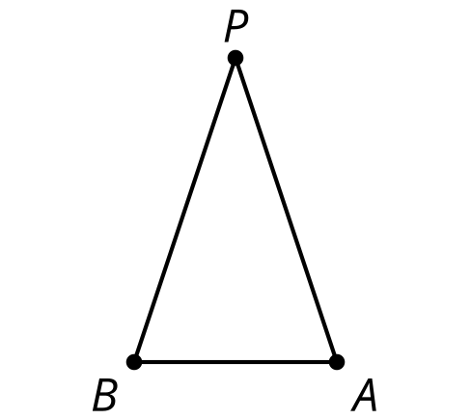
Draw $\underset{_}{}$.
Segment $PA$ is congruent to segment $PB$ because of the definition of isosceles triangle.
Angle $\underset{_}{}$ is congruent to angle $\underset{_}{}$ because $\underset{_}{}$.
Segment $PQ$ is congruent to itself.
Therefore, triangle $APQ$ is congruent to triangle $BPQ$ by the Side-Angle-Side Triangle Congruence Theorem.
Therefore, $\underset{_}{}$.

Lesson 6 Summary
If all pairs of corresponding sides and angles in 2 triangles are congruent, then it is possible to find a rigid transformation that takes corresponding vertices onto one another. This proves that if 2 triangles have all pairs of corresponding sides and angles congruent, then the triangles must be congruent. But, justifying that the vertices must line up does not require knowing all the pairs of corresponding sides and angles are congruent. We can justify that the triangles must be congruent if all we know is that 2 pairs of corresponding sides and the pair of corresponding angles between the sides are congruent. This is called the Side-Angle-Side Triangle Congruence Theorem.
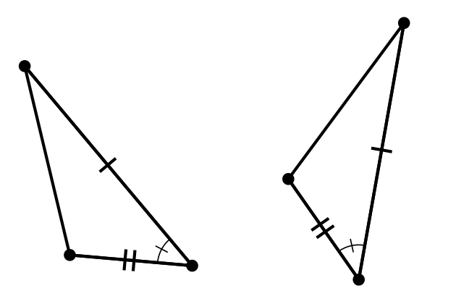
To find out if 2 triangles, or 2 parts of triangles, are congruent, see if the given information or the diagram indicates that 2 pairs of corresponding sides and the pair of corresponding angles between the sides are congruent. If that is the case, we don’t need to show and justify all the transformations that take one triangle onto the other triangle. Instead, we can explain how we know the pairs of corresponding sides and angles are congruent and say that the 2 triangles must be congruent because of the Side-Angle-Side Triangle Congruence Theorem.
Sometimes, to find congruent triangles, we may need to add more lines to the diagram. We can decide what properties those lines have based on how we construct the lines (An angle bisector? A perpendicular bisector? A line connecting 2 given points?). Mathematicians call these additional lines auxiliary lines because auxiliary means “providing additional help or support.” These are lines that give us extra help in seeing hidden triangle structures.
© CC BY 2019 by Illustrative Mathematics®

