Unit 6 Lesson 7: Connecting Representations of Functions

1 Which are the Same? Which are Different? (Warm up)

Student Task Statement
Here are three different ways of representing functions. How are they alike? How are they different?
$y=2x$
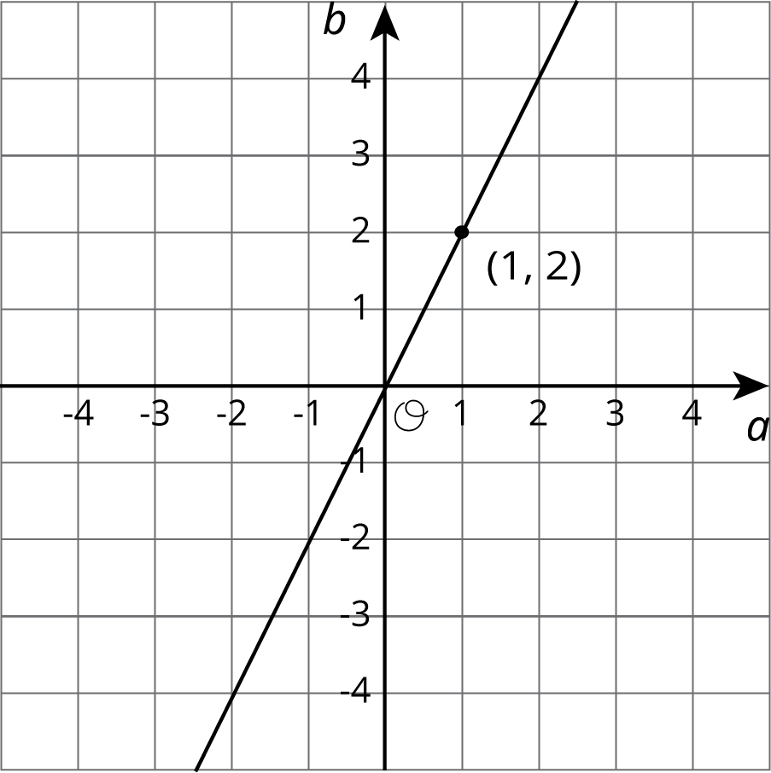
$p$ | -2 | -1 | 0 | 1 | 2 | 3
$q$ | 4 | 2 | 0 | -2 | -4 | -6

2 Comparing Temperatures

Student Task Statement
The graph shows the temperature between noon and midnight in City A on a certain day.
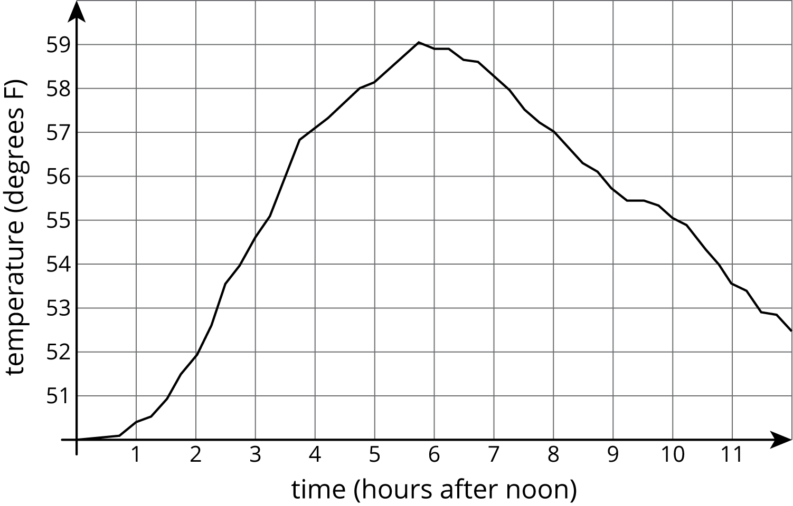
The table shows the temperature, $T$, in degrees Fahrenheit, for $h$ hours after noon, in City B.
$h$ | 1 | 2 | 3 | 4 | 5 | 6
$T$ | 82 | 78 | 75 | 62 | 58 | 59
- Which city was warmer at 4:00 p.m.?
- Which city had a bigger change in temperature between 1:00 p.m. and 5:00 p.m.?
- How much greater was the highest recorded temperature in City B than the highest recorded temperature in City A during this time?
- Compare the outputs of the functions when the input is 3.

3 Comparing Volumes

Student Task Statement
The volume, $V$, of a cube with edge length $s$ cm is given by the equation $V=s^{3}$.
The volume of a sphere is a function of its radius (in centimeters), and the graph of this relationship is shown here.
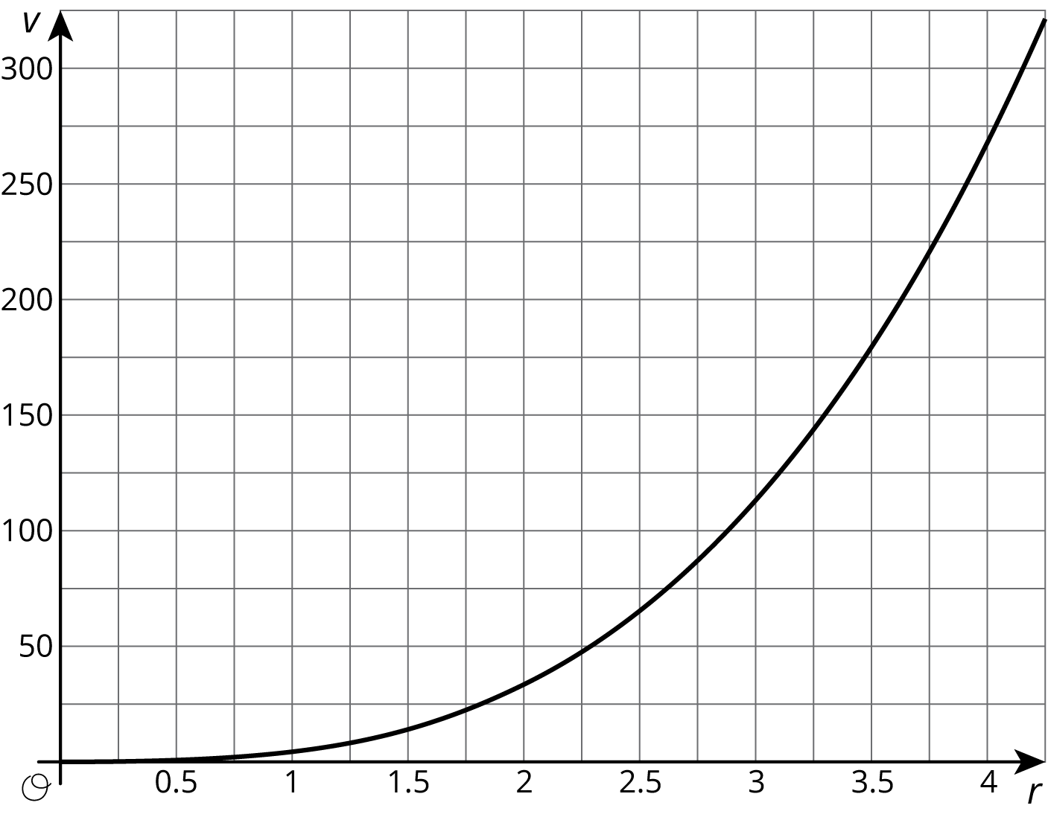
- Is the volume of a cube with edge length $s=3$ greater or less than the volume of a sphere with radius 3?
- If a sphere has the same volume as a cube with edge length 5, estimate the radius of the sphere.
- Compare the outputs of the two volume functions when the inputs are 2.

4 It’s Not a Race (Optional)

Student Task Statement
Elena’s family is driving on the freeway at 55 miles per hour.
Andre’s family is driving on the same freeway, but not at a constant speed. The table shows how far Andre's family has traveled, $d$, in miles, every minute for 10 minutes.
$t$ | 1 | 2 | 3 | 4 | 5 | 6 | 7 | 8 | 9 | 10
$d$ | 0.9 | 1.9 | 3.0 | 4.1 | 5.1 | 6.2 | 6.8 | 7.4 | 8 | 9.1
- How many miles per minute is 55 miles per hour?
- Who had traveled farther after 5 minutes? After 10 minutes?
- How long did it take Elena’s family to travel as far as Andre’s family had traveled after 8 minutes?
- For both families, the distance in miles is a function of time in minutes. Compare the outputs of these functions when the input is 3.
© CC BY Open Up Resources. Adaptations CC BY IM.

