Lesson 10 Practice Problems
- Find three different ways to write the number 437,000 using powers of 10.
- For each pair of numbers below, circle the number that is greater. Estimate how many times greater.
  - $17⋅{10}^{8}$ or $4⋅{10}^{8}$
  - $2⋅{10}^{6}$ or $7.839⋅{10}^{6}$
  - $42⋅{10}^{7}$ or $8.5⋅{10}^{8}$
- What number is represented by point $A$? Explain or show how you know.
- 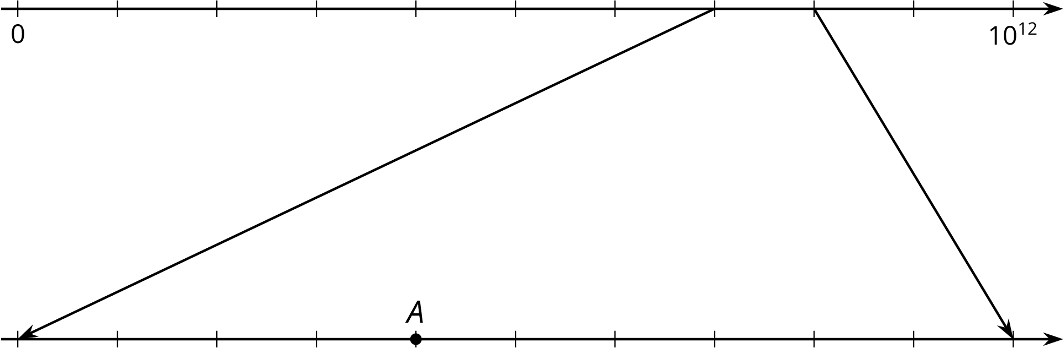

- Here is a scatter plot that shows the number of points and assists by a set of hockey players. Select all the following that describe the association in the scatter plot:
- 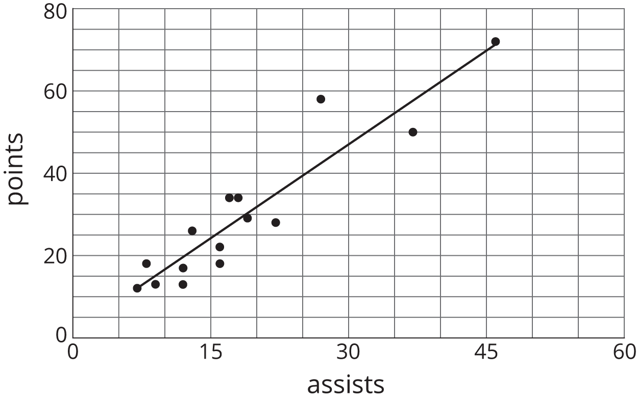
  - Linear association
  - Non-linear association
  - Positive association
  - Negative association
  - No association
- (From Unit 6, Lesson 7.)
- Here is the graph of days and the predicted number of hours of sunlight, $h$, on the $d$-th day of the year.
- 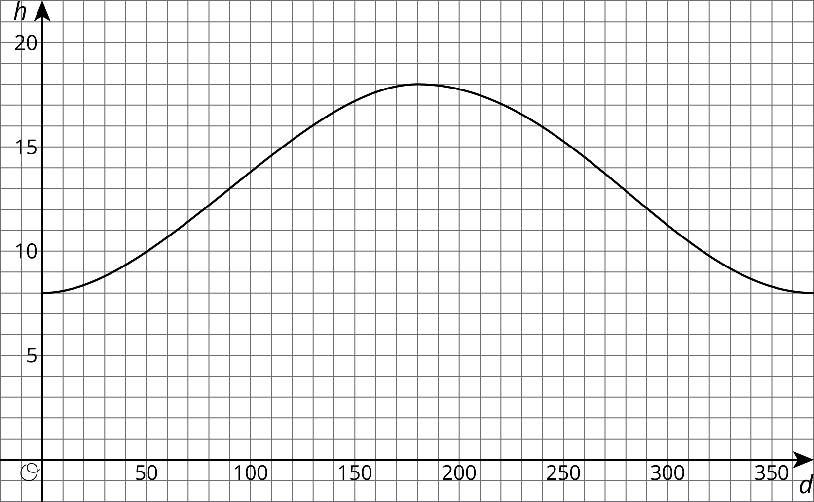

  - Is hours of sunlight a function of days of the year? Explain how you know.
  - For what days of the year is the number of hours of sunlight increasing? For what days of the year is the number of hours of sunlight decreasing?
  - Which day of the year has the greatest number of hours of sunlight?
- (From Unit 5, Lesson 5.)
© CC BY Open Up Resources. Adaptations CC BY IM.

