Lesson 12 Practice Problems
- Select all the points that are on the line through $\left(0,5\right)$ and $\left(2,8\right)$.
  - $\left(4,11\right)$
  - $\left(5,10\right)$
  - $\left(6,14\right)$
  - $\left(30,50\right)$
  - $\left(40,60\right)$
- All three points displayed are on the line. Find an equation relating $x$ and $y$.
- 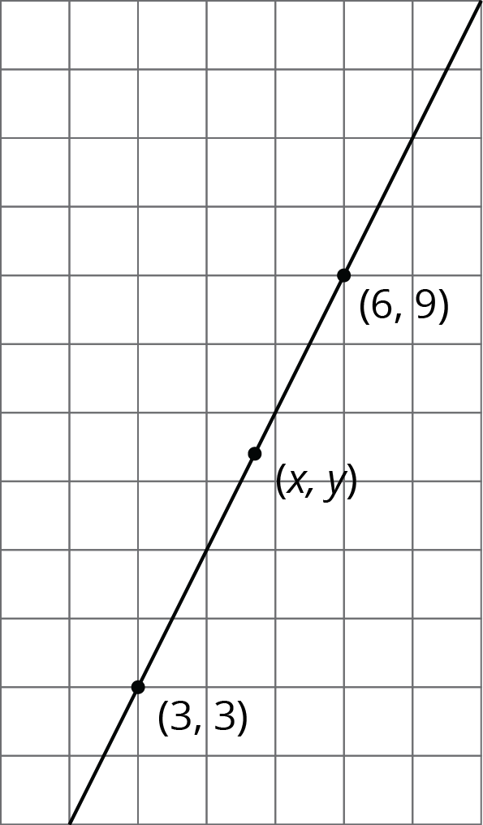
- Here is triangle $ABC$.
- 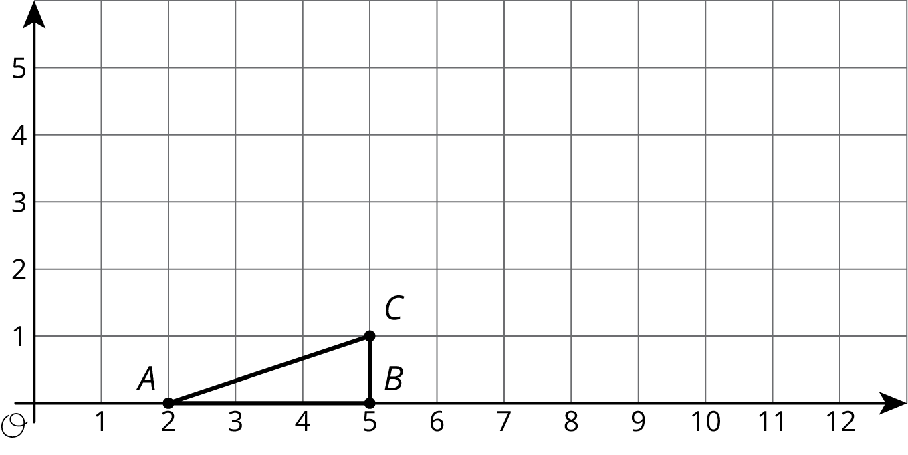
  - Draw the dilation of triangle $ABC$ with center $\left(2,0\right)$ and scale factor 2.
  - Draw the dilation of triangle $ABC$ with center $\left(2,0\right)$ and scale factor 3.
  - Draw the dilation of triangle $ABC$ with center $\left(2,0\right)$ and scale factor $\frac{1}{2}$.
  - What are the coordinates of the image of point $C$ when triangle $ABC$ is dilated with center $\left(2,0\right)$ and scale factor $s$?
  - Write an equation for the line containing all possible images of point $C$.
- Here are some line segments.
- 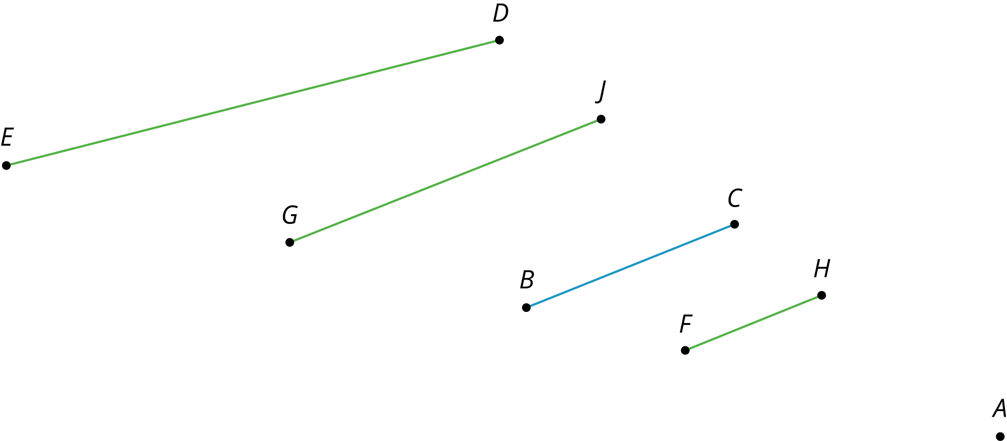
  - Which segment is a dilation of $\overset{¯}{BC}$ using $A$ as the center of dilation and a scale factor of $\frac{2}{3}$?
  - Which segment is a dilation of $\overset{¯}{BC}$ using $A$ as the center of dilation and a scale factor of $\frac{3}{2}$?
  - Which segment is not a dilation of $\overset{¯}{BC}$, and how do you know?
- (From Unit 2, Lesson 4.)
© CC BY Open Up Resources. Adaptations CC BY IM.

