Lesson 5 Practice Problems
- Match each quadratic expression with an equivalent expression in factored form.​​​​​​
  - $x^{2}+6x$
  - $x^{2}+6x+5$
  - $x^{2}+6x−7$
  - $x^{2}+6x+8$
  - $x^{2}+6x+9$
  - $\left(x+7\right)\left(x−1\right)$
  - $\left(x+5\right)\left(x+1\right)$
  - $\left(x+4\right)\left(x+2\right)$
  - $\left(x+3\right)\left(x+3\right)$
  - $x\left(x+6\right)$
- An equation of a circle is $x^{2}−8x+16+y^{2}+10y+25=81$.
  - What is the radius of the circle?
  - What is the center of the circle?
- Write 3 perfect square trinomials. Then rewrite them as squared binomials.
- Write an equation of the circle that has a diameter with endpoints $\left(12,3\right)$ and $\left(\text{-}18,3\right)$.
- (From Unit 6, Lesson 4.)

  - Graph the circle ${\left(x−2\right)}^{2}+{\left(y−1\right)}^{2}=25$.
  - For each point, determine if it is on the circle. If not, decide whether it is inside the circle or outside of the circle.
    - $\left(4,0\right)$
    - $\left(\text{-}3,3\right)$
    - $\left(\text{-}2,\text{-}2\right)$
  - How can you use distance calculations to decide if a point is inside, on, or outside a circle?
- 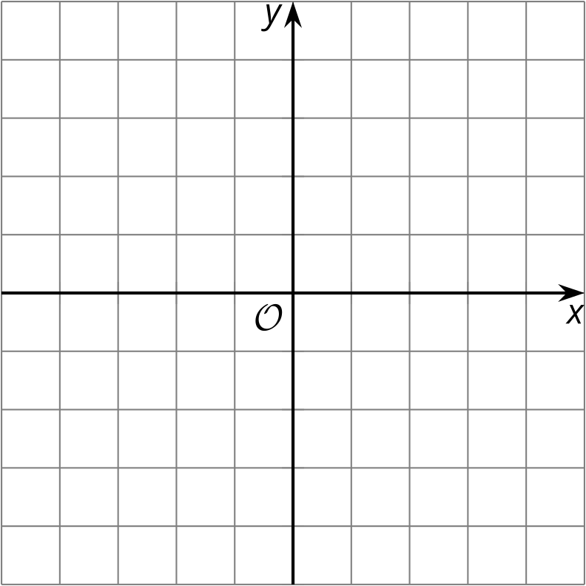
- (From Unit 6, Lesson 4.)
- The triangle whose vertices are $\left(2,5\right),\left(3,1\right),$ and $\left(4,2\right)$ is transformed by the rule $\left(x,y\right)→\left(x−2,y+4\right)$. Is the image similar or congruent to the original figure?
  - The image is congruent to the original triangle.
  - The image is similar but not congruent to the original triangle.
  - The image is neither similar nor congruent to the original triangle.
- (From Unit 6, Lesson 3.)
- Technology required. A triangular prism has height 6 units. The base of the prism is shown in the image. What is the volume of the prism? Round your answer to the nearest tenth.
- 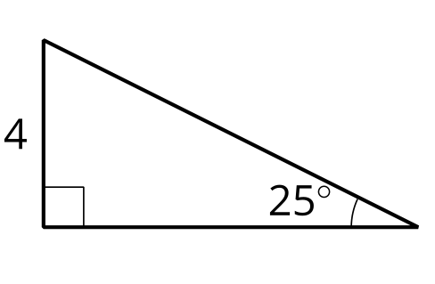
- (From Unit 5, Lesson 15.)
© CC BY 2019 by Illustrative Mathematics®

