Unit 3 Lesson 9: Causal Relationships

1 Used Car Relationships (Warm up)

Student Task Statement
Describe the strength and sign of the relationship you expect for each pair of variables. Explain your reasoning.
- Used car price and original sale price of the car.
- Used car price and number of cup holders in the car.
- Used car price and number of oil changes the car has had.
- Used car price and number of miles the car has been driven.

2 Cause or Effect?

Student Task Statement
Each of the scatter plots show a strong relationship. Write a sentence or two describing how you think the variables are related.
- 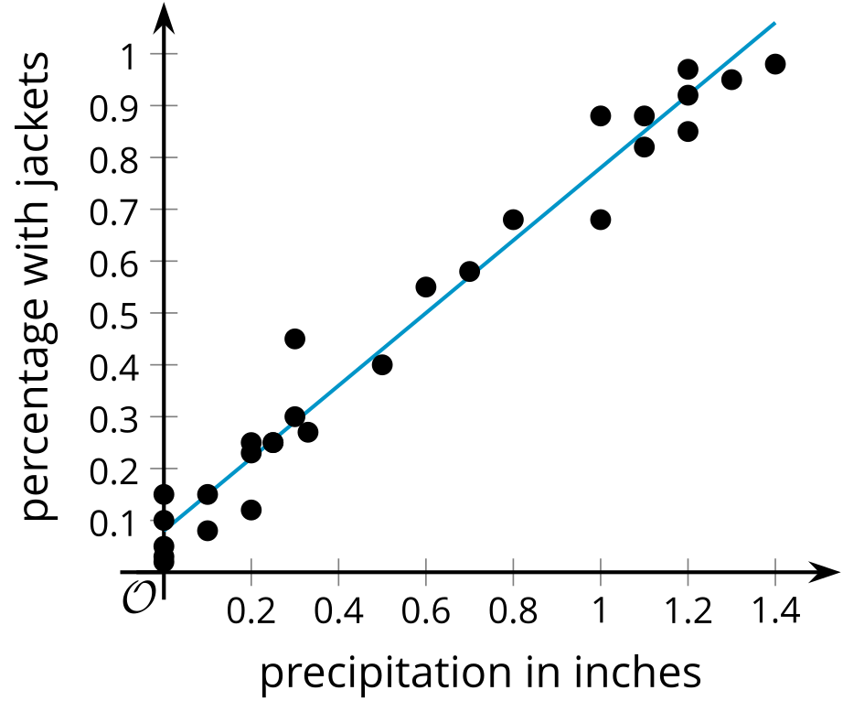
- During the month of April, Elena keeps track of the number of inches of rain recorded for the day and the percentage of people who come to school with rain jackets.
- 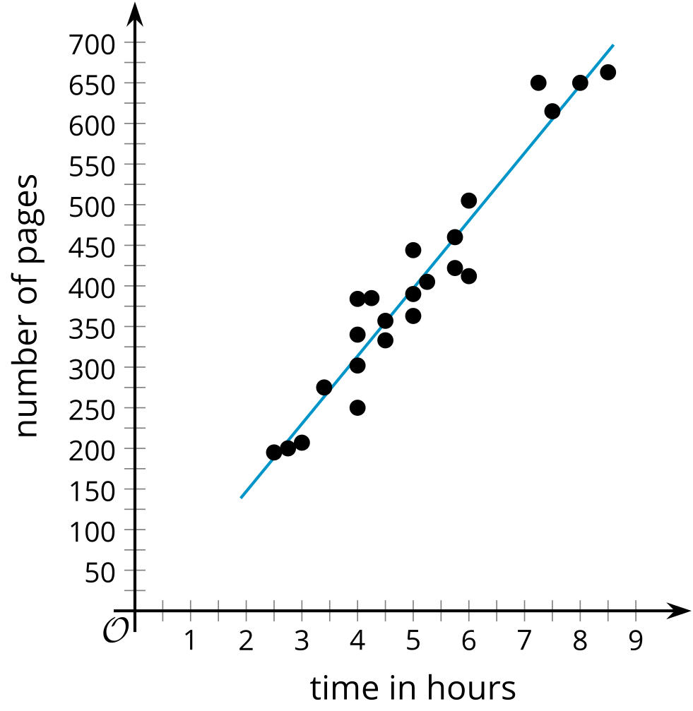
- A school book club has a list of 100 books for its members to read. They keep track of the number of pages in the books the members read from the list and the amount of time it took to read the book.
- 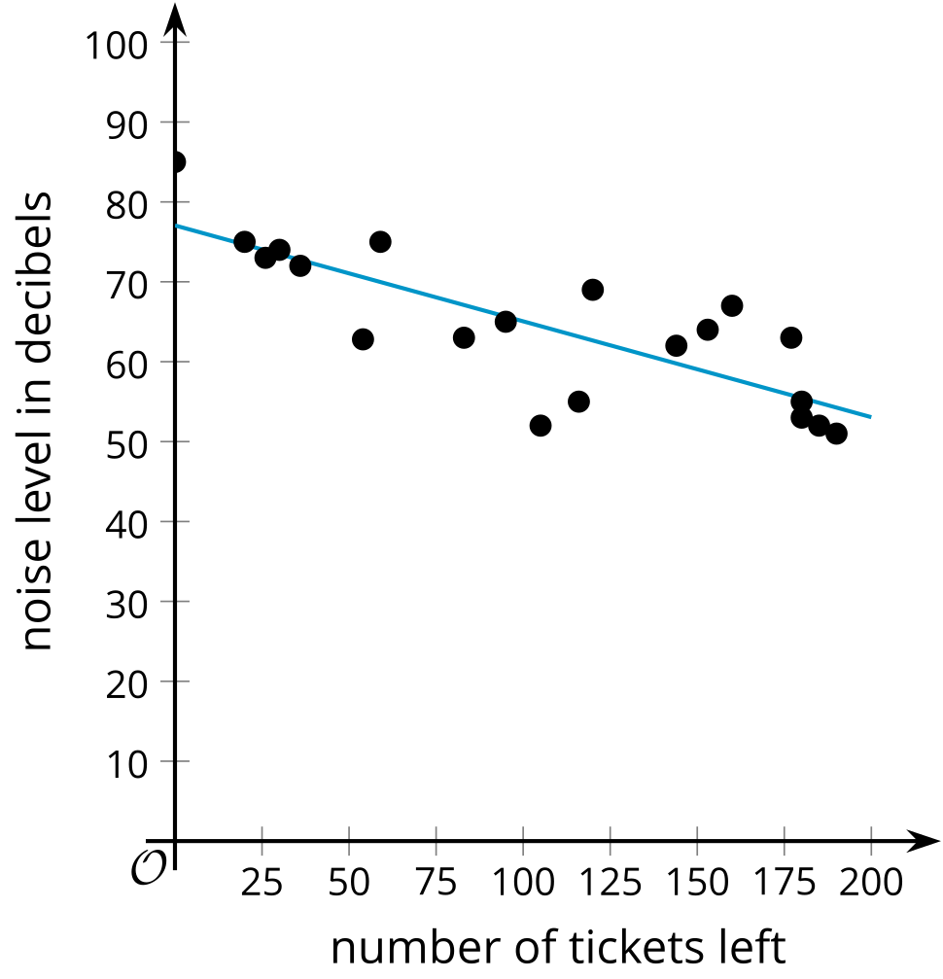
- Number of tickets left for holiday parties at a venue and noise level at the party.
- 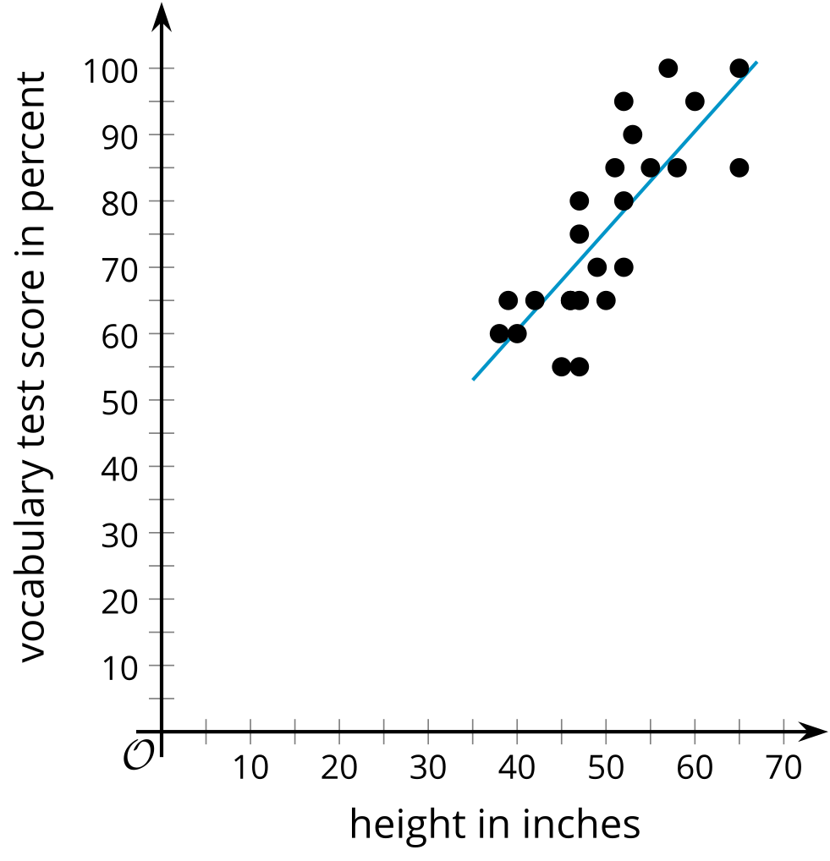
- The height and score on a test of vocabulary for several children ages 6 to 13.

3 Find Your Cause

Student Task Statement
Describe a pair of variables with each condition. Explain your reasoning.
- Two variables with a causal relationship.
- The variables are strongly related, but a third factor might be the cause for the changes in the variables.
- The variables are only weakly related.
© CC BY 2019 by Illustrative Mathematics®

