Unit 6 Lesson 12: Solving Problems about Percent Increase or Decrease

1 20% Off (Warm up)

Student Task Statement
An item costs $x$ dollars and then a 20% discount is applied. Select all the expressions that could represent the price of the item after the discount.
- $\frac{20}{100}x$
- $x−\frac{20}{100}x$
- $\left(1−0.20\right)x$
- $\frac{100−20}{100}x$
- $0.80x$
- $\left(100−20\right)x$

2 Walking More Each Day

Student Task Statement
- Mai started a new exercise program. On the second day, she walked 5 minutes more than on the first day. On the third day, she increased her walking time from day 2 by 20% and walked for 42 minutes. Mai drew a diagram to show her progress.
- 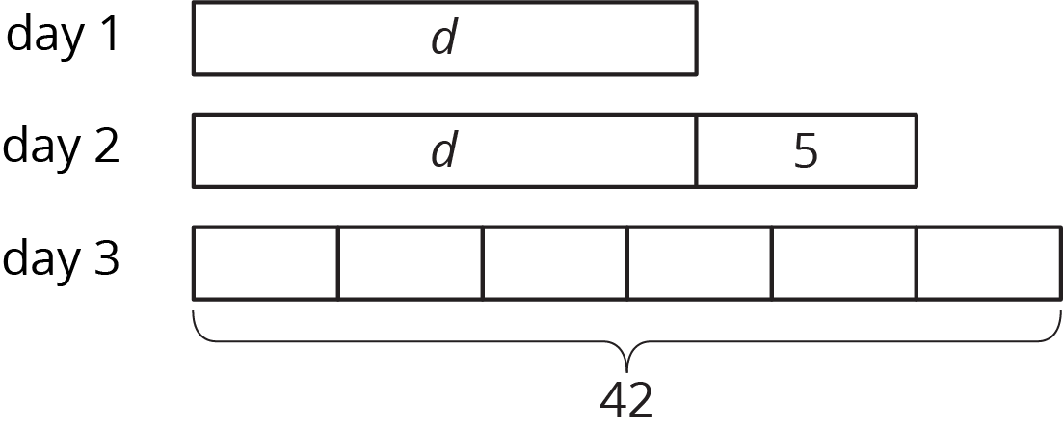
- Explain how the diagram represents the situation.
- Noah said the equation $1.20\left(d+5\right)=42$ also represents the situation. Do you agree with Noah? Explain your reasoning.
- Find the number of minutes Mai walked on the first day. Did you use the diagram, the equation, or another strategy? Explain or show your reasoning.
- Mai has been walking indoors because of cold temperatures. On Day 4 at noon, Mai hears a report that the temperature is only 9 degrees Fahrenheit. She remembers the morning news reporting that the temperature had doubled since midnight and was expected to rise 15 degrees by noon. Mai is pretty sure she can draw a diagram to represent this situation but isn't sure if the equation is $9=15+2t$ or $2\left(t+15\right)=9$. What would you tell Mai about the diagram and the equation and how they might be useful to find the temperature, $t$, at midnight?

3 A Sale on Shoes

Student Task Statement
- A store is having a sale where all shoes are discounted by 20%. Diego has a coupon for $3 off of the regular price for one pair of shoes. The store first applies the coupon and then takes 20% off of the reduced price. If Diego pays $18.40 for a pair of shoes, what was their original price before the sale and without the coupon?
- Before the sale, the store had 100 pairs of flip flops in stock. After selling some, they notice that $\frac{3}{5}$ of the flip flops they have left are blue. If the store has 39 pairs of blue flip flops, how many pairs of flip flops (any color) have they sold?
- When the store had sold $\frac{2}{9}$ of the boots that were on display, they brought out another 34 pairs from the stock room. If that gave them 174 pairs of boots out, how many pairs were on display originally?
- On the morning of the sale, the store donated 50 pairs of shoes to a homeless shelter. Then they sold 64% of their remaining inventory during the sale. If the store had 288 pairs after the donation and the sale, how many pairs of shoes did they have at the start?
© CC BY Open Up Resources. Adaptations CC BY IM.

