Lesson 13 Practice Problems
- Select all expressions that are equal to $3⋅3⋅3⋅3⋅3$.
  - $3⋅5$
  - $3^{5}$
  - $3^{4}⋅3$
  - $5⋅3$
  - $5^{3}$
- Noah starts with 0 and then adds the number 5 four times. Diego starts with 1 and then multiplies by the number 5 four times. For each expression, decide whether it is equal to Noah’s result, Diego’s result, or neither.
  - $4⋅5$
  - $4+5$
  - $4^{5}$
  - $5^{4}$
- Decide whether each equation is true or false, and explain how you know.
  - $9⋅9⋅3=3^{5}$
  - $7+7+7=3+3+3+3+3+3+3$
  - $\frac{1}{7}⋅\frac{1}{7}⋅\frac{1}{7}=\frac{3}{7}$
  - $4^{1}=4⋅1$
  - $6+6+6=6^{3}$

  - What is the area of a square with side lengths of $\frac{3}{5}$ units?
  - What is the side length of a square with area $\frac{1}{16}$ square units?
  - What is the volume of a cube with edge lengths of $\frac{2}{3}$ units?
  - What is the edge length of a cube with volume $\frac{27}{64}$ cubic units?
- Select all the expressions that represent the area of the shaded rectangle.
- 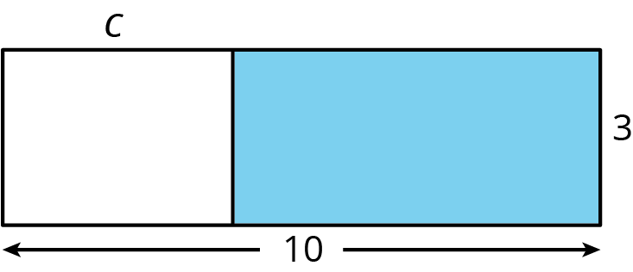
  - $3\left(10−c\right)$
  - $3\left(c−10\right)$
  - $10\left(c−3\right)$
  - $10\left(3−c\right)$
  - $30−3c$
  - $30−10c$
- (From Unit 6, Lesson 10.)
- A ticket at a movie theater costs $8.50. One night, the theater had $29,886 in ticket sales.
  - Estimate about how many tickets the theater sold. Explain your reasoning.
  - How many tickets did the theater sell? Explain your reasoning.
- (From Unit 5, Lesson 13.)
- A fence is being built around a rectangular garden that is $8\frac{1}{2}$ feet by $6\frac{1}{3}$ feet. Fencing comes in panels. Each panel is $\frac{2}{3}$ of a foot wide. How many panels are needed? Explain or show your reasoning.
- (From Unit 4, Lesson 12.)
© CC BY Open Up Resources. Adaptations CC BY IM.

