Unit 4 Lesson 6: Using Diagrams to Find the Number of Groups

1 How Many of These in That? (Warm up)

Student Task Statement
- We can think of the division expression $10÷2\frac{1}{2}$ as the question: “How many groups of $2\frac{1}{2}$ are in 10?” Complete the tape diagram to represent this question. Then find the answer.
- 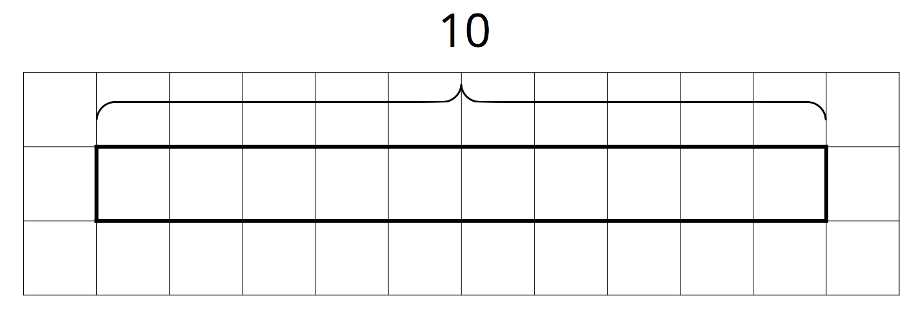
- Complete the tape diagram to represent the question: “How many groups of 2 are in 7?” Then find the answer.
- 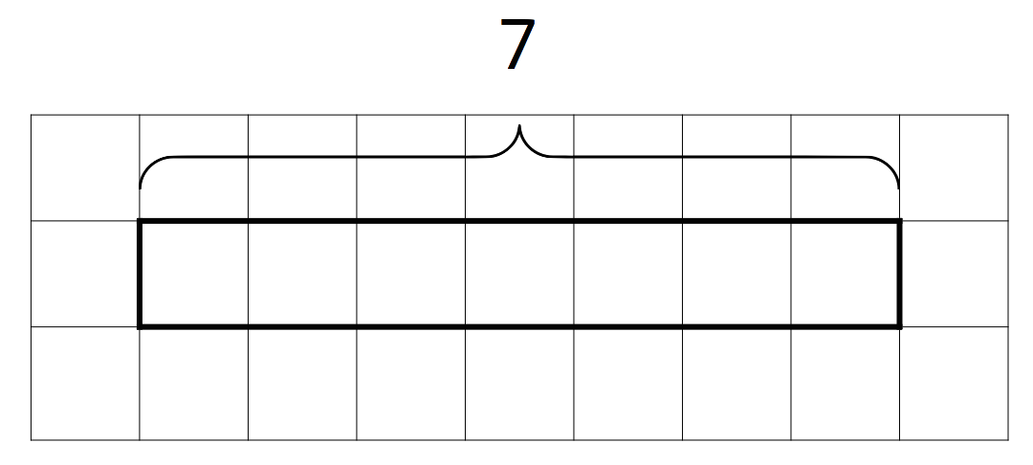

2 Representing Groups of Fractions with Tape Diagrams

Student Task Statement
To make sense of the question “How many $\frac{2}{3}$s are in 1?,” Andre wrote equations and drew a tape diagram.
$?⋅\frac{2}{3}=1$
$1÷\frac{2}{3}=?$
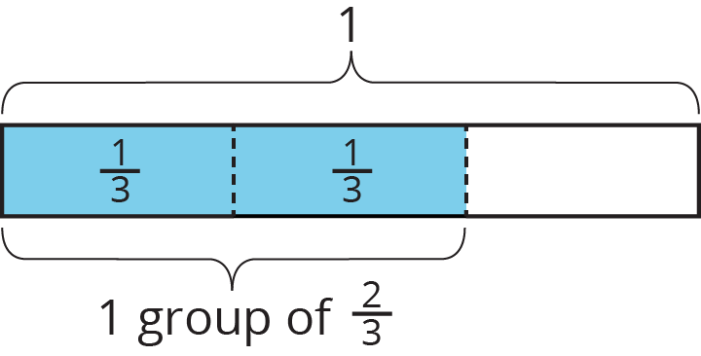
- In an earlier task, we used pattern blocks to help us solve the equation $1÷\frac{2}{3}=?$. Explain how Andre’s tape diagram can also help us solve the equation.
- Write a multiplication equation and a division equation for each question. Then, draw a tape diagram and find the answer.
  - How many $\frac{3}{4}$s are in 1?
  - How many $\frac{2}{3}$s are in 3?
  - How many $\frac{3}{2}$s are in 5?

3 Finding Number of Groups

Student Task Statement
- Write a multiplication equation or a division equation for each question. Then, find the answer and explain or show your reasoning.
  - How many $\frac{3}{8}$-inch thick books make a stack that is 6 inches tall?
  - How many groups of $\frac{1}{2}$ pound are in $2\frac{3}{4}$ pounds?
- Write a question that can be represented by the division equation $5÷1\frac{1}{2}=?$. Then, find the answer and explain or show your reasoning.
© CC BY Open Up Resources. Adaptations CC BY IM.

