Unit 2 Lesson 1: Expressing Mathematics

1 Notice and Wonder: Party Planning (Warm up)

Student Task Statement
What do you notice? What do you wonder?
“Kiran is helping his aunt and uncle plan a cookout. His family has a lot of experience planning parties."
“Kiran’s uncle is in charge of the food. He tells Kiran that he plans to use $\frac{1}{4}$ pounds of ground beef per person and 2 ears of corn per person."
“Kiran’s aunt is getting plates and paper towels. She plans on buying one plate per person, plus 10 extra plates just in case, and she’s going to buy one roll of paper towels for every 10 people.”

2 Feeding Operation

Student Task Statement
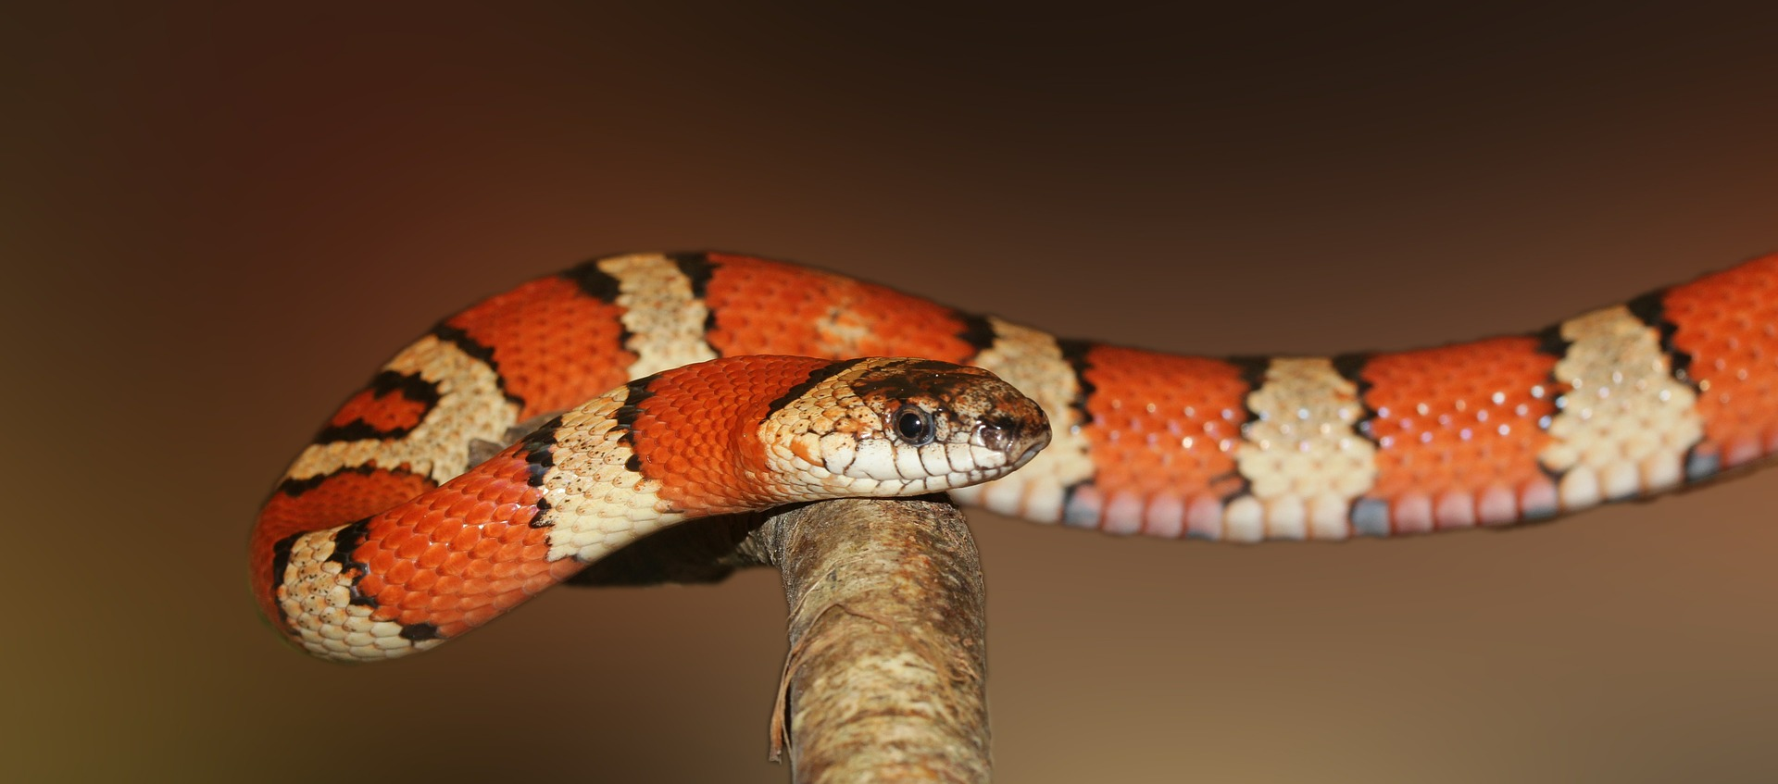
A zookeeper is preparing to care for snakes in an exhibit. For each question, write an expression representing the supplies needed.
- She needs one mouse for each snake, plus two extra mice. How many mice are needed if the number of the snakes is:
  - 10
  - 6
  - $x$
- She needs 4.5 ounces of crickets for each snake. How many ounces of crickets are needed if the number of snakes is:
  - 10
  - 6
  - $x$
- For every 2 snakes, she needs 1 bowl of water. How many bowls of water are needed if the number of snakes is:
  - 10
  - 6
  - $x$
- There is one male snake, and the rest are female. She needs one vitamin pill for every female snake. How many vitamin pills does she need if the number of snakes is:
  - 10
  - 6
  - $x$

3 Important Quantities

Student Task Statement
To understand the situation, what is some information you would like to know? What information is already given?
- Clare is in charge of getting snacks for a road trip with her two friends and her dog. She has $35 to go to the store to get some supplies.
- Andre wants to surprise his neighbor with a picnic basket of fruit and vegetables from his garden. The basket can hold up to 12 food items.
- Tyler is packing his bags for vacation.
- Mai's teacher orders tickets to the local carnival for herself, the entire class, and 2 more chaperones.
- Jada wants to prepare the fabric for the bridesmaids dresses she is creating for a wedding party.
© CC BY 2019 by Illustrative Mathematics®

