Lesson 4 Practice Problems
- The solution to $5−3x>35$ is either $x>\text{-}10$ or $\text{-}10>x$. Which solution is correct? Explain how you know.
- The school band director determined from past experience that if they charge $t$ dollars for a ticket to the concert, they can expect attendance of $1000−50t$. The director used this model to figure out that the ticket price needs to be $8 or greater in order for at least 600 to attend. Do you agree with this claim? Why or why not?
- Which inequality is true when the value of $x$ is -3?
  - $\text{-}x−6<\text{-}3.5$
  - $\text{-}x−6>3.5$
  - $\text{-}x−6>\text{-}3.5$
  - $x−6>\text{-}3.5$
- (From Unit 4, Lesson 3.)
- Draw the solution set for each of the following inequalities.
  - $x≤5$
  - $x<\frac{5}{2}$
- (From Unit 4, Lesson 3.)
- Write three different equations that match the tape diagram.
- 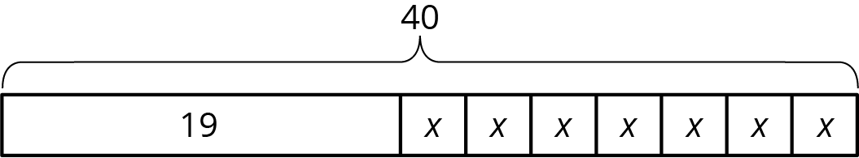

- (From Unit 3, Lesson 3.)
- A baker wants to reduce the amount of sugar in his cake recipes. He decides to reduce the amount used in 1 cake by $\frac{1}{2}$ cup. He then uses $4\frac{1}{2}$ cups of sugar to bake 6 cakes.
- 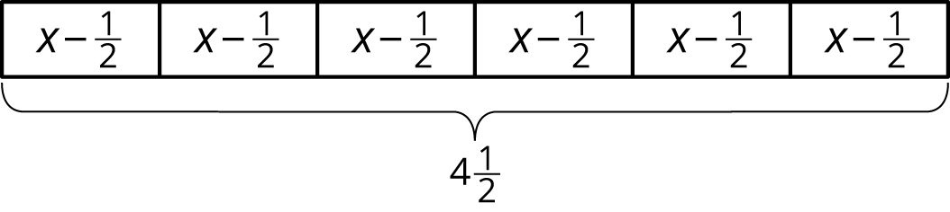
  - Describe how the tape diagram represents the story.
  - How much sugar was originally in each cake recipe?
- (From Unit 3, Lesson 2.)
© CC BY Open Up Resources. Adaptations CC BY IM.

