Lesson 7: Inequivalent Equations
- Let’s see what happens when we square each side of an equation.

7.1: 2 and -2
What do you notice? What do you wonder?
- $x^{2}=4$
- $x^{2}=\text{-}4$
- $\left(x−2\right)\left(x+2\right)=0$
- $x=\sqrt{4}$

7.2: Careful When You Take the Square Root
Tyler was solving this equation:
$x^{2}−1=3$
He said, “I can add 1 to each side of the equation and it doesn’t change the equation. I get $x^{2}=4$.”
- Priya said, “It does change the equation. It just doesn’t change the solutions!” Then she showed these two graphs.

- Figure A
- 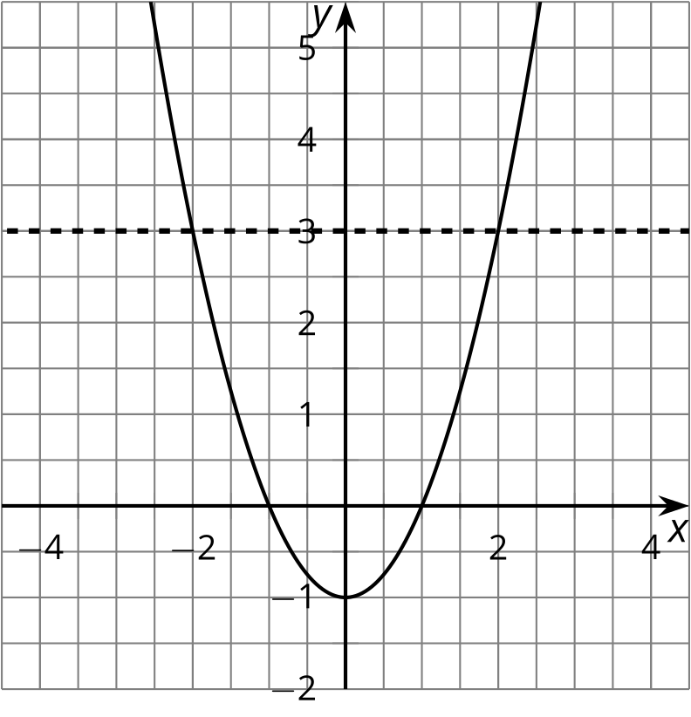

- Figure B
- 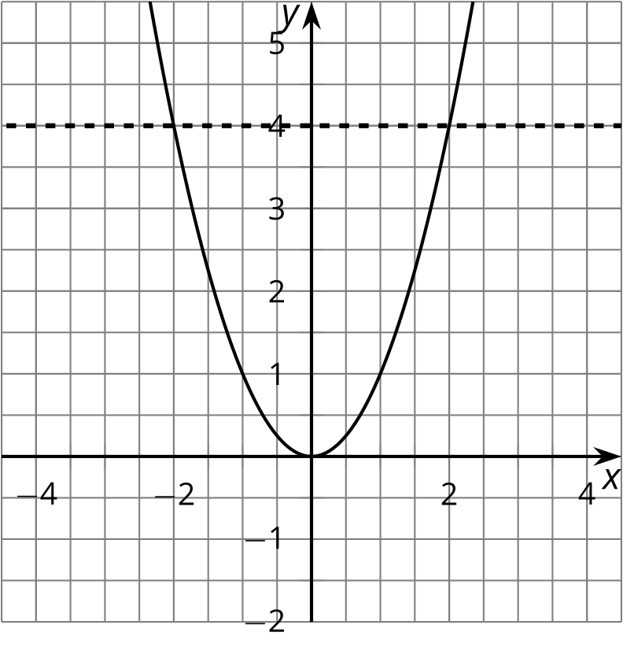
  - How can you see the solution to the equation $x^{2}−1=3$ in Figure A?
  - How can you see the solution to the equation $x^{2}=4$ in Figure B?
  - Use the graphs to explain why the equations have the same solutions.
- Tyler said, “Now I can take the square root of each side to get the solution to $x^{2}=4$. The square root of $x^{2}$ is $x$. The square root of 4 is 2.” He wrote:
- $\begin{matrix}x^{2} & =4 \\ \sqrt{x^{2}} & =\sqrt{4} \\ x & =2\end{matrix}$
- Priya said, “But the graphs show that there are two solutions!” What went wrong?

7.3: Another Way to Solve
Han was solving this equation: $\frac{x+3}{2}=4$
He said, "I know that half of $x+3$ is 4. So $x+3$ must be 8, since half of 8 is 4. This means that $x$ is 5."
- Use Han's reasoning to solve this equation: ${\left(x+3\right)}^{2}=4$.
- What advice would you give to someone who was going to solve an equation like ${\left(x+3\right)}^{2}=4$?

7.4: What Happens When You Square Each Side?
Mai was solving this equation: $\sqrt{x−1}=3$
She said, “I can square each side of the equation to get another equation with the same solutions.” Then she wrote:
$\begin{matrix}\sqrt{x−1} & =3 \\ {\left(\sqrt{x−1}\right)}^{2} & =3^{2} \\ x−1 & =9 \\ x & =10\end{matrix}$
- Check to see if her solution makes the original equation true.
- Andre said, “I tried your technique to solve $\sqrt{x−1}=\text{-}3$but it didn’t work.” Why doesn’t it work? Explain or show your reasoning.

7.5: Solve These Equations With Square Roots in Them
Find the solution(s) to each of these equations, or explain why there is no solution.
- $\sqrt{t+4}=3$
- $\text{-}10=\text{-}\sqrt{a}$
- $\sqrt{3−w}−4=0$
- $\sqrt{z}+9=0$

Are you ready for more?
Are there values of $a$ and $b$ so that the equation $\sqrt{t+a}=b$ has more than one solution? Explain your reasoning.

Lesson 7 Summary
Every positive number has two square roots. You can see this by looking at the graph of $y=x^{2}$:
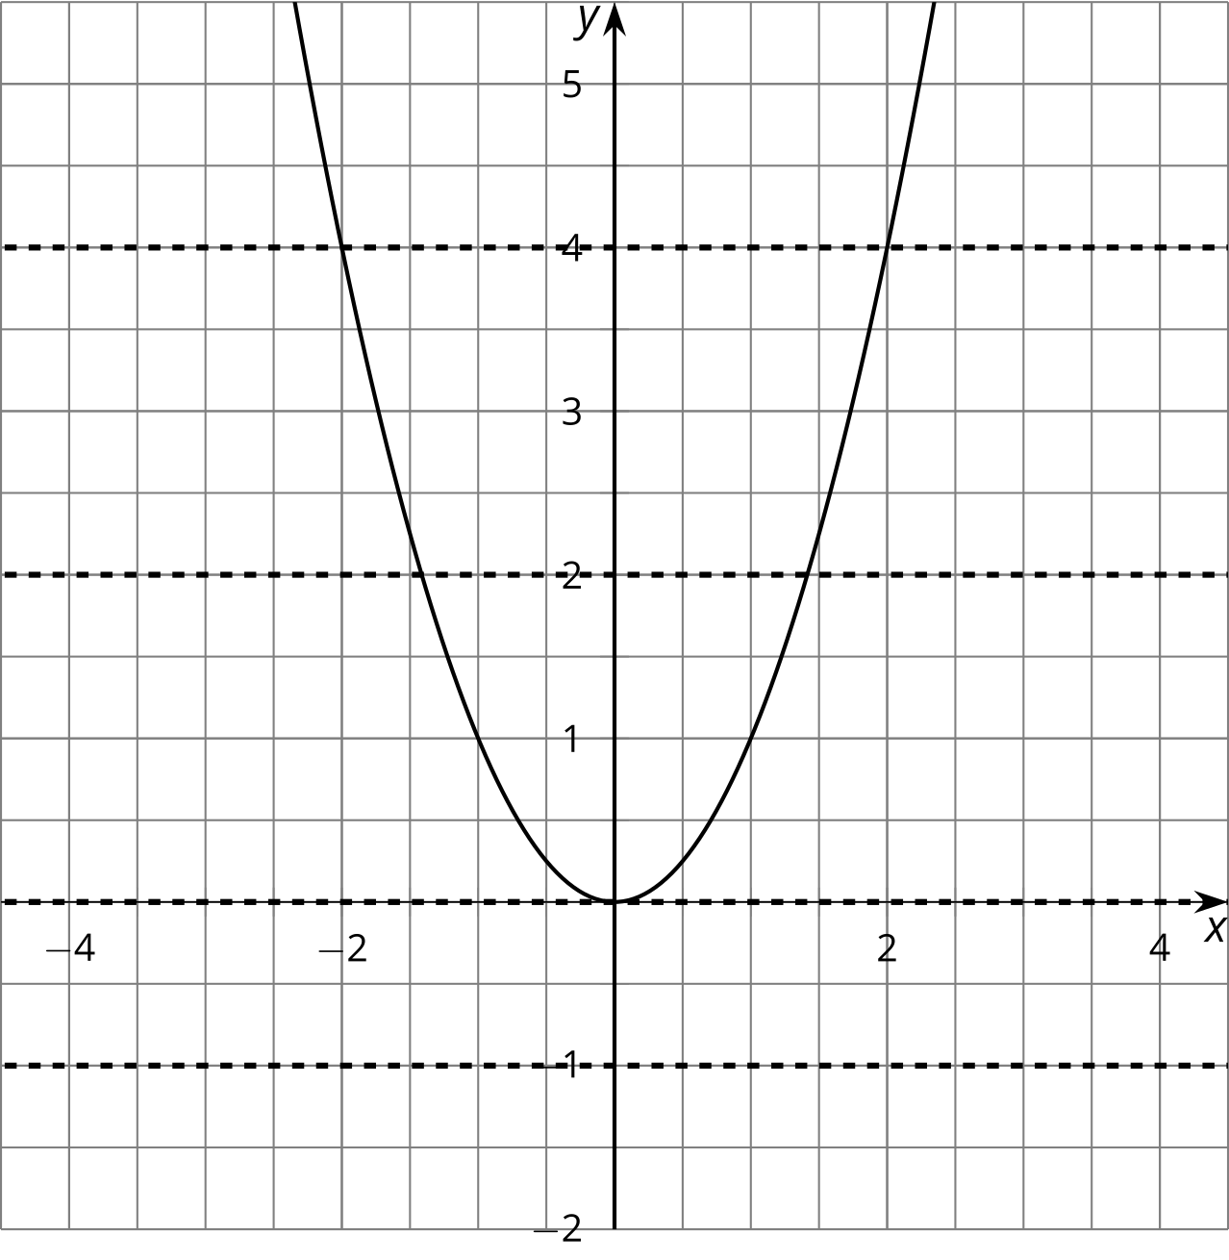
If $y$ is a positive number like 4, then we can see that $y=4$ crosses the graph in two places, so the equation $x^{2}=4$ will have two solutions, namely, $\sqrt{4}$ and $\text{-}\sqrt{4}$. This is true for any positive number $a$: $y=a$ will cross the graph in two places, and $x^{2}=a$ will have two solutions, $x=\sqrt{a}$ and $x=\text{-}\sqrt{a}$.
When we have a square root in an equation like $\sqrt{t}−6=0$, we can isolate the square root and then square each side:
$\begin{matrix}\sqrt{t}−6 & =0 \\ \sqrt{t} & =6 \\ t & =6^{2} \\ t & =36\end{matrix}$
But sometimes, squaring each side of an equation gives results that aren’t solutions to the original equation. For example:
$\begin{matrix}\sqrt{t}+6 & =0 \\ \sqrt{t} & =\text{-}6 \\ t & ={\left(\text{-}6\right)}^{2} \\ t & =36\end{matrix}$
Note that 36 is not a solution to the original equation, because $\sqrt{36}+6$ doesn’t equal 0. In fact, $\sqrt{t}+6=0$ has no solutions, because it’s impossible for the sum of two positive numbers to be zero.
Remember: sometimes the new equation has solutions that the old equation doesn’t have. Always check your solutions in the original equation!
© CC BY 2019 by Illustrative Mathematics®

