Lesson 6 Practice Problems
- Suppose a classmate missed the lessons on completing the square to find the center and radius of a circle. Explain the process to them. If it helps, use a problem you’ve already done as an example.
- Match each expression with the value needed in the box in order for the expression to be a perfect square trinomial.
  - x2−8x+3
  - x2+20x+3
  - x2−16x+3
  - x2+9x+3
  - 16
  - 20.25
  - 64
  - 100
- Find the center and radius of the circle represented by the equation $x^{2}+y^{2}+4x−10y+20=0$.
- Select all the expressions that can be factored into a squared binomial.
  - $y^{2}+2y+1$
  - $w^{2}+5w+\frac{25}{4}$
  - $y^{2}−10y+5$
  - $x^{2}−10x+25$
  - $x^{2}+10x+25$
  - $w^{2}+20w+40$
- (From Unit 6, Lesson 5.)
- An equation of a circle is given by ${\left(x+3\right)}^{2}+{\left(y−9\right)}^{2}=5^{2}$. Apply the distributive property to the squared binomials and rearrange the equation so that one side is 0.
- (From Unit 6, Lesson 5.)

  - Graph the circle ${\left(x+1\right)}^{2}+{\left(y−3\right)}^{2}=16$.
  - Find the distance from the center of the circle to each point on the list.
    - $\left(2,1\right)$
    - $\left(4,1\right)$
    - $\left(3,3\right)$
  - What do these distances tell you about whether each point is inside, on, or outside the circle?
- 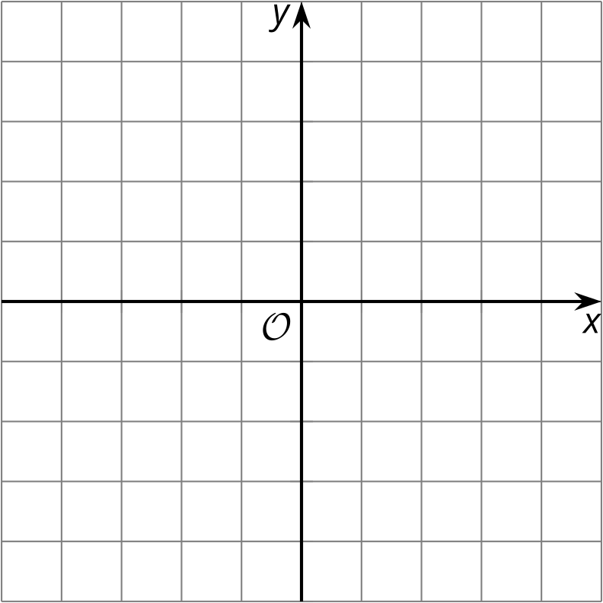
- (From Unit 6, Lesson 4.)
- The triangle whose vertices are $\left(3,\text{-}1\right),\left(2,4\right),$ and $\left(5,1\right)$ is transformed by the rule $\left(x,y\right)→\left(2x,5y\right)$. Is the image similar or congruent to the original figure?
  - The image is congruent to the original triangle.
  - The image is similar but not congruent to the original triangle.
  - The image is neither similar nor congruent to the original triangle.
- (From Unit 6, Lesson 3.)
- A cube has side length 3 inches. A sphere has a radius of 3 inches.
  - Before doing any calculations, predict which solid has greater surface area to volume ratio.
  - Calculate the surface area, volume, and surface area to volume ratio for each solid.
- (From Unit 5, Lesson 16.)
© CC BY 2019 by Illustrative Mathematics®

