Unit 6 Lesson 11: Zeros of Functions and Intercepts of Graphs

1 Which Output is 0? (Warm up)

Student Task Statement
Which of these functions have an output of 0 when the input is -4?
- $v\left(x\right)=4x$
- $w\left(x\right)=\text{-}4x$
- $y\left(x\right)=8+2x$
- $z\left(x\right)=2x−8$

2 Intercept Detective

Student Task Statement
Here are the definitions of some functions, followed by some possible inputs for the functions.
$a\left(x\right)=x−5$
$b\left(x\right)=x+5$
$c\left(x\right)=x−3$
$d\left(x\right)=x+1$
$f\left(x\right)=3x−6$
$g\left(x\right)=3x+6$
$h\left(x\right)=\left(x+5\right)\left(x+3\right)$
$m\left(x\right)=\left(x+1\right)\left(x−3\right)$
$n\left(x\right)=\left(3x−6\right)\left(x−5\right)$
Possible inputs: -5, -4, -3, -2, -1, 0, 1, 2, 3, 4, and 5.
- For each function, decide which input or inputs would give an output of 0.
- Here are graphs of $b$, $f$, and $m$. Label each intercept with its coordinates, and be prepared to explain how you know.
- 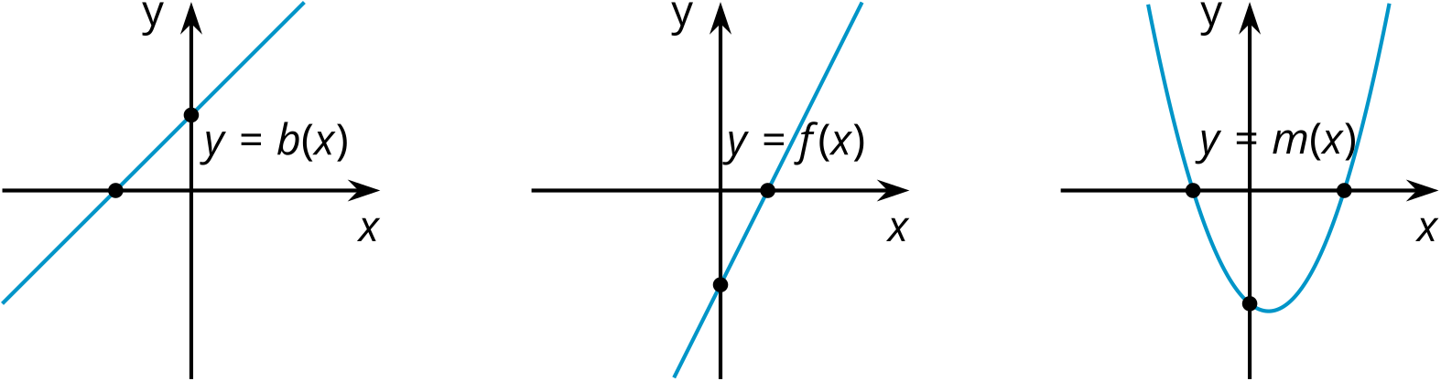

3 Making More Connections

Student Task Statement
- For each function, identify the input that would give an output of 0.
  - $p\left(x\right)=x+10$
  - $q\left(x\right)=x−10$
  - $r\left(x\right)=8−x$
  - $s\left(x\right)=\text{-}8−x$
  - $t\left(x\right)=2x−8$
  - $u\left(x\right)=2x+8$
- Match each graph to a function in the previous question. Be prepared to explain your matches.
- 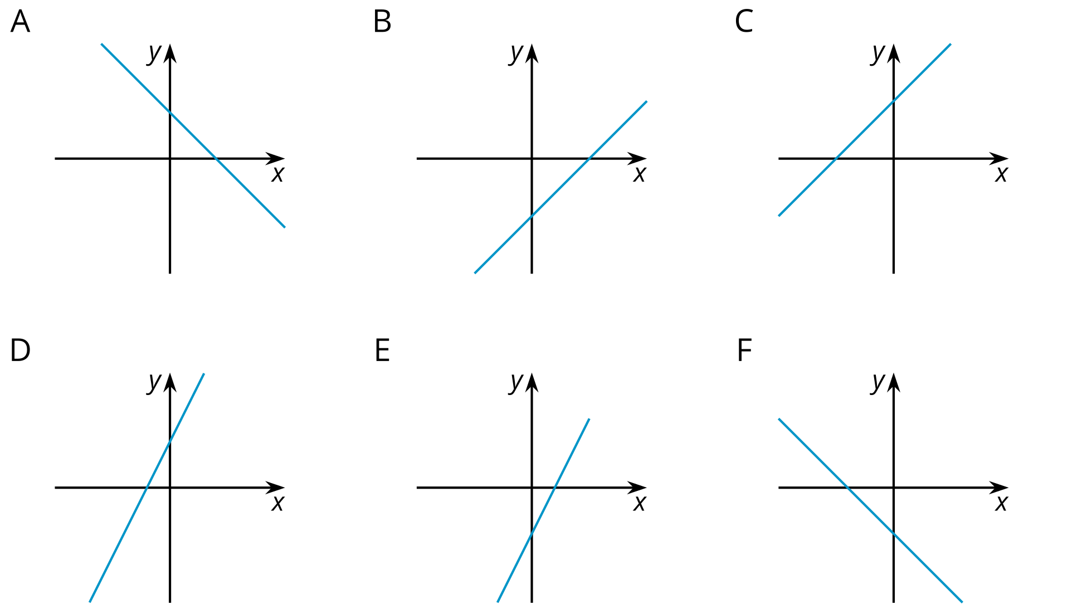
- Label the intercepts on each graph with their coordinates.
- For each function, identify the inputs that would give an output of 0.
  - $v\left(x\right)=\left(x+10\right)\left(2x−8\right)$
  - $w\left(x\right)=\left(2x+8\right)\left(10−x\right)$
- Create three different functions whose output is 0 when the input is 7. At least one of your functions must be quadratic.
© CC BY 2019 by Illustrative Mathematics®

