Unit 4 Lesson 8: How Much in Each Group? (Part 1)

1 Inventing a Situation (Warm up)

Student Task Statement
- Think of a situation with a question that can be represented by the equation $12÷\frac{2}{3}= ?$ Describe the situation and the question.
- Trade descriptions with your partner, and answer your partner’s question.

2 How Much in One Batch?

Student Task Statement
To make 5 batches of cookies, 10 cups of flour are required. Consider the question: How many cups of flour does each batch require?
We can write equations and draw a diagram to represent this situation.
$5 ⋅?=10$ $10÷5=?$
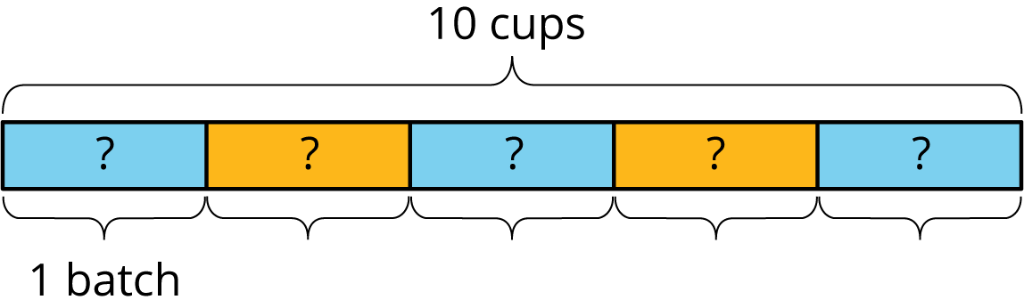
This helps us see that each batch requires 2 cups of flour.
For each question, write a multiplication equation and a division equation, draw a diagram, and find the answer.
- To make 4 batches of cupcakes, it takes 6 cups of flour. How many cups of flour are needed for 1 batch?
- To make $\frac{1}{2}$ batch of rolls, it takes $\frac{5}{4}$ cups of flour. How many cups of flour are needed for 1 batch?
- Two cups of flour make $\frac{2}{3}$ batch of bread. How many cups of flour make 1 batch?

Activity Synthesis
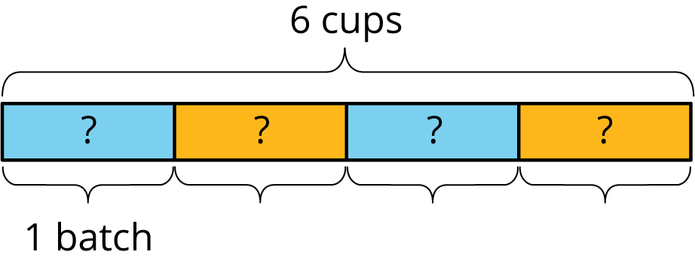
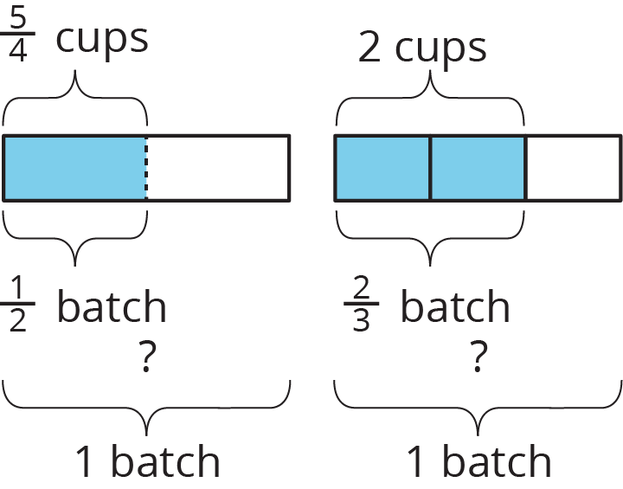

3 One Container and One Section of Highway

Images for Launch
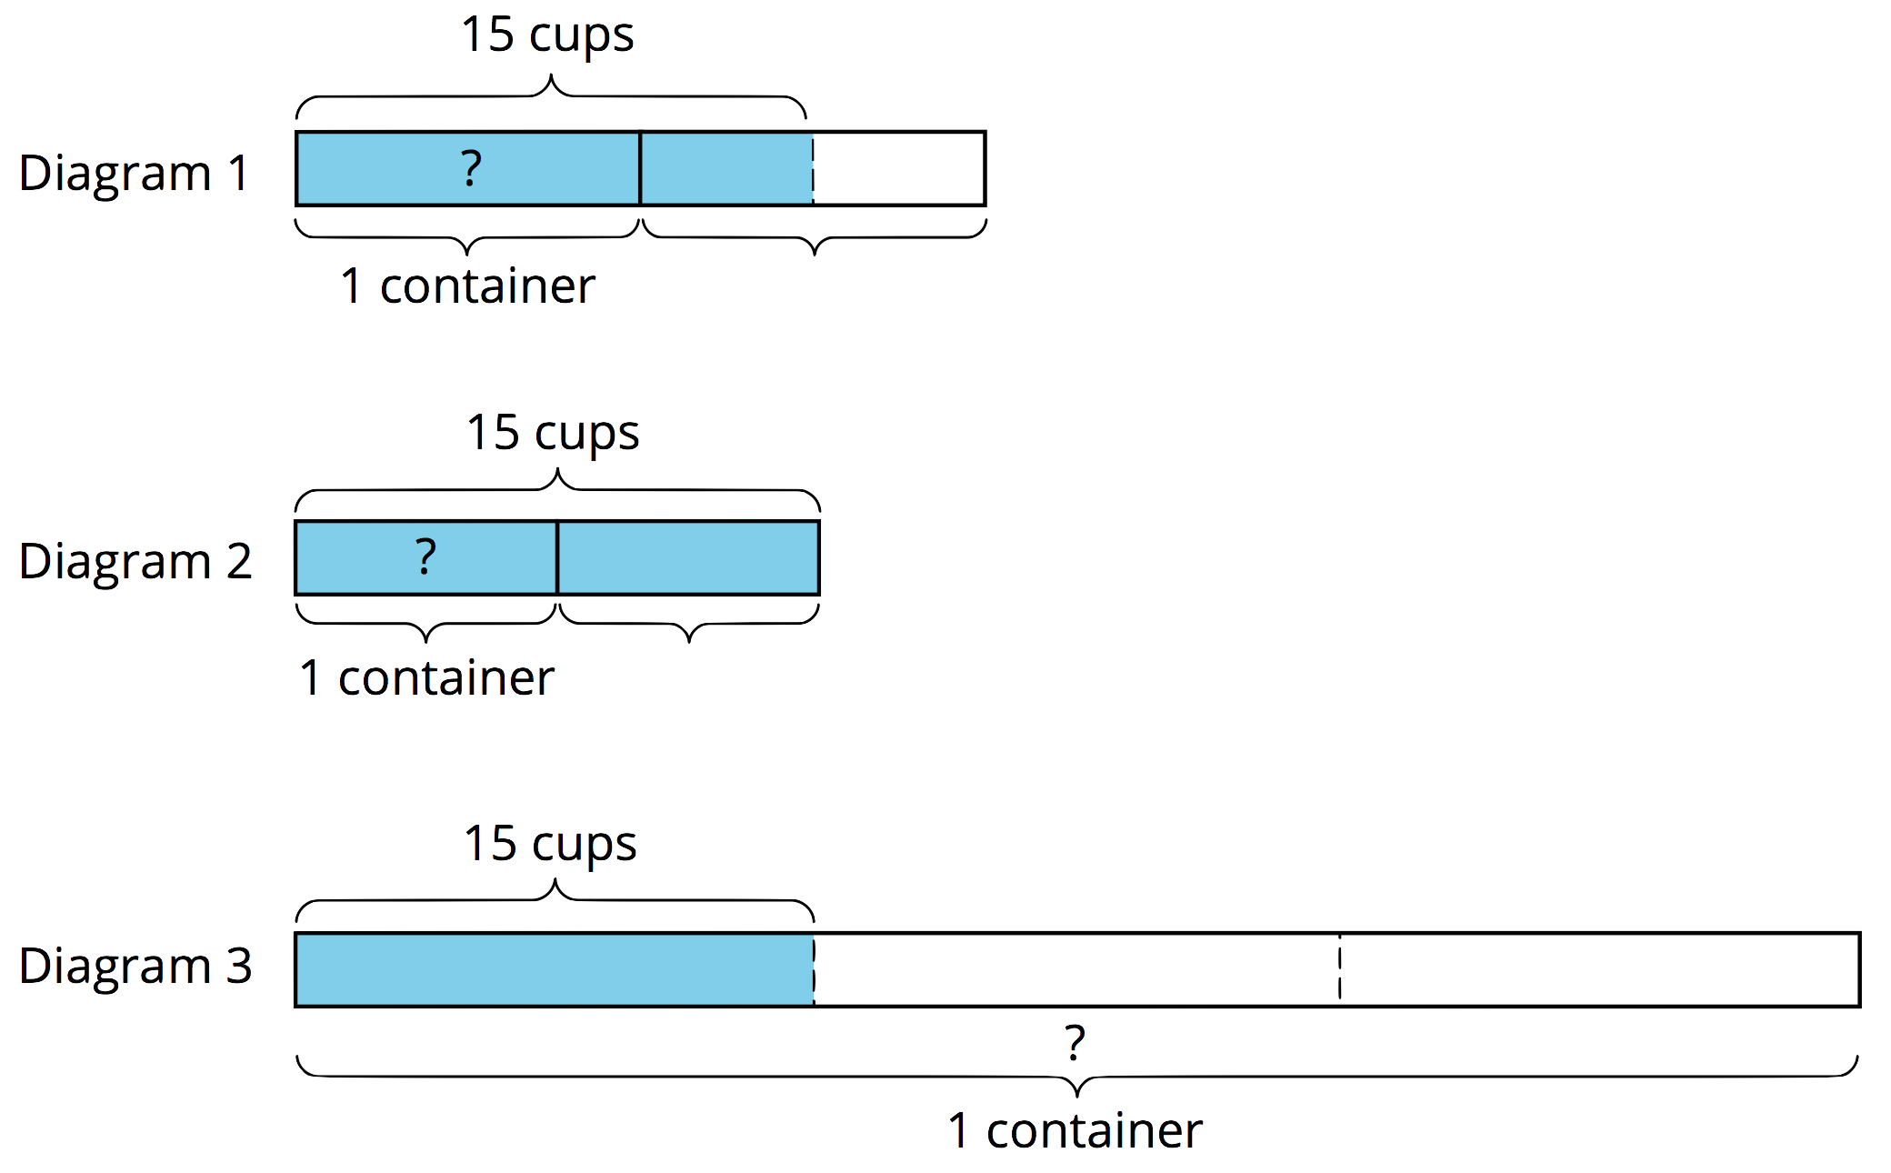
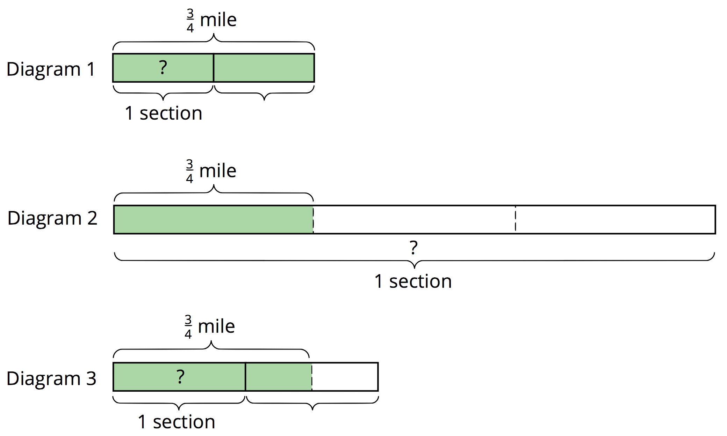

Student Task Statement
Here are three tape diagrams that represent situations about filling containers of water.
Match each situation to a diagram and use the diagram to help you answer the question. Then, write a multiplication equation and a division equation to represent the situation.
- Tyler poured a total of 15 cups of water into 2 equal-sized bottles and filled each bottle. How much water was in each bottle?
- Kiran poured a total of 15 cups of water into equal-sized pitchers and filled $1\frac{1}{2}$ pitchers. How much water was in the full pitcher?
- It takes 15 cups of water to fill $\frac{1}{3}$ pail. How much water is needed to fill 1 pail?
- Here are tape diagrams that represent situations about cleaning sections of highway.
- Match each situation to a diagram and use the diagram to help you answer the question. Then, write a multiplication equation and a division equation to represent the situation.
- Priya’s class has adopted two equal sections of a highway to keep clean. The combined length is $\frac{3}{4}$ of a mile. How long is each section?
- Lin’s class has also adopted some sections of highway to keep clean. If $1\frac{1}{2}$ sections are $\frac{3}{4}$ mile long, how long is each section?
- A school has adopted a section of highway to keep clean. If $\frac{1}{3}$ of the section is $\frac{3}{4}$ mile long, how long is the section?
© CC BY Open Up Resources. Adaptations CC BY IM.

