Lesson 3: Introducing Polynomials
- Let’s see what polynomials can look like.

3.1: Which One Doesn’t Belong: What are Polynomials?
Which one doesn’t belong?
A: $4−x^{2}+x^{3}−4x$
B: $2x^{4}+x^{2}−5.7x+2$
C: $x^{2}+7x−x^{\frac{1}{3}}+2$
D: $x^{5}+8.36x^{3}−2.4x^{2}+0.32x$

3.2: Card Sort: Equations and Graphs
Your teacher will give you a set of cards. Group them into pairs that represent the same polynomial function. Be prepared to explain your reasoning.

3.3: Let’s Make Some Curves
Use graphing technology to write equations for polynomial functions whose graphs have the characteristics listed when plotted on the coordinate plane.
- A 1st degree polynomial function whose graph intercepts the vertical axis at 8.
- A 2nd degree polynomial function whose graph has only positive $y$-values.
- A 2nd degree polynomial function whose graph contains the point $\left(0,\text{-}9\right)$.
- A 3rd degree polynomial function whose graph crosses the horizontal axis more than once.
- A 4th degree or higher polynomial function whose graph never crosses the horizontal axis.

Are you ready for more?
For each of the following letters, find the equation for a polynomial function whose graph resembles the given letter: U, N, M, W.

Lesson 3 Summary
A polynomial function of $x$ is a function given by a sum of terms, each of which is a constant times a whole number power of $x$. Polynomials are often classified by the term with the highest exponent on the independent variable. For example, a quadratic function, like $g\left(t\right)=10+96t−16t^{2}$, is considered a 2nd-degree polynomial because the highest exponent on $t$ is 2. Similarly, a linear function like $f\left(x\right)=3x−10$ is considered a 1st-degree polynomial. Earlier, we considered the function $V\left(x\right)=\left(11−2x\right)\left(8.5−2x\right)\left(x\right)$, which gives the volume, in cubic inches, of a box made by removing the squares of side length $x$, in inches, from each corner of a rectangle of paper and then folding up the 4 sides. This is an example of a 3rd-degree polynomial, which is easier to see if we use the distributive property to rewrite the equation as $V\left(x\right)=4x^{3}−39x^{2}+93.5x$.
Graphs of polynomials have a variety of appearances. Here are three graphs of different polynomials with degree 1, 3, and 6, respectively:
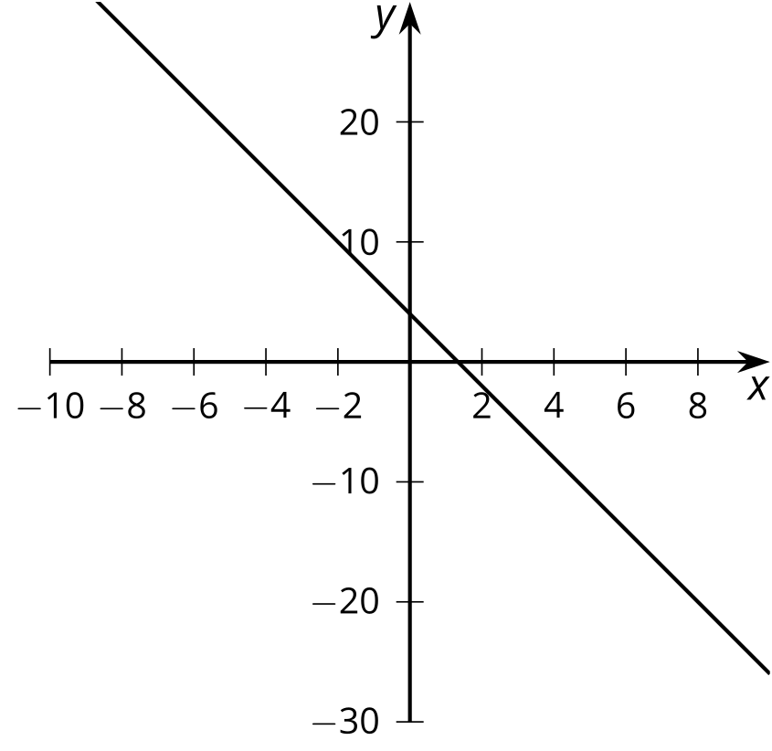
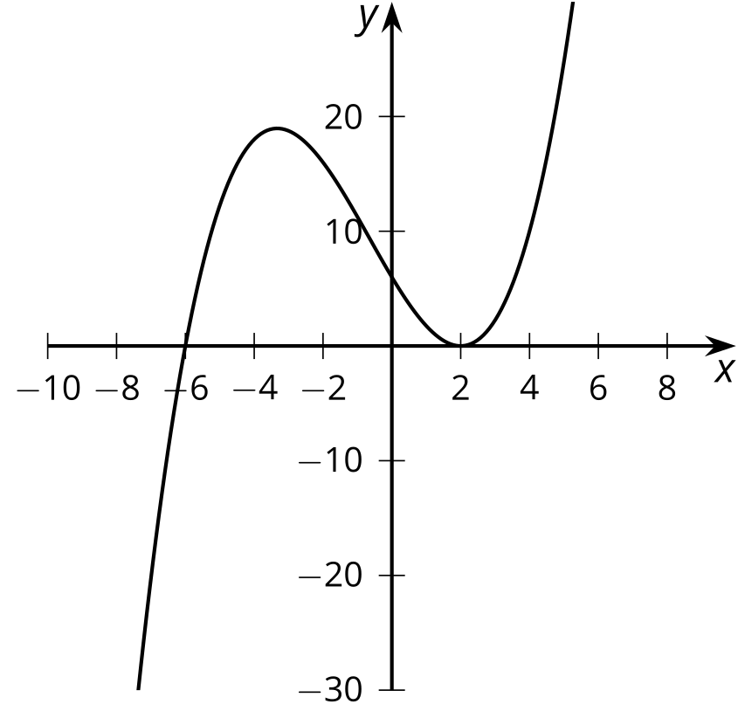
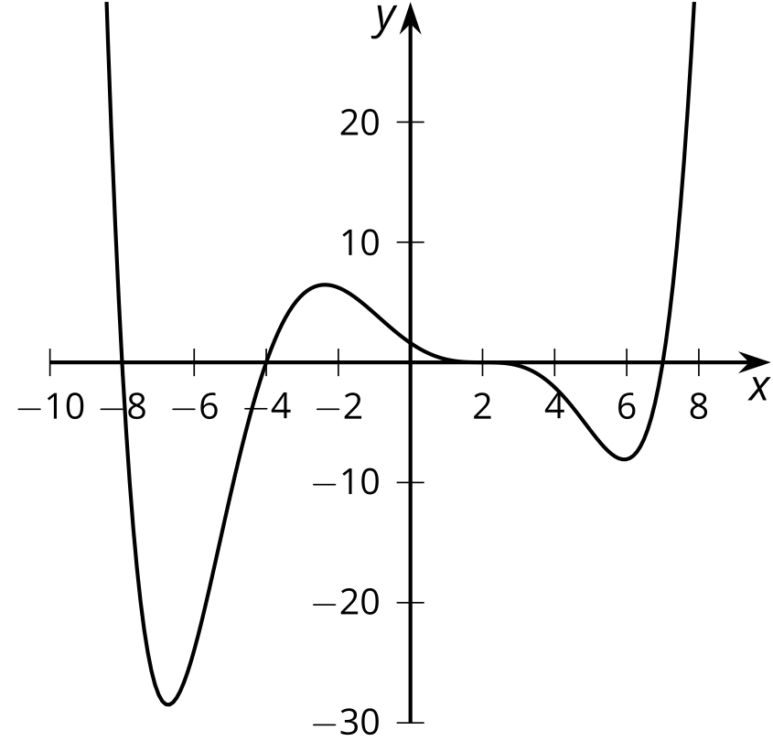
Since graphs of polynomials can curve up and down multiple times, they can have points that are higher or lower than the rest of the points around them. These points are relative maximums and relative minimums. In the second graph, there is a relative maximum at about $\left(\text{-}3,18\right)$ and a relative minimum at $\left(2,0\right)$. The word relative is used because while these are maximums and minimums relative to surrounding points, there are other points that are higher or lower.
In future lessons, we’ll explore connections between equations and graphs of polynomials and learn more about how the degree of a polynomial affects the shape of the graph.
© CC BY 2019 by Illustrative Mathematics®

