Lesson 3 Practice Problems
- There is a closed carton of eggs in Mai's refrigerator. The carton contains $e$ eggs and it can hold 12 eggs.
  - What does the inequality $e<12$ mean in this context?
  - What does the inequality $e>0$ mean in this context?
  - What are some possible values of $e$ that will make both $e<12$ and $e>0$ true?
- Here is a diagram of an unbalanced hanger.
- 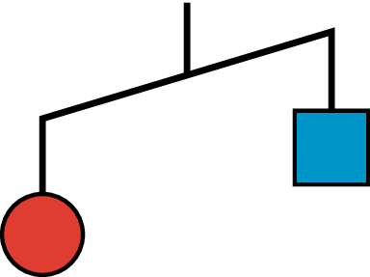
  - Write an inequality to represent the relationship of the weights. Use $s$ to represent the weight of the square in grams and $c$ to represent the weight of the circle in grams.
  - One red circle weighs 12 grams. Write an inequality to represent the weight of one blue square.
  - Could 0 be a value of $s$? Explain your reasoning.
- Here is an inequality: $\text{-}3x>18$.
  - List some values for $x$ that would make this inequality true.
  - How are the solutions to the inequality $\text{-}3x≥18$ different from the solutions to $\text{-}3x>18$? Explain your reasoning.
- Tyler has more than $10. Elena has more money than Tyler. Mai has more money than Elena. Let $t$ be the amount of money that Tyler has, let $e$ be the amount of money that Elena has, and let $m$ be the amount of money that Mai has. Select all statements that are true:
  - $t<j$
  - $m>10$
  - $e>10$
  - $t>10$
  - $e>m$
  - $t<e$
- For each inequality, find two values for $x$ that make the inequality true and two values that make it false.
  - $x+3>70$
  - $x+3<70$
  - $\text{-}5x<2$
  - $5x<2$
© CC BY Open Up Resources. Adaptations CC BY IM.

