Unit 4 Lesson 4: How Many Groups? (Part 1)

1 Equal-sized Groups (Warm up)

Student Task Statement
Write a multiplication equation and a division equation for each sentence or diagram.
- Eight $5 bills are worth $40.
- There are 9 thirds in 3 ones.
- 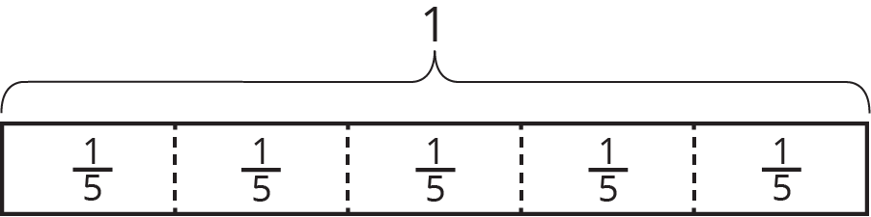

2 Reasoning with Pattern Blocks

Student Task Statement
Your teacher will give you pattern blocks as shown here. Use them to answer the questions.
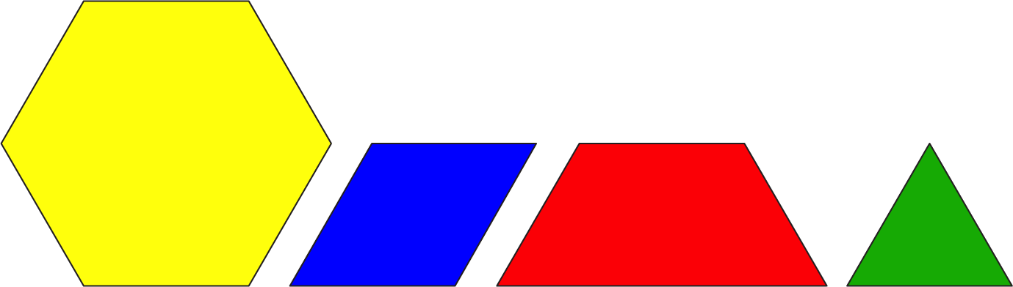
- If a hexagon represents 1 whole, what fraction does each of the following shapes represent? Be prepared to show or explain your reasoning.
  - 1 triangle
  - 1 rhombus
  - 1 trapezoid
  - 4 triangles
  - 3 rhombuses
  - 2 hexagons
  - 1 hexagon and 1 trapezoid
- Here are Elena’s diagrams for $2⋅\frac{1}{2}=1$ and $6⋅\frac{1}{3}=2$. Do you think these diagrams represent the equations? Explain or show your reasoning.
- 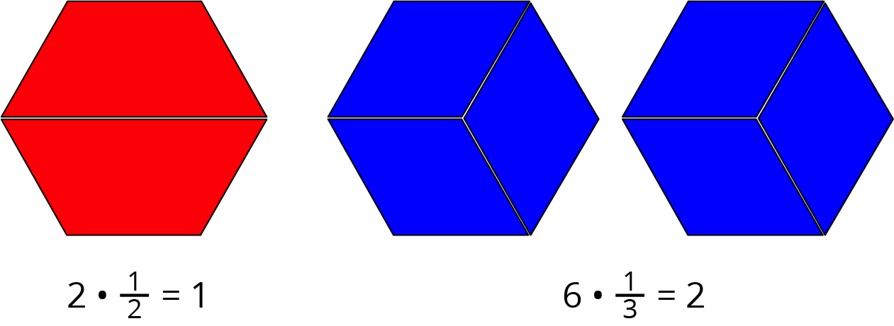
- Use pattern blocks to represent each multiplication equation. Remember that a hexagon represents 1 whole.
  - $3⋅\frac{1}{6}=\frac{1}{2}$
  - $2⋅\frac{3}{2}=3$
- Answer the questions. If you get stuck, consider using pattern blocks.
  - How many $\frac{1}{2}$s are in 4?
  - How many $\frac{2}{3}$s are in 2?
  - How many $\frac{1}{6}$s are in $1\frac{1}{2}$?
© CC BY Open Up Resources. Adaptations CC BY IM.

