Lesson 3: Exponents That Are Unit Fractions
- Let’s explore exponents like $\frac{1}{2}$ and $\frac{1}{3}$.

3.1: Sometimes It’s Squared and Sometimes It’s Cubed
Find a solution to each equation.
- $x^{2}=25$
- $z^{2}=7$
- $y^{3}=8$
- $w^{3}=19$

3.2: To the...Half?
- Clare said, “I know that $9^{2}=9⋅9$, $9^{1}=9$, and $9^{0}=1$. I wonder what $9^{\frac{1}{2}}$ means?” First, she graphed $y=9^{x}$ for some whole number values of $x$, and estimated $9^{\frac{1}{2}}$ from the graph.
  - Graph the function yourself. What estimate do you get for $9^{\frac{1}{2}}$?
  - 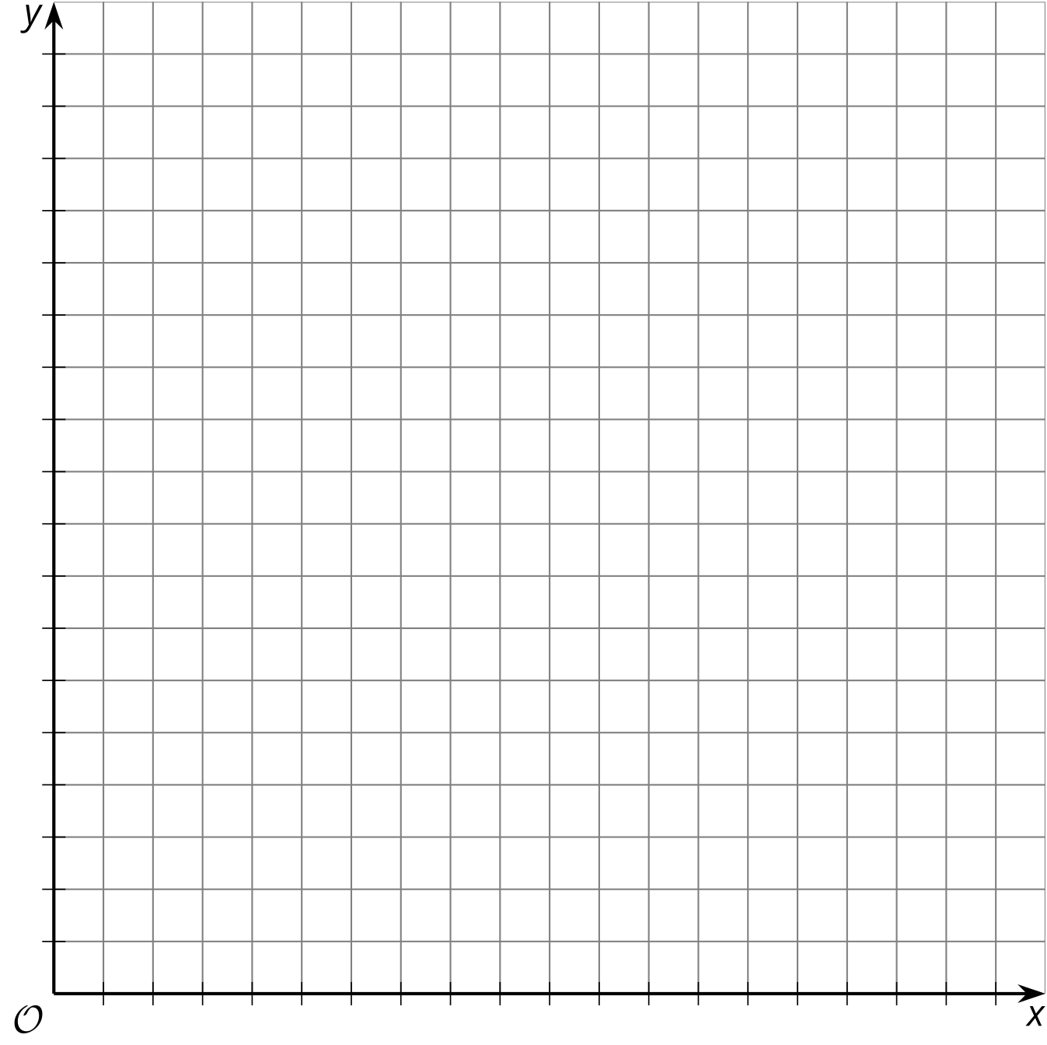
  - Using the properties of exponents, Clare evaluated $9^{\frac{1}{2}}⋅9^{\frac{1}{2}}$. What did she get?
  - For that to be true, what must the value of $9^{\frac{1}{2}}$ be?
- Diego saw Clare’s work and said, “Now I’m wondering about $3^{\frac{1}{2}}$.” First he graphed $y=3^{x}$ for some whole number values of $x$, and estimated $3^{\frac{1}{2}}$ from the graph.
  - Graph the function yourself. What estimate do you get for $3^{\frac{1}{2}}$?
  - Next he used exponent rules to find the value of ${\left(3^{\frac{1}{2}}\right)}^{2}$. What did he find?
  - Then he said, “That looks like a root!” What do you think he means?

3.3: Fraction of What, Exactly?
Use the exponent rules and your understanding of roots to find the exact value of:
- ${25}^{\frac{1}{2}}$
- ${15}^{\frac{1}{2}}$
- $8^{\frac{1}{3}}$
- $2^{\frac{1}{3}}$

3.4: Exponents and Radicals
Match each exponential expression to an equivalent expression.
- $7^{3}$
- $7^{2}$
- $7^{1}$
- $7^{0}$
- $7^{\text{-}1}$
- $7^{\text{-}2}$
- $7^{\text{-}3}$
- $7^{\frac{1}{2}}$
- $7^{\text{-}\frac{1}{2}}$
- $7^{\frac{1}{3}}$
- $7^{\text{-}\frac{1}{3}}$
- $\frac{1}{49}$
- $\frac{1}{343}$
- $\sqrt{7}$
- $\frac{1}{\sqrt[3]{7}}$
- $\sqrt[3]{7}$
- 49
- $\frac{1}{\sqrt{7}}$
- 343
- 7
- $\frac{1}{7}$
- 1

Are you ready for more?
How do we know without counting that the number of circles equals the number of squares? Because we can match every circle to exactly one square, and each square has a match:
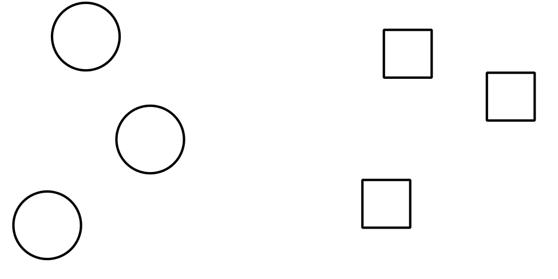
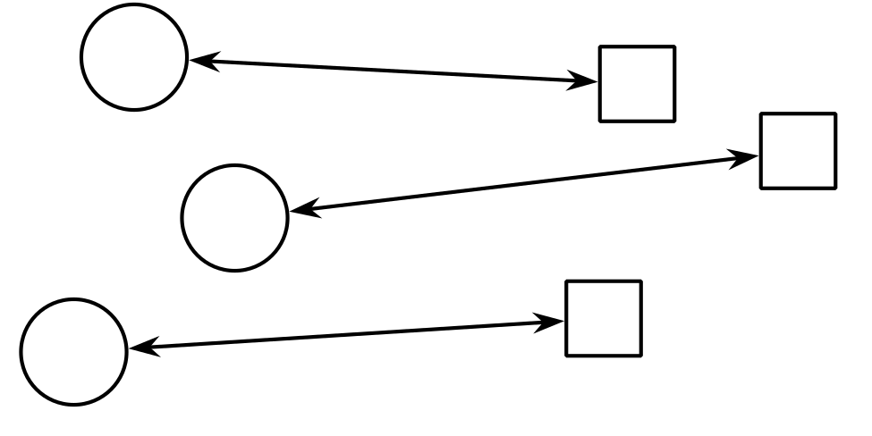
We say that we have shown that there is a one-to-one correspondence of the set of circles and the set of squares. We can do this with infinite sets, too! For example, there are the same “number” of positive integers as there are even positive integers:
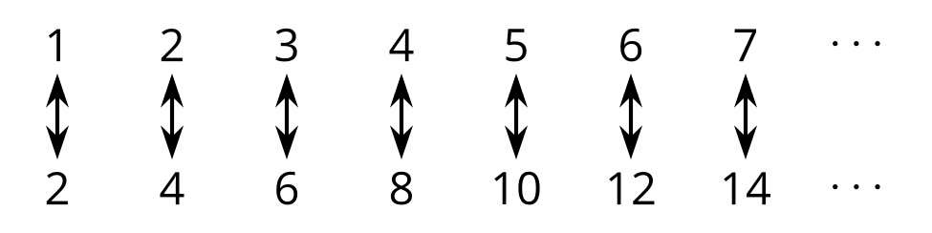
Every positive integer is matched to exactly one even positive integer, and every even integer has a match! We have shown that there is a one-to-one correspondence between the set of positive integers and the set of even positive integers. Whenever we can make a one-to-one matching like this of the positive integers to another set, we say the other set is countable.
- Show that the set of square roots of positive integers is countable.
- Show that the set of positive integer roots of 2 is countable.
- Show that the set of positive integer roots of positive integers is countable. (Hint: there is a famous proof that the positive rational numbers are countable. Find and study this proof.)

Lesson 3 Summary
How can we make sense of the expression ${11}^{\frac{1}{2}}$? For this expression to make any sense at all, we should be able to apply exponent rules to it. Let’s try squaring ${11}^{\frac{1}{2}}$ using exponent rules: ${\left({11}^{\frac{1}{2}}\right)}^{2}={11}^{\frac{1}{2}⋅2}$, which is simply 11. In other words, if we square the number ${11}^{\frac{1}{2}}$ using exponent rules, we get 11. That means that ${11}^{\frac{1}{2}}$ must be equal to $\sqrt{11}$.
Similarly, ${11}^{\frac{1}{3}}$ must be equal to $\sqrt[3]{11}$ because $\begin{matrix}{\left({11}^{\frac{1}{3}}\right)}^{3} & ={11}^{\frac{1}{3}⋅3} \\ & =11\end{matrix}$
In general, if $a$ is any positive number, then
$a^{\frac{1}{2}}=\sqrt{a}$
and
$a^{\frac{1}{3}}=\sqrt[3]{a}$
Remember, these expressions that involve the $\sqrt{​}$ symbol are often referred to as radical expressions.
© CC BY 2019 by Illustrative Mathematics®

