Lesson 2: Funding the Future
- Let’s look at some other things that polynomials can model.

2.1: Notice and Wonder: Writing Numbers
What do you notice? What do you wonder?
$300+20+9$
3 100s, 2 10s, 9 1s
$3\left({10}^{2}\right)+2\left({10}^{1}\right)+9\left({10}^{0}\right)$

2.2: Polynomials in the Integers
Consider the polynomial function $p$ given by $p\left(x\right)=5x^{3}+6x^{2}+4x$.
- Evaluate the function at $x=\text{-}5$ and $x=15$.
- How does knowing that $5,​000+600+40=5,​640$ help you solve the equation $5x^{3}+6x^{2}+4x=5,​640$?

Are you ready for more?
Han notices:
- ${11}^{2}=121$ and ${\left(x+1\right)}^{2}=x^{2}+2x+1$
- ${11}^{3}=1331$ while ${\left(x+1\right)}^{3}=x^{3}+3x^{2}+3x+1$
The digits in the powers of 11 correspond to the coefficients of the polynomials.
- Is this still true for ${11}^{4}$ and ${\left(x+1\right)}^{4}$? What about ${11}^{5}$ and ${\left(x+1\right)}^{5}$?
- Give a mathematical justification of Han’s observation.

2.3: A Yearly Gift
At the end of 12th grade, Clare’s aunt started investing money for her to use after graduating from college four years later. The first deposit was $300. If $r$ is the annual interest rate of the account, then at the end of each school year the balance in the account is multiplied by a growth factor of $x=1+r$.
- After one year, the total value is $300x$. After two years, the total value is $300x⋅x=300x^{2}$. Write an expression for the total value after graduation in terms of $x$.
- If Clare’s aunt had invested another $500 at the end of her freshman year, what would the expression be for the total value after graduation in terms of $x$?
- Pause here for a whole-class discussion.
- Suppose that $250 was invested at the end of sophomore year, and $400 at the end of junior year in addition to the original $300 and the $500 invested at the end of freshman year. Write an expression for the total value after graduation in terms of $x$.
- The total amount $y$, in dollars, after four years is a function $y=C\left(x\right)$ of the growth factor $x$. If the total Clare receives after graduation is $C\left(x\right)=1,​580$, use a graph to find the interest rate that the account earned.

Lesson 2 Summary
Let’s say we’re going to invest $200 at an annual interest rate of $r$. This means at the end of a year, the balance in the account is multiplied by a growth factor of $x=1+r$. After the first year, the amount in the account can be expressed as $200x$, which is a polynomial. Similarly, after the second year, the amount will be $200x^{2}$, after three years, the amount will be $200x^{3}$, etc.
If an additional $350 is invested at the end of the first year, we can revise the polynomial. The amount of money in the account after 1 year is the same, but now the amount of money after two years is $\left(200x+350\right)x=200x^{2}+350x$.
What will the polynomial expression look like if $400 more is invested at the end of the second year and $150 more is invested at the end of the third year? $200x^{4}+350x^{3}+400x^{2}+150x$.
Let $D\left(x\right)$ be the amount of money in dollars in the account after four years and $x$ be the growth factor where $D\left(x\right)=200x^{4}+350x^{3}+400x^{2}+150x$. A graph of $y=D\left(x\right)$ helps us visualize how the amount in the account after four years depends on different values of $x$.
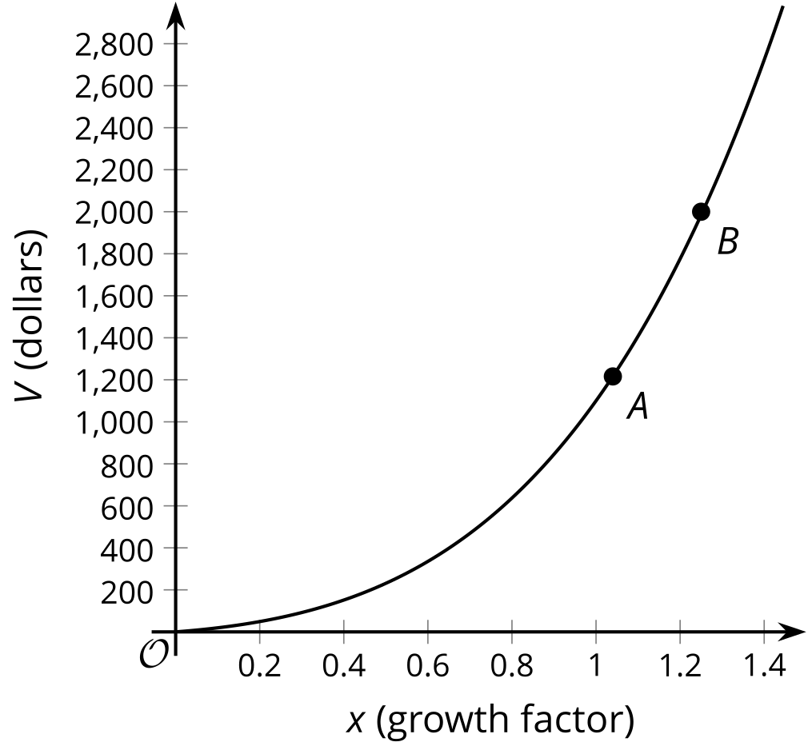
We can use this polynomial model to examine the effect of different annual interest rates, or to estimate what the annual interest rate needs to be to achieve a specific quantity at the end of the four years. For example, point A is at $\left(1.04,D\left(1.04\right)\right)≈\left(1.04,1216\right)$. From this, we know that the amount in the account after 4 years with an interest rate of 4% each year is approximately $1,216. Similarly, if we want the account to have $2,000 after four years, that corresponds to point B, and at that point the growth rate is approximately 1.25 each year, since $\left(1.25,D\left(1.25\right)\right)≈\left(1.25,2000\right)$. So an interest rate of 25% will get us there, though we are not likely to find a bank that would offer that rate. Note also that the values $x<1$ correspond to negative rates, which are also unlikely!
Polynomial models are adaptable to a variety of situations even as they grow in complexity.
© CC BY 2019 by Illustrative Mathematics®

