Lesson 19: Beyond Circles
- Let's use trigonometric functions to model data.

19.1: Notice and Wonder: Examining Data
Here is some data that we will study in today’s lesson.
day | amount
1 | 0.99
2 | 1.00
3 | 0.98
4 | 0.93
5 | 0.86
6 | 0.77
7 | 0.67
8 | 0.57
9 | 0.46
10 | 0.37

day | amount
11 | 0.28
12 | 0.19
13 | 0.13
14 | 0.07
15 | 0.03
16 | 0.01
17 | 0.00
18 | 0.01
19 | 0.04
20 | 0.09

day | amount
21 | 0.16
22 | 0.24
23 | 0.33
24 | 0.43
25 | 0.54
26 | 0.65
27 | 0.76
28 | 0.85
29 | 0.92
30 | 0.98
31 | 1.00
What do you notice? What do you wonder?

19.2: Watching the Evening Sky
The data from the warm-up is the amount of the Moon that is visible from a particular location on Earth at midnight for each day in January 2018. A value of 1 represents a full moon in which all of illuminated portion of the moon's face is visible. A value of 0.25 means one fourth of the illuminated portion of the moon's face is visible.
- What is an appropriate midline for modeling the Moon data? What about the amplitude? Explain your reasoning.
- What is an appropriate period for modeling the Moon data? Explain your reasoning.
- Choose a sine or cosine function to model the data. What is the horizontal translation for your choice of function?
- Propose a function to model the Moon data. Explain the meaning of each parameter in your model and specify units for the input and output of your function.
- Plot the data using graphing technology and check your choice of parameters (midline, amplitude, period, horizontal translation). What changes did you make to your model?
- Use your model to predict when the next two full moons will be in 2018. Are your predictions accurate?
- How much of the Moon do you expect to be visible on your birthday? Explain your reasoning.

Lesson 19 Summary
Sometimes a phenomenon can be periodic even though it is not connected to motion in a circle. For example, here is a graph of the water level in Bridgeport, Connecticut, over a 50 hour period in 2018.
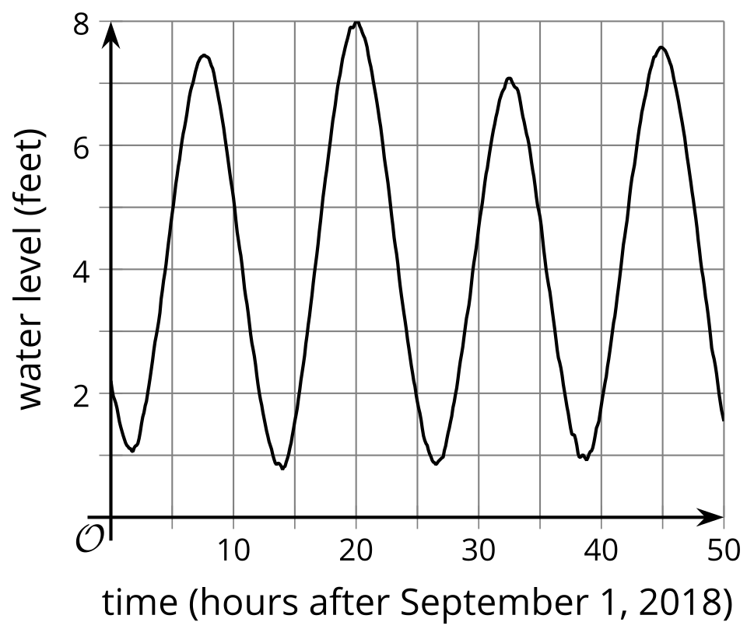
Notice that each day (or each 24 hour period) there are two tides, a small one where the water goes up to a little less than 3 feet and then a bigger one when the tide goes up to a little more than 3 feet. Since there are two tides per day, the period for this graph is about 12 hours. The data begins about 1 hour before the tide is at the 0 value. Since $sin\left(0\right)=0$, this would make the sine a good choice for modeling the tide.
Putting together all of our information gives model $f\left(h\right)=3sin\left(\frac{2π}{12}\left(h−1\right)\right)$, where $h$ measures hours since midnight on September 1.
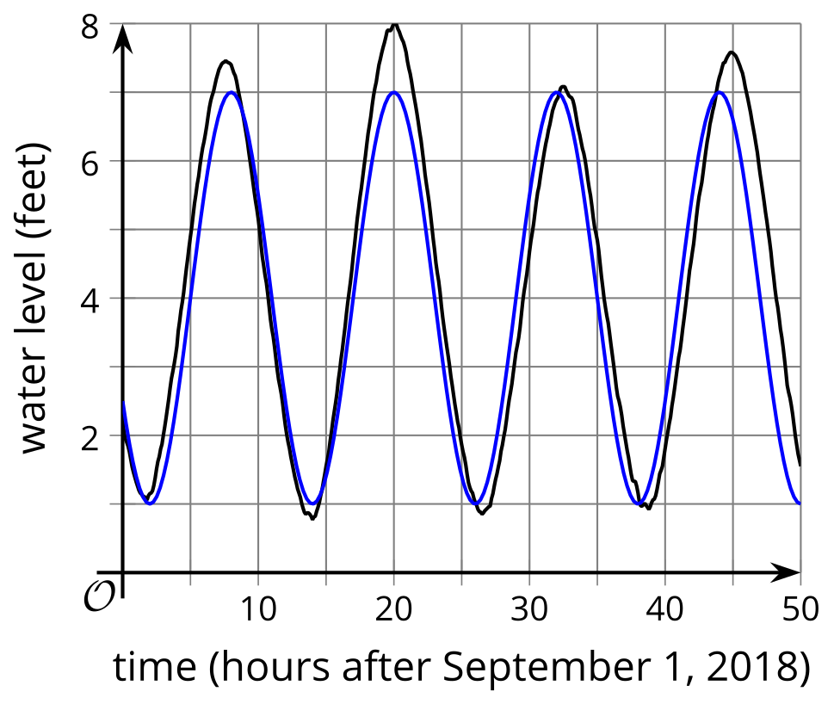
Notice that:
- The coefficient of 3 is the amplitude, which averages out the bigger and smaller tides.
- $\frac{2π}{12}$ makes the period 12 hours.
- -1 translates the sine graph to the right by 1 hour to so it has a value of 0 at about 1 hour after midnight.
© CC BY 2019 by Illustrative Mathematics®

