Lesson 2 Practice Problems

  - Select all numbers that are solutions to the inequality $k>5$.
  - 4
  - 5
  - 6
  - 5.2
  - 5.01
  - 0.5
  - Draw a number line to represent this inequality.
- A sign on the road says: “Speed limit, 60 miles per hour.”
  - Let $s$ be the speed of a car. Write an inequality that matches the information on the sign.
  - Draw a number line to represent the solutions to the inequality.
  - Could 60 be a value of $s$? Explain your reasoning.
- One day in Boston, MA, the high temperature was 60 degrees Fahrenheit, and the low temperature was 52 degrees.
  - Write one or more inequalities to describe the temperatures $T$ that are between the high and low temperature on that day.
  - Show the possible temperatures on a number line.
- Describe a rigid transformation that you could use to show the polygons are congruent.
- 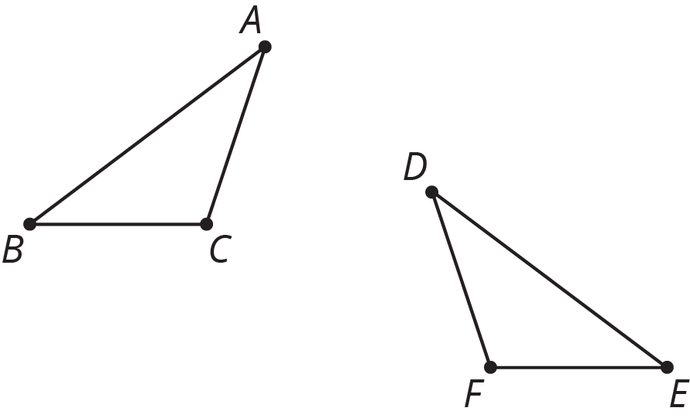

- (From Unit 1, Lesson 11.)

  - Jada is taller than Diego. Diego is 54 inches tall (4 feet, 6 inches). Write an inequality that compares Jada’s height in inches, $j$, to Diego’s height.
  - Jada is shorter than Elena. Elena is 5 feet tall. Write an inequality that compares Jada’s height in inches, $j$, to Elena’s height.
- (From Unit 4, Lesson 1.)
© CC BY Open Up Resources. Adaptations CC BY IM.

