Lesson 1 Practice Problems
- Here are questions about two types of angles.
  - Draw a right angle. How do you know it's a right angle? What is its measure in degrees?
  - Draw a straight angle. How do you know it’s a straight angle? What is its measure in degrees?
- An equilateral triangle’s angles each have a measure of 60 degrees.
  - Can you put copies of an equilateral triangle together to form a straight angle? Explain or show your reasoning.
  - Can you put copies of an equilateral triangle together to form a right angle? Explain or show your reasoning.
- Here is a square and some regular octagons.
- In this pattern, all of the angles inside the octagons have the same measure. The shape in the center is a square. Find the measure of one of the angles inside one of the octagons.
- 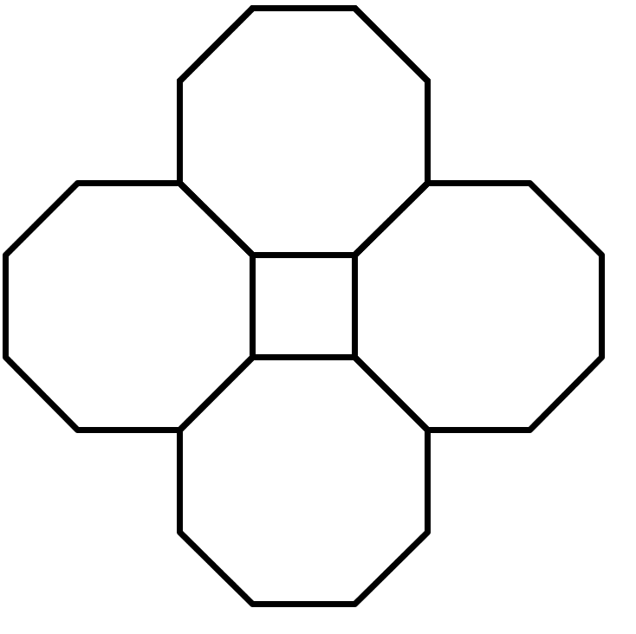
- The height of the water in a tank decreases by 3.5 cm each day. When the tank is full, the water is 10 m deep. The water tank needs to be refilled when the water height drops below 4 m.
  - Write a question that could be answered by solving the equation $10−0.035d=4$.
  - Is 100 a solution of $10−0.035d>4$? Write a question that solving this problem could answer.
- (From Unit 6, Lesson 17.)
- Use the distributive property to write an expression that is equivalent to each given expression.
  - $\text{-}3\left(2x−4\right)$
  - $0.1\left(\text{-}90+50a\right)$
  - $\text{-}7\left(\text{-}x−9\right)$
  - $\frac{4}{5}\left(10y+\text{-}x+\text{-}15\right)$
- (From Unit 6, Lesson 18.)
- Lin’s puppy is gaining weight at a rate of 0.125 pounds per day. Describe the weight gain in days per pound.
- (From Unit 2, Lesson 3.)
© CC BY Open Up Resources. Adaptations CC BY IM.

