Unit 7 Lesson 14: Putting It All Together

1 Equal Slices (Warm up)

Student Task Statement
At a pizza restaurant, a personal pizza has a radius of 10 centimeters and costs $5. Another restaurant takes a pizza with radius 30 centimeters, cuts it into 8 slices of equal area, and charges $5 per slice. Which is a better deal? Explain your reasoning.

2 Pizza Palooza

Student Task Statement
Elena was researching offers for the upcoming Pizza Palooza festival. She wants to get a good deal on a single slice of pizza.
Your teacher will give you cards that show the deals offered by 4 vendors. Which vendor should Elena choose? Explain or show your reasoning.

3 A Fair Split (Optional)

Student Task Statement
Jada and Andre want to share a big slice of pizza so that each of them gets the same amount, but Andre doesn’t like the crust. The pizza slice is a sector of a circle with a radius of 20 cm and a central angle that measures $\frac{π}{3}$ radians.
How can Andre and Jada divide the slice of pizza into 2 equal pieces so that Andre doesn’t have to eat any crust?

4 Let Your Light Shine (Optional)

Student Task Statement
Noah is taking photos of a sculpture he made in art class. He will submit the photos to a contest. The sculpture is in front of a backdrop, which is represented from an overhead view in the image by segment $AB$. Noah positioned a light at point $C$ so that the edges of the light beam meet up exactly with the backdrop at segment $AB$.
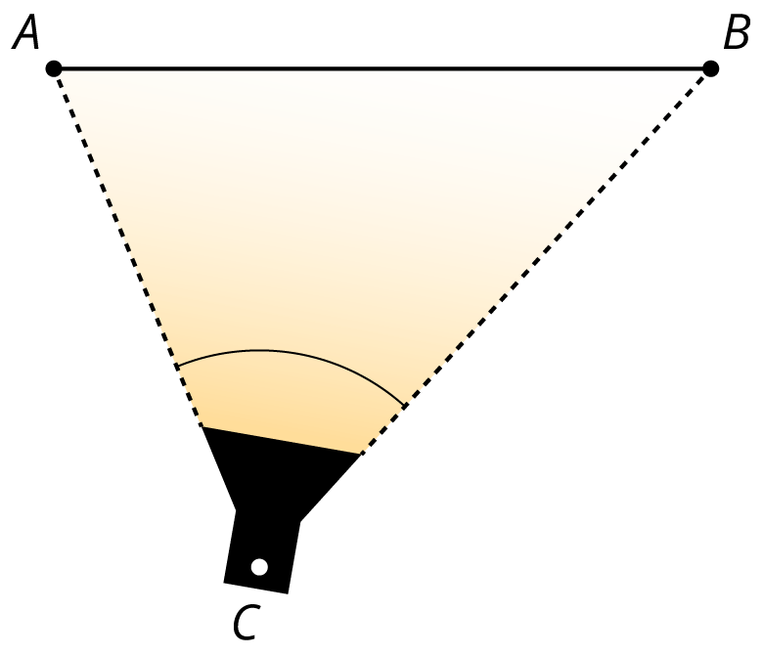
Noah wants to try different positions for the light to highlight different aspects of the sculpture, but he still wants the edges of the beam to exactly meet the endpoints of the backdrop. Find at least 3 other places Noah can place the light. Explain or show your reasoning.
© CC BY 2019 by Illustrative Mathematics®

