Unit 3 Lesson 5: Fitting Lines

1 Selecting the Best Line (Warm up)

Student Task Statement
Which of the lines is the best fit for the data in each scatter plot? Explain your reasoning.
1.
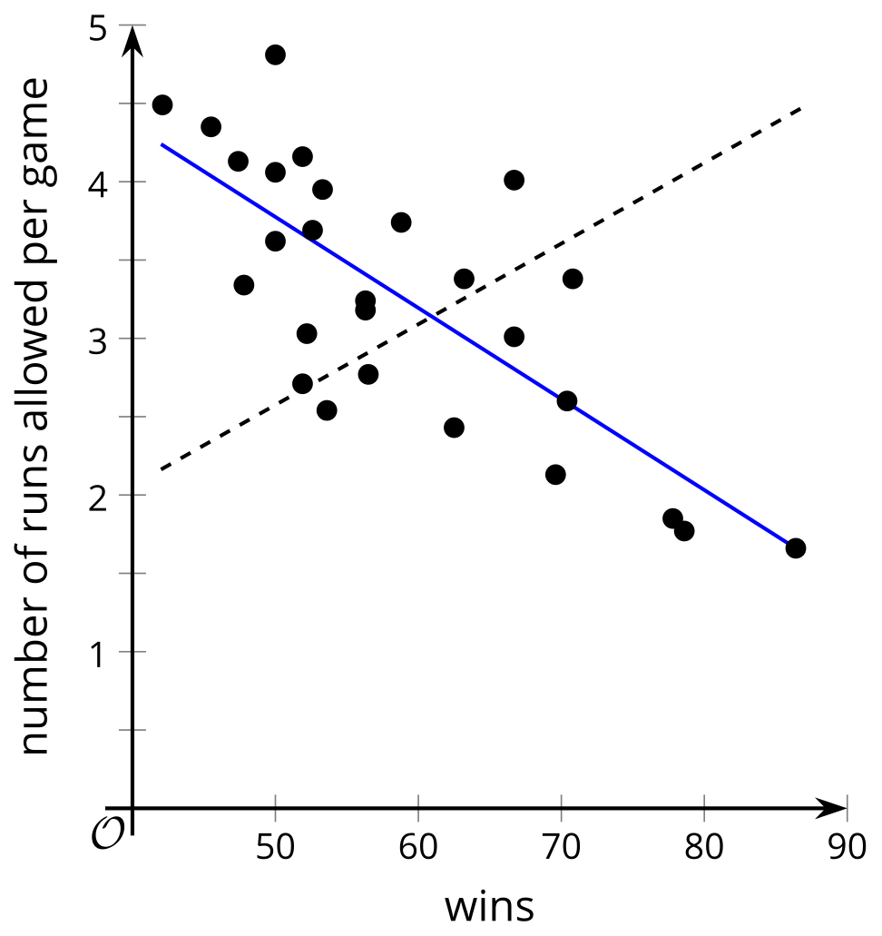
2.
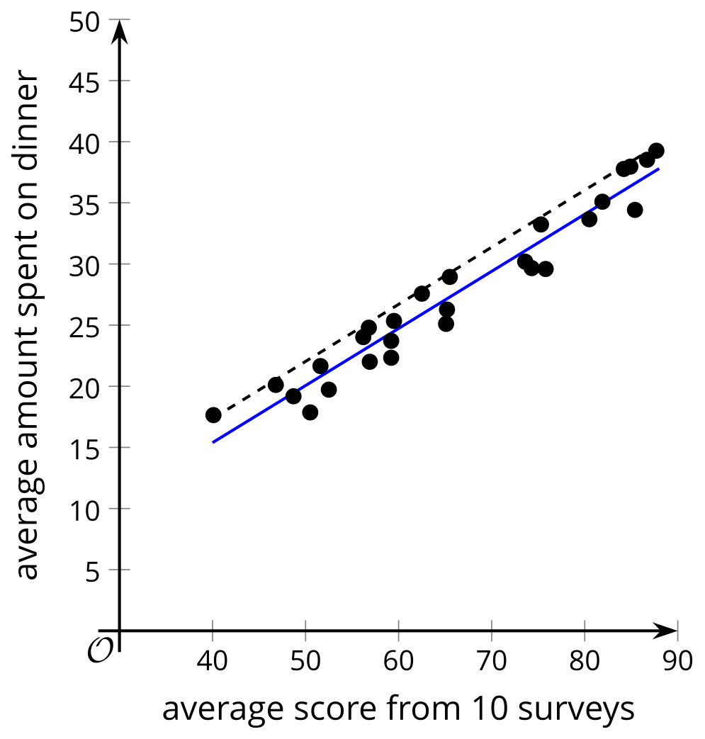
3.
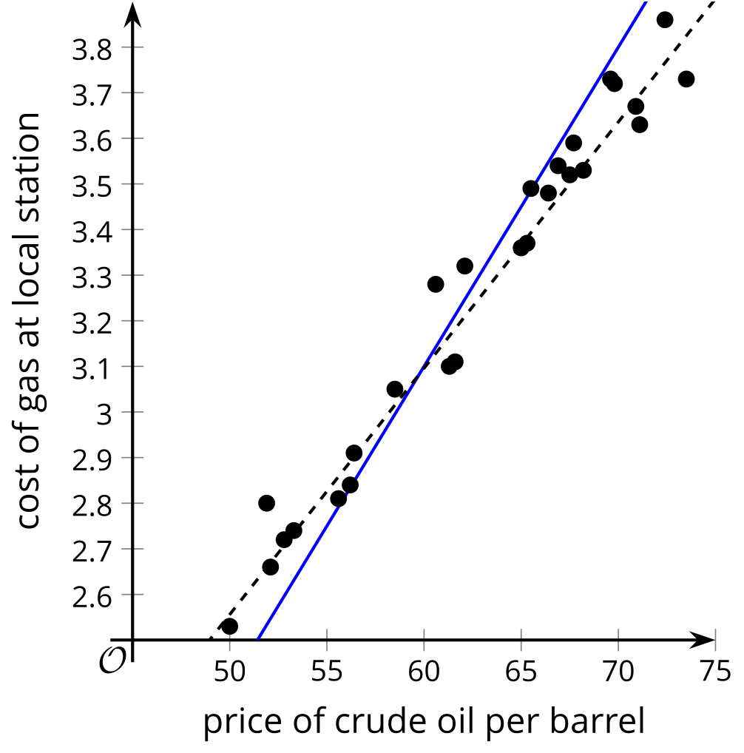
4.
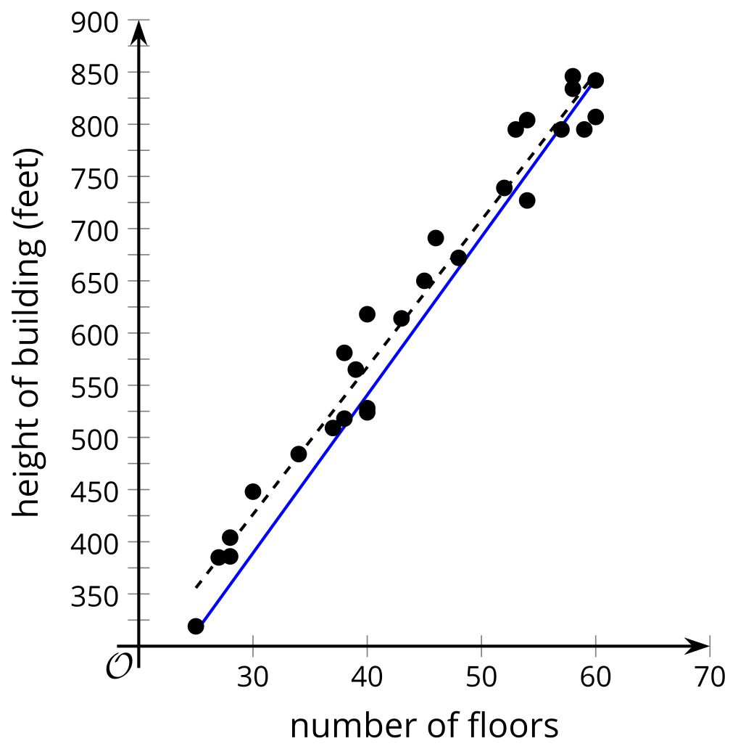

2 Card Sort: Data Patterns

Student Task Statement
Your teacher will give you a set of cards that show scatter plots.
- Arrange all the cards in three different ways. Ensure that you and your partner agree on the arrangement before moving on to the next one. Sort all the cards in order from:
  - best to worst for representing with a linear model
  - least to greatest slope of a linear model that fits the data well
  - least to greatest vertical intercept of a linear model that fits the data well
- For each card, write a sentence that describes how $y$ changes as $x$ increases and whether the linear model is a good fit for the data or not.

3 Fitting Lines with Technology

Student Task Statement
The weight of ice cream sold in a day at a small store in pounds ($x$) and the average temperature outside during the day in degrees Celsius ($y$) are recorded in the table.
$x$ | 20 | 18 | 21 | 17 | 21.5 | 19.5 | 21 | 18
$y$ | 6 | 4.5 | 6.5 | 3.5 | 7.5 | 6.5 | 7 | 5
- For this data, create a scatter plot and sketch a line that fits the data well.
- Use technology to compute the best fit line. Round any numbers to 2 decimal places.
- What are the values for the slope and $y$-intercept for the best fit line? What do these values mean in this situation?
- Use the best fit line to predict the $y$ value when $x$ is 10. Is this a good estimate for the data? Explain your reasoning.
- Your teacher will give you a data table for one of the other scatter plots from the previous activity. Use technology and this table of data to create a scatter plot that also shows the line of best fit, then interpret the slope and $y$-intercept.

Activity Synthesis

A. $y=1.1979x+1.3196$
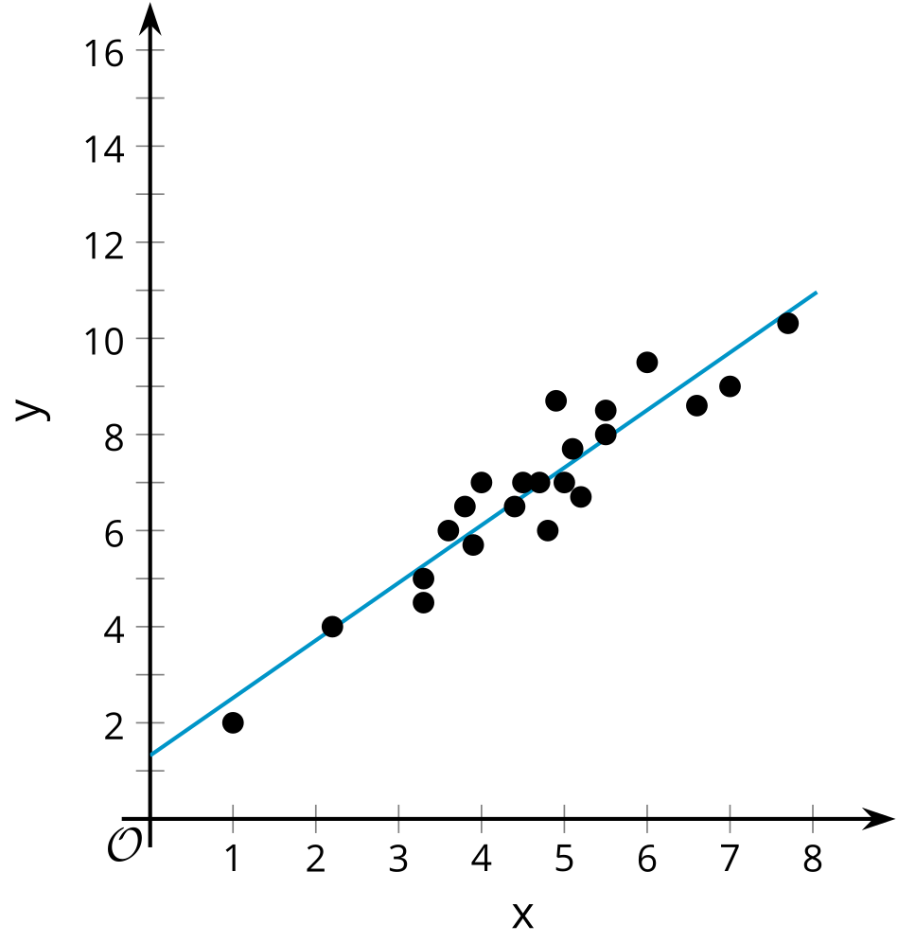

B. $y=−0.4337x+12.288$
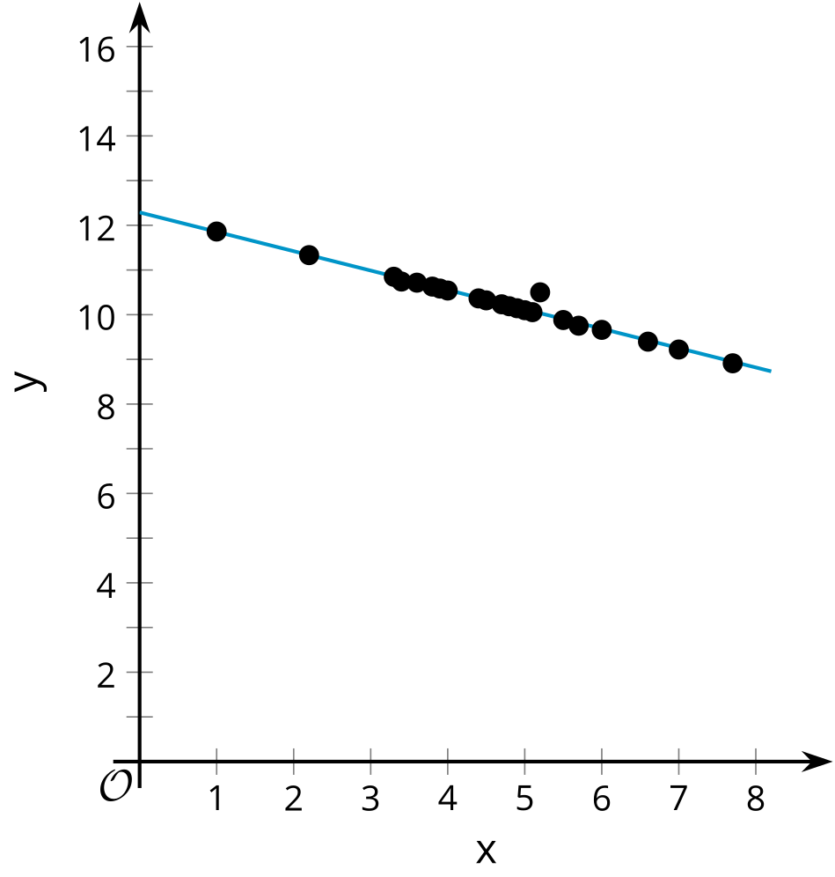

C. $y=0.9749x+4.6529$
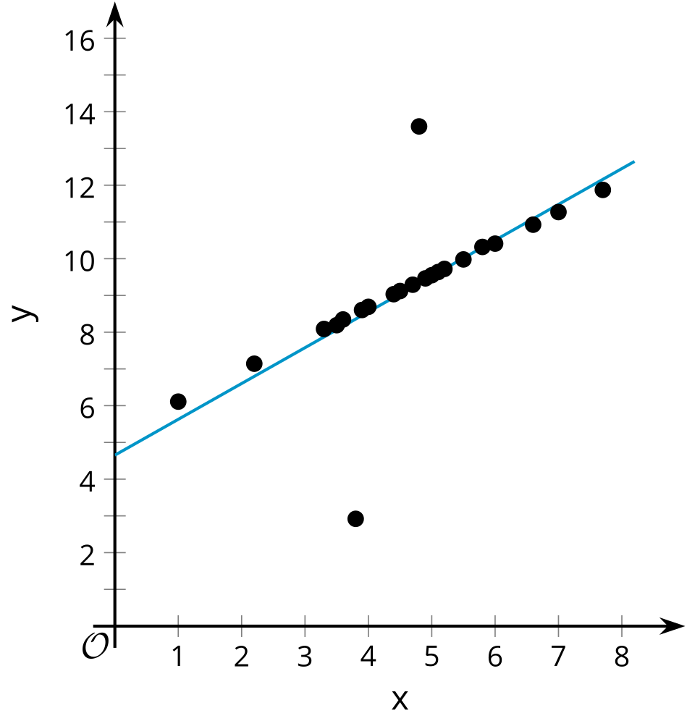

D. $y=−2.063x+16.144$
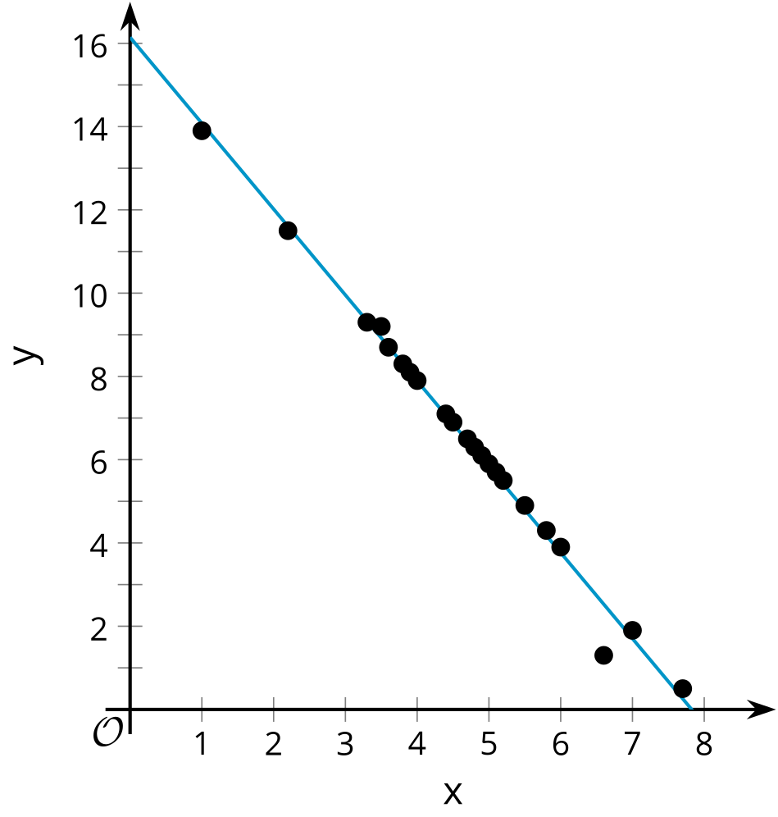

E. $y=1.1979x+5.8196$
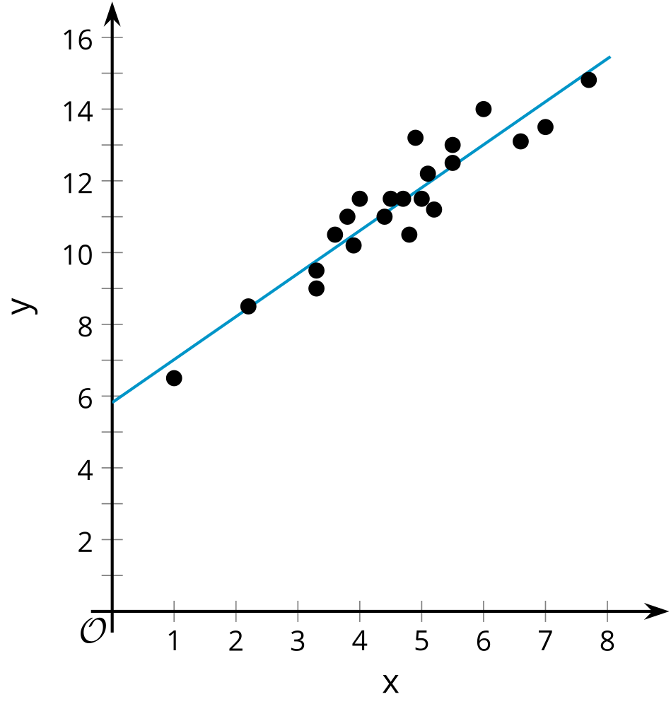

Images for Activity Synthesis
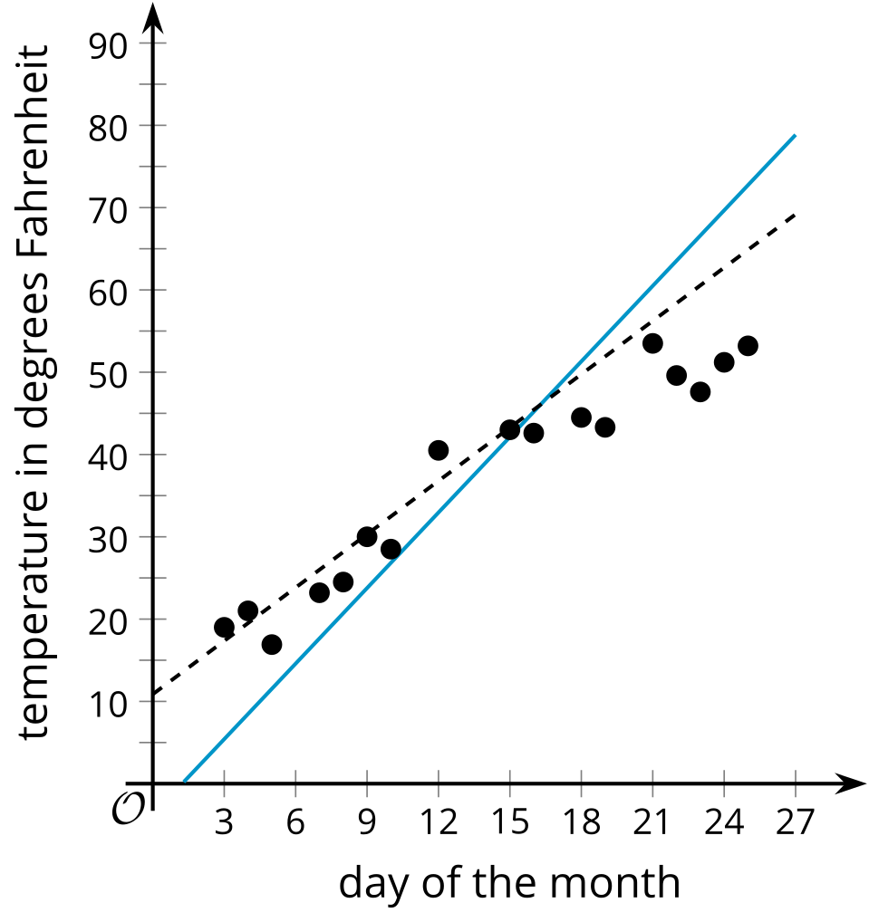
© CC BY 2019 by Illustrative Mathematics®

