Lesson 10: Resolvamos problemas sobre perímetros y áreas

Standards Alignments
Addressing | 3.MD.D.8, 3.OA.C.7, 3.OA.D.8

Teacher-facing Learning Goals
- Solve problems that involve perimeter and area of rectangles.

Student-facing Learning Goals
- Resolvamos problemas sobre perímetros y áreas.

Lesson Purpose
The purpose of this lesson is for students to solve problems that involve both perimeter and area of rectangles in order to reinforce the difference between perimeter and area.
In previous lessons, students learned what area is and how to find the area of rectangles and figures made up of rectangles. They also learned how to measure the perimeter of other shapes, solve problems that involved perimeter, and recognize situations in which perimeter is and is not relevant. By the end of this lesson, students confirm that while perimeter and area are both measurements that can appear together in problems, perimeter is a linear measurement while area is two-dimensional.

Access for:

Students with Disabilities
- Representation (Activity 2)

English Learners
- MLR1 (Activity 1)

Instructional Routines
MLR4 Information Gap (Activity 2), True or False (Warm-up)

Materials to Copy
- Info Gap: A Garden and a Playground, Spanish (groups of 2): Activity 2

Lesson Timeline
Warm-up | 10 min
Activity 1 | 15 min
Activity 2 | 20 min
Lesson Synthesis | 10 min
Cool-down | 5 min

Teacher Reflection Question
What was the best question you asked students today? Why would you consider it the best one based on what students said or did?

Cool-down
(to be completed at the end of the lesson) 5min
La cerca de la huerta de Lin

Standards Alignments
Addressing | 3.MD.D.8

Student-facing Task Statement
Lin está construyendo una cerca alrededor de su huerta rectangular. Observa el diagrama. El área de la huerta es 36 pies cuadrados. ¿Cuántos pies de cerca va a necesitar Lin para encerrar la huerta completamente?
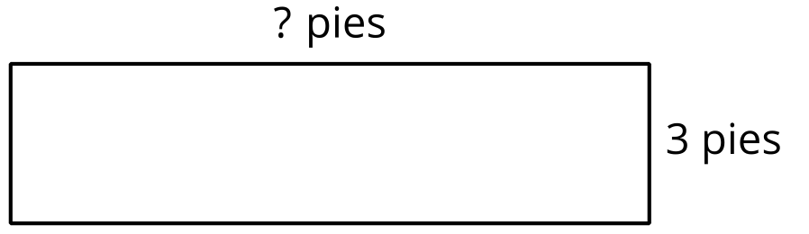

Student Responses
30 feet. Sample response: If the area is 36 square feet and one side is 3, I can divide 36 by 3 to find the missing side. Since $3×12=36$, the missing side is 12 feet long. The perimeter can be found by adding $2×12$ and $2×3$, which is 24 and 6. $24+6=30$.

