Unit 7 Lesson 12: Radian Sense

1 Which One Doesn’t Belong: Angle Measures (Warm up)

Student Task Statement
Which one doesn’t belong?

A
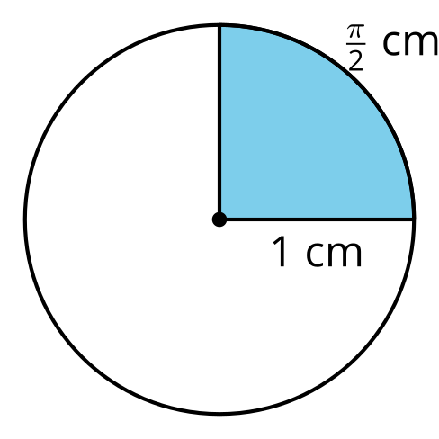

B
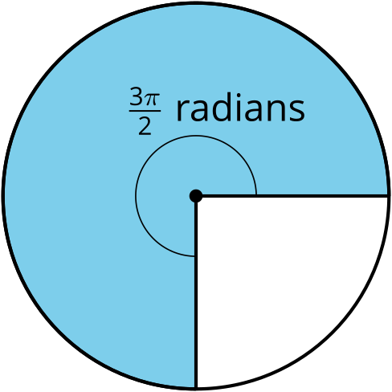

C
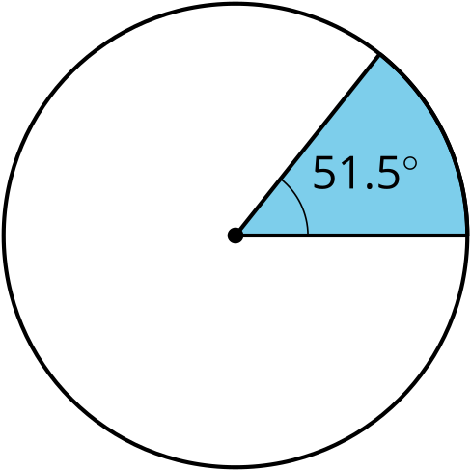

D
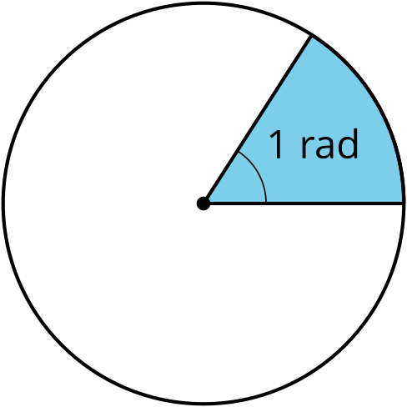

2 Degrees Versus Radians

Student Task Statement
This double number line shows degree measurements on one line and radians on another.
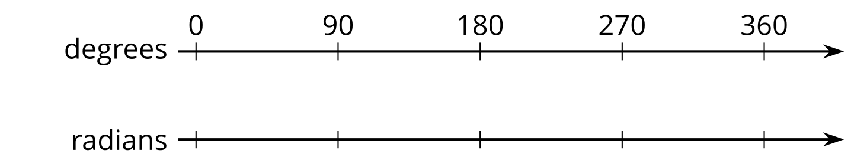
- Fill in the radian measures on the bottom line for 0$​^{∘}$, 90$​^{∘}$, 180$​^{∘}$, 270$​^{∘}$, and 360$​^{∘}$.
- Express each radian measurement in degrees.
  - $\frac{π}{3}$ radians
  - $\frac{5π}{4}$ radians
- Express each degree measurement in radians.
  - 30$​^{∘}$
  - 120$​^{∘}$

3 Pie Coloring Contest

Student Task Statement
Your teacher will give you a set of cards with angle measures on them. Place the cards upside down in a pile. Choose 1 student to go first. This student should draw a card, then on either circle shade a sector of the circle whose central angle is the measure on the card that was drawn.
Take turns repeating these steps. If you are shading in a circle that already has a shaded sector, choose a spot next to the already-shaded sectors—don’t leave any gaps. You might have to draw additional lines to break the sectors into smaller pieces.
Continue until an angle is drawn that won’t fit in any of the sectors that are still blank.
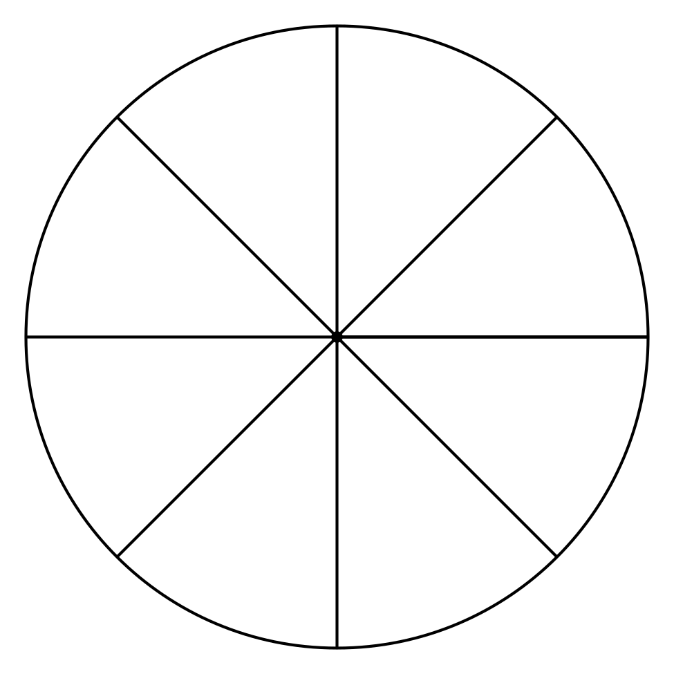
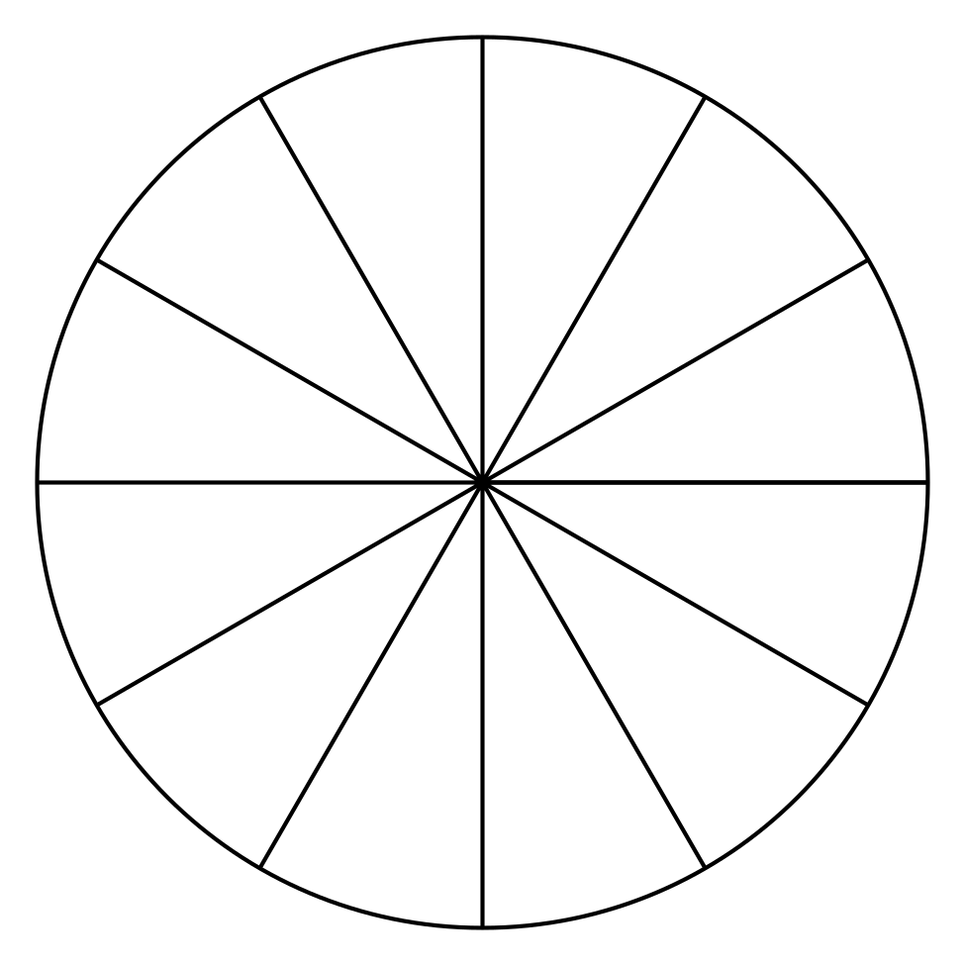
When you’re finished, answer these questions about each circle:
- What is the central angle measure for the remaining unshaded sector?
- What is the central angle measure for the block of shaded sectors?
© CC BY 2019 by Illustrative Mathematics®

