## Unit 3 Lesson 3: Associations in Categorical Data

### 1 Cake or Pie (Warm up)

#### Student Task Statement

The table displays the dessert preference and dominant hand (left- or right-handed) for a sample of 300 people.

|  | prefers cake | prefers pie | total |
| --- | --- | --- | --- |
| left-handed | 10 | 20 | 30 |
| right-handed | 90 | 180 | 270 |
| total | 100 | 200 | 300 |

For each of the calculations, describe the interpretation of the percentage in terms of the situation.

1. 10% from
2. 67% from
3. 30% from

### 2 Associations in Categorical Data

#### Student Task Statement

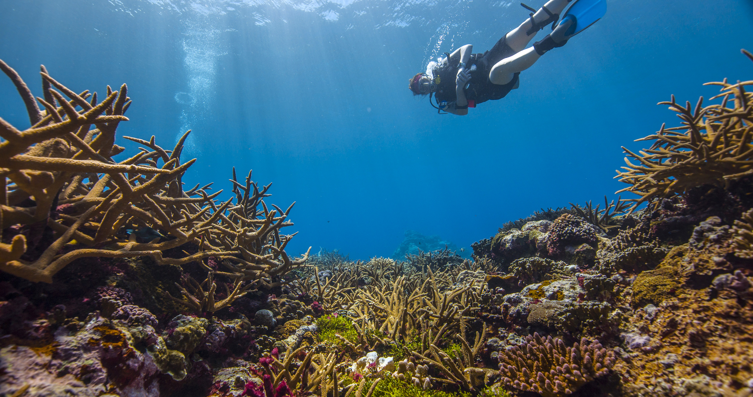

1. The two-way table displays data about 55 different locations. Scientists have a list of possible chemicals that may influence the health of the coral. They first look at how nitrate concentration might be related to coral health. The table displays the health of the coral (healthy or unhealthy) and nitrate concentration (low or high).

|  | * low nitrate concentration | * high nitrate concentration | * total |
| --- | --- | --- | --- |
| * healthy | * 20 | * 5 | * 25 |
| * unhealthy | * 8 | * 22 | * 30 |
| * total | * 28 | * 27 | * 55 |

* 1. Complete the two-way relative frequency table for the data in the two-way table in which the relative frequencies are based on the total for each column.

|  | * + low nitrate concentration | * + high nitrate concentration |
| --- | --- | --- |
| * + healthy |  |  |
| * + unhealthy |  |  |
| * + total | * + 100% | * + 100% |

* 1. When there is a low nitrate concentration, which had a higher relative frequency, healthy or unhealthy coral?
  2. When there is a high nitrate concentration, is there a higher relative frequency of healthy or unhealthy coral?
  3. Based on this data, is there a possible **association** between coral health and the level of nitrate concentration? Explain your reasoning.
  4. The scientists next look at how silicon dioxide concentration might be related to coral health. The relative frequencies based on the total for each column are shown in the table. Based on this data, is there a possible association between coral health and the level of silicon dioxide concentration? Explain your reasoning.

|  | * + low silicon dioxide concentration | * + high silicon dioxide concentration |
| --- | --- | --- |
| * + healthy | * + 44% | * + 46% |
| * + unhealthy | * + 56% | * + 54% |
| * + total | * + 100% | * + 100% |

1. Jada surveyed 300 people from various age groups about their shoe preference. The two-way table summarizes the results of the survey.

|  | * prefers sneakers without laces | * prefers sneakers with laces | * prefers shoes that are not sneakers | * total |
| --- | --- | --- | --- | --- |
| * 4–10 years old | * 21 | * 12 | * 3 | * 36 |
| * 11–17 years old | * 21 | * 48 | * 39 | * 108 |
| * 18–24 years old | * 15 | * 54 | * 87 | * 156 |
| * total | * 57 | * 114 | * 129 | * 300 |

* Jada concludes that there is a possible association between age and shoe preference. Is Jada’s conclusion reasonable? Explain your reasoning.

1. The two-way table summarizes data on writing utensil preference and the dominant hand for a sample of 100 people.

|  | * left-handed | * right-handed | * total |
| --- | --- | --- | --- |
| * prefers pen | * 7 | * 82 | * 89 |
| * prefers pencil | * 6 | * 5 | * 11 |
| * total | * 13 | * 87 | * 100 |

* Is there a possible association between dominant hand and writing utensil preference? Explain your reasoning.

### 3 Associating Your Own Variables

#### Student Task Statement

1. Work with your group to identify a pair of categorical variables you think might be associated and another pair you think would not be associated.
2. Imagine your group collected data for each pair of categorical variables. Create a two-way table that could represent each set of data. Invent some data with 100 total values to complete each table. Remember that one table shows a possible association, and the other table shows no association.
3. Explain or show why there appears to be an association for the first pair of variables and why there appears to be no association for the other pair of variables.
4. Prepare a display of your work to share.



© CC BY 2019 by Illustrative Mathematics®