Lesson 16: Features of Trigonometric Graphs (Part 2)
- Let's explore a trigonometric function modeling a situation.

16.1: Which One Doesn't Belong: Graph Periods
Which one doesn't belong?

A. $y=sin\left(πθ\right)$
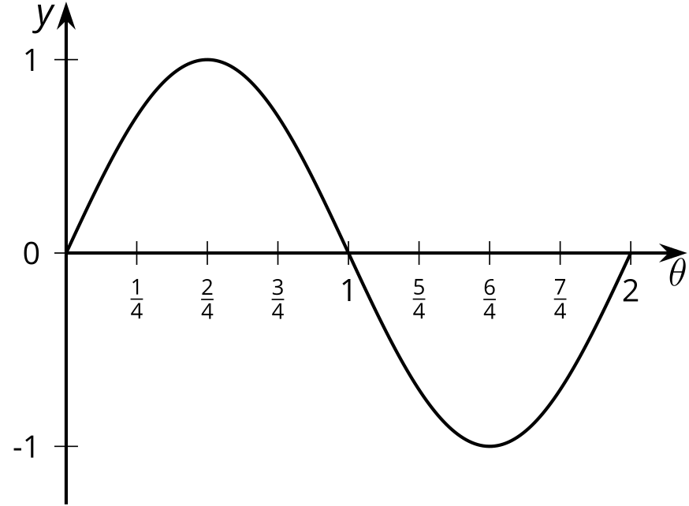

B. $y=sin\left(θ\right)$
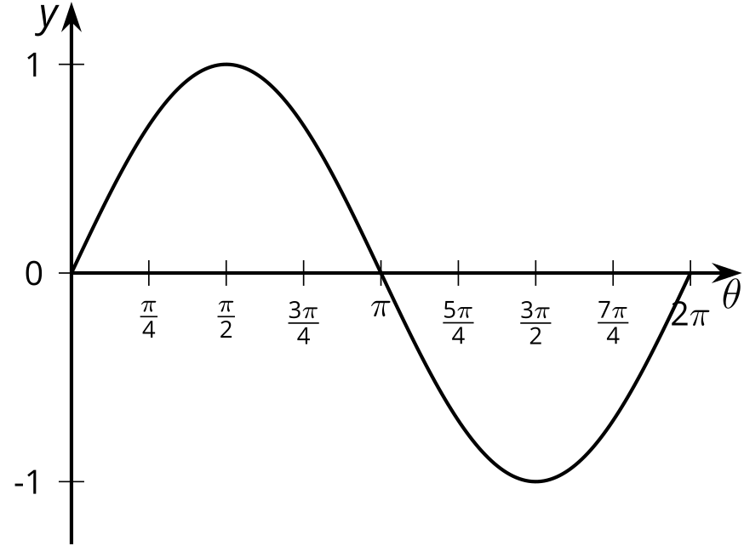

C. $y=sin\left(\frac{1}{2}θ\right)$
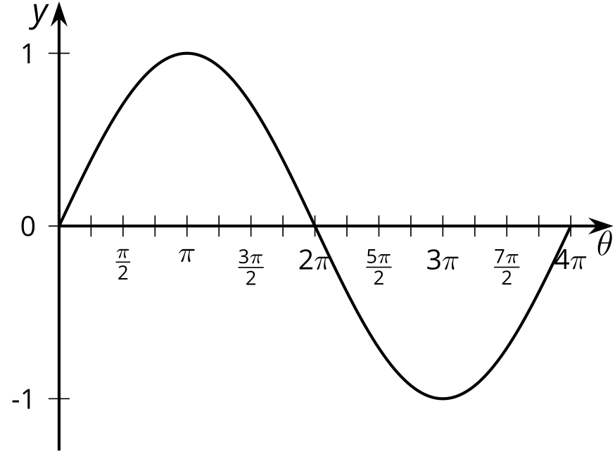

D. $y=sin\left(θ+\frac{π}{2}\right)$
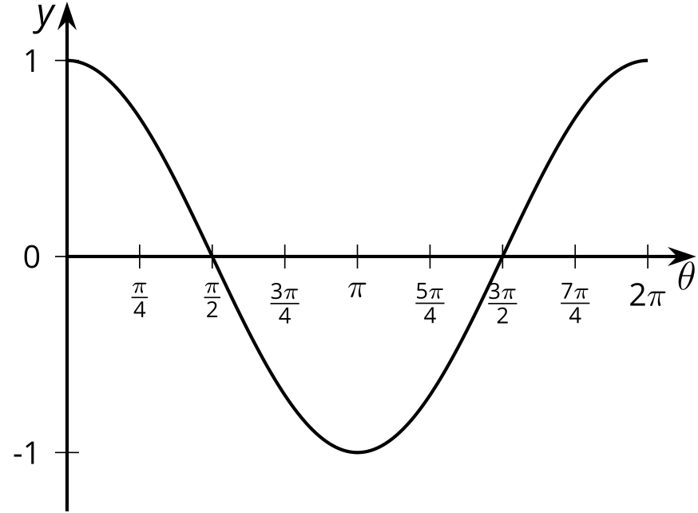

16.2: Any Period
- For each graph of a trigonometric function, identify the period.

- A
- 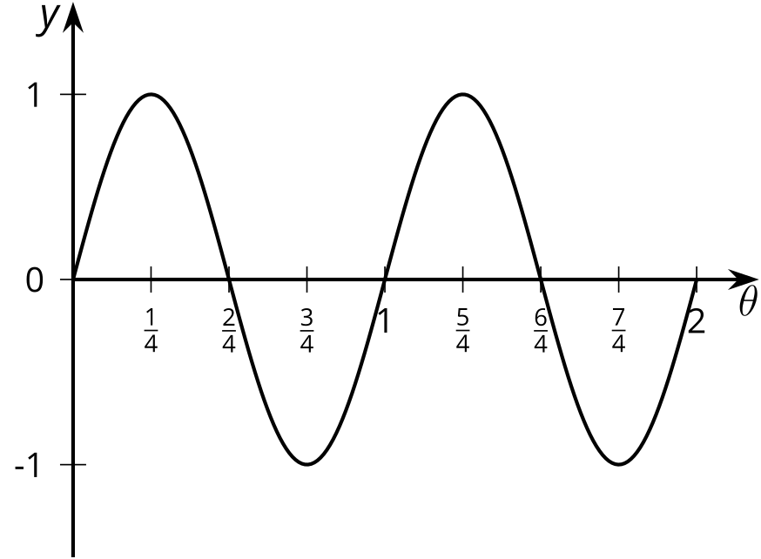

- B
- 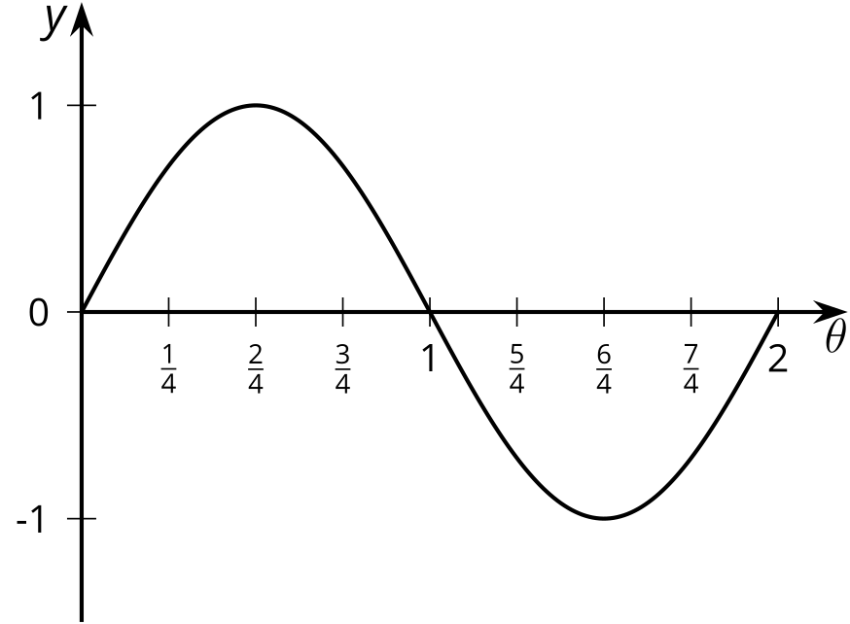

- C
- 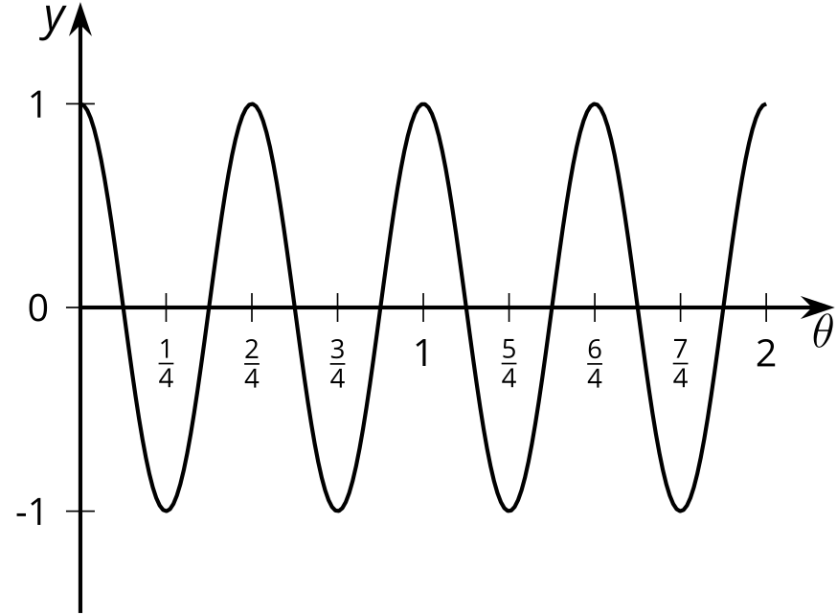

- D
- 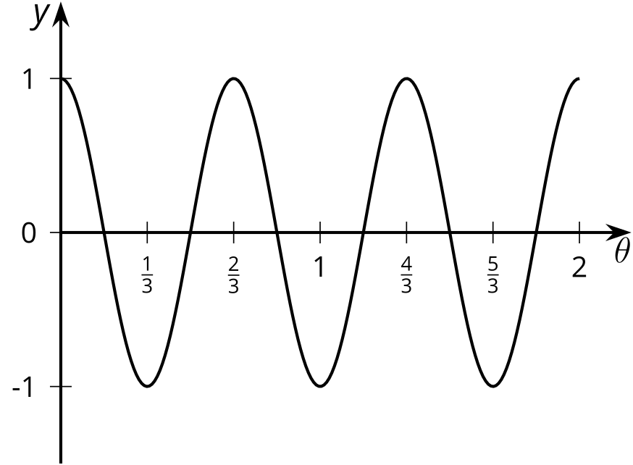
- Here are some trigonometric functions. Find the period of each function.
- function | - period
- $y=cos\left(θ\right)$
- $y=cos\left(3θ\right)$
- $y=sin\left(6θ\right)$
- $y=sin\left(10θ\right)$
- $y=cos\left(\frac{1}{3}θ\right)$
- What is the period of the function $y=cos\left(πθ\right)$? Explain your reasoning.
- Identify a possible equation for a trigonometric function with this graph.
- 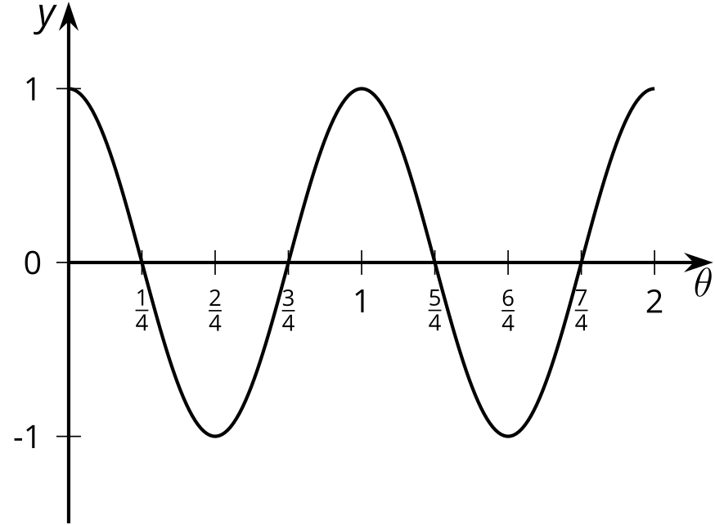

16.3: Around the World’s Largest Ferris Wheel
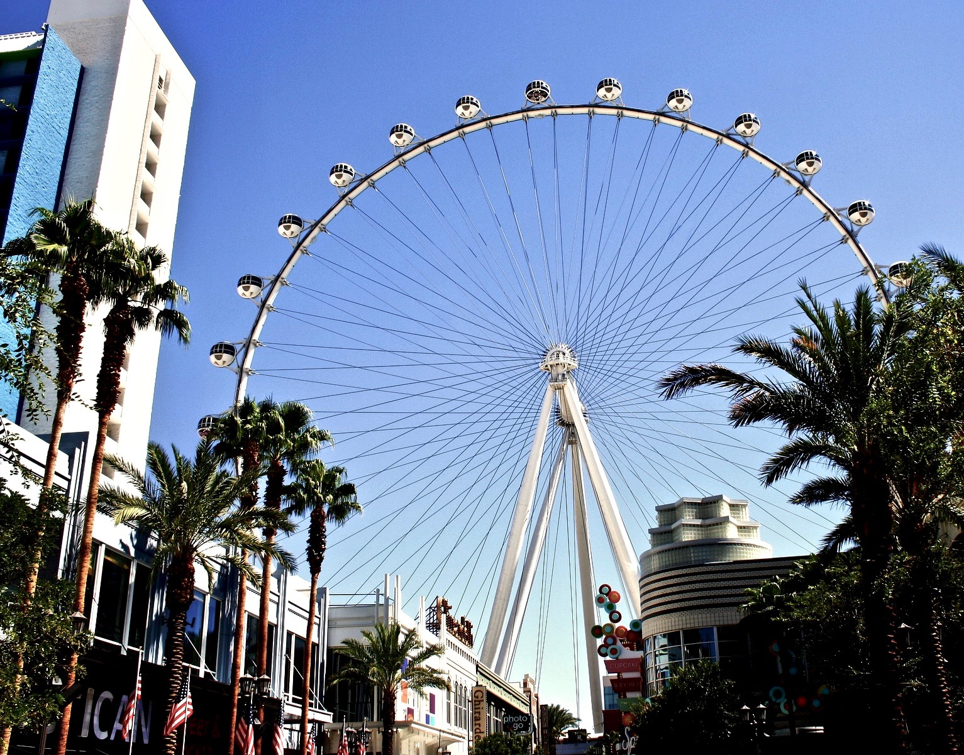
The world’s tallest Ferris wheel is in Las Vegas. The height $h$ in feet of one of the passenger seats on the Ferris wheel can be modeled by the function $f\left(t\right)=275+260sin\left(\frac{2πt}{30}\right)$ where time $t$ is measured in minutes after 8:00 a.m.
- What is the diameter of the Ferris wheel? Explain how you know.
- How long does it take the Ferris wheel to make a complete revolution? Explain how you know.
- Give at least three different times when the passenger seat modeled by $f$ is at its lowest point. Explain how you know.
- Sketch a graph of the height of the seat on the Ferris wheel for at least two full revolutions.

Are you ready for more?
Here is a graph of a wave where the amplitude is not constant but rather decreases over time. Write an equation which could match this graph.
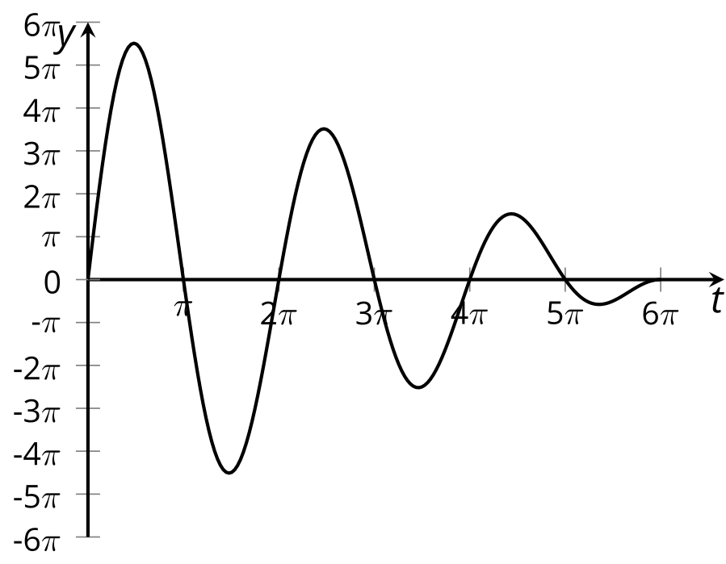

Lesson 16 Summary
Here is a point $P$ on a wheel.
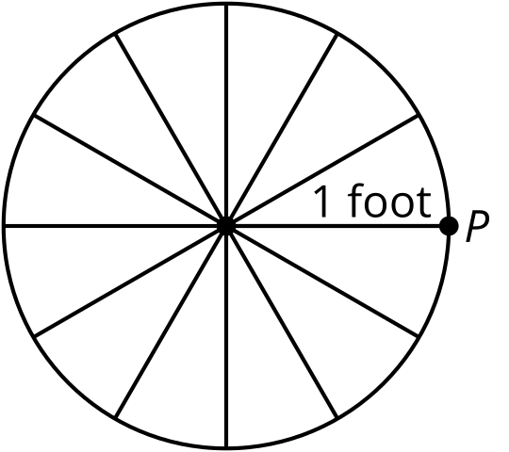
Imagine the height $h$ of $P$ in feet relative to the center of the wheel after $t$ seconds is given by the equation $h=sin\left(2πt\right)$. When $t=1$, that is after 1 second, the wheel will be back where it started. It will return to its starting position every second.
What if $h=sin\left(4πt\right)$ was the equation representing the height of $P$ instead? What does this equation tell us about how long it takes the wheel to complete a full revolution? In this case, when $t=1$ the wheel has made 2 complete revolutions, so it makes one complete revolution in 0.5 seconds. Here are the graphs of these two functions.
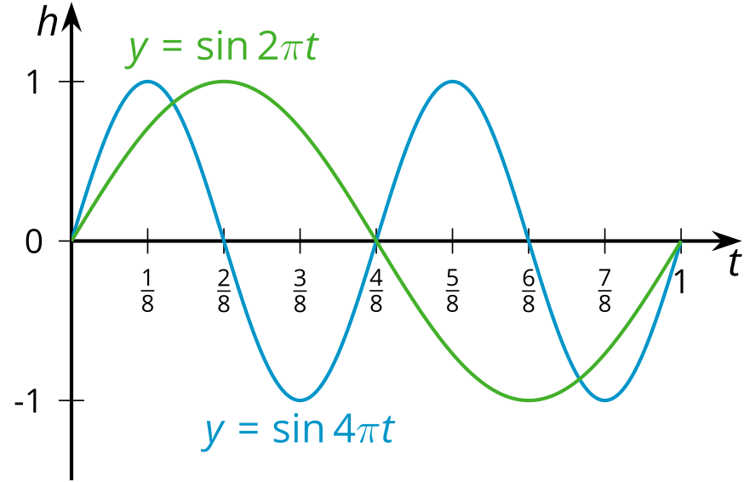
Notice that the midline is the $t$-axis for each function and the amplitude is 1. The only difference is the period, how long it takes each function to complete one full revolution.
Now let's consider the height of a point on a wheel with a radius of 11 inches, the center of the wheel 11 inches off the ground, and completing two revolutions per second.
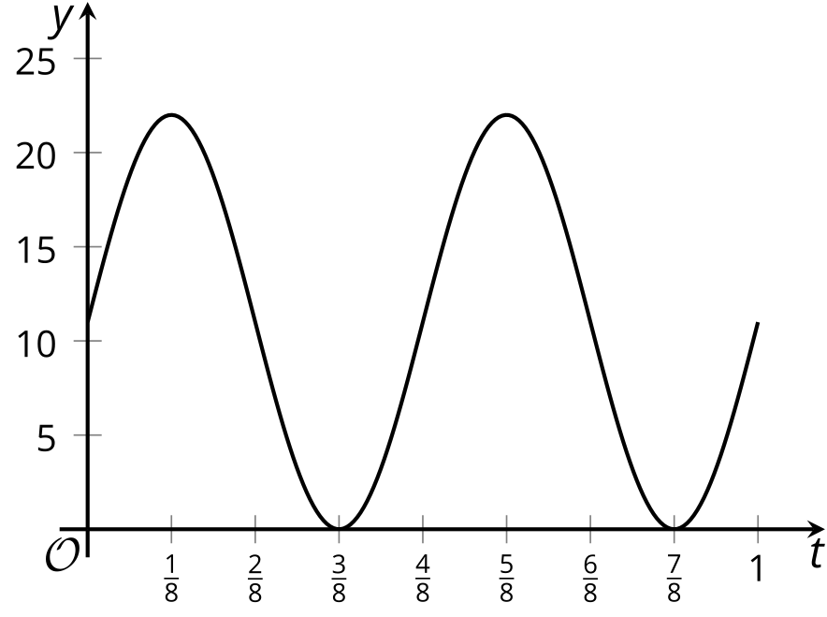
Notice that the midline and amplitude are 11. An equation defining this graph is $h=11sin\left(4πt\right)+11$ where $h$ is the height, in inches, of the point on the wheel after $t$ seconds.
© CC BY 2019 by Illustrative Mathematics®

