Lesson 15 Practice Problems
- In the right triangles shown, the measure of angle $ABC$ is the same as the measure of angle $EBD$. ​​​What is the length of side $BE$?
- 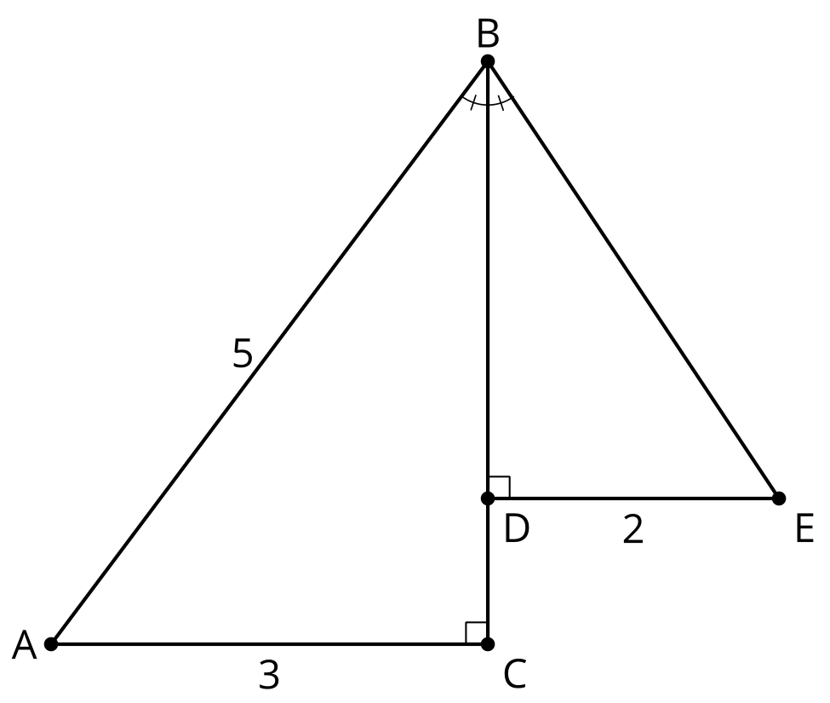
- In right triangle $ABC$, angle $C$ is a right angle, $AB=13$, and $BC=5$. What is the length of $AC$?
- In this diagram, lines $AC$ and $DE$ are parallel, and line $DC$ is perpendicular to each of them. What is a reasonable estimate for the length of side $BE$?

- $AC∥DE$, $DC⊥DE$, $DC⊥AC$
- 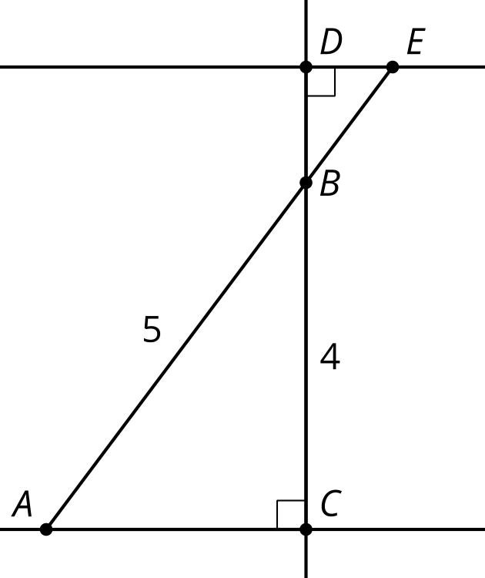
  - $\frac{1}{3}$
  - 1
  - $\frac{5}{3}$
  - 5
- Select all of the right triangles.
  - Triangle $ABC$ with $AB=30$, $BC=40$, and $AC=50$
  - Triangle $XYZ$ with $XY=1$, $YZ=1$, and $XZ=2$
  - Triangle $EFG$ with $EF=8$, $FG=15$, and $EG=17$
  - Triangle $LMN$ with $LM=7$, $MN=24$, and $LN=25$
  - Triangle $QRS$ with $QR=4$, $RS=5$, and $QS=6$
- (From Unit 3, Lesson 14.)
- Andre says he can find the length of the third side of triangle $ABC$ and it is 13 units. Mai disagrees and thinks that the side length is unknown. Who do you agree with? Show or explain your reasoning.
- 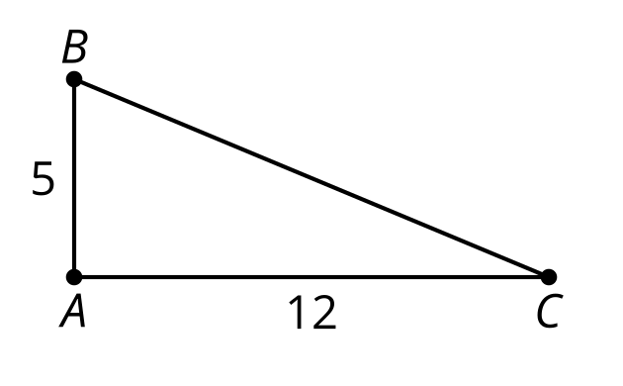
- (From Unit 3, Lesson 14.)
- In right triangle $ABC$, altitude $CD$ with length $h$ is drawn to its hypotenuse. We also know $AD=8$ and $DB=2$. What is the value of $h$?
- 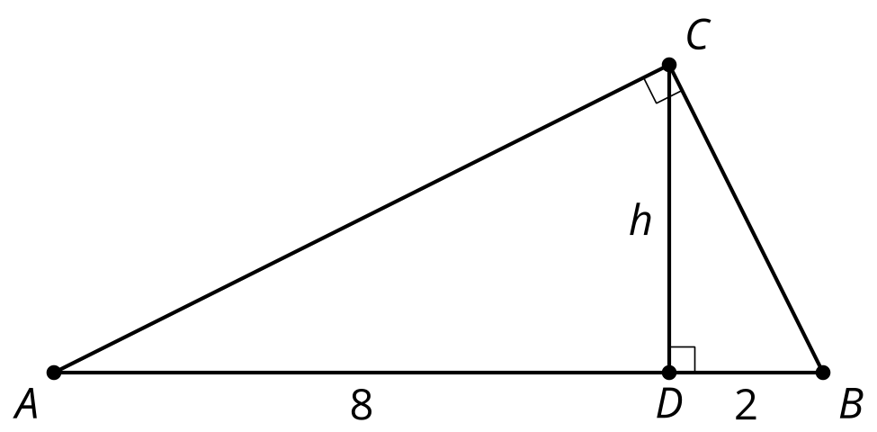
- (From Unit 3, Lesson 13.)
- Select the sequence of transformations of triangle $ADE$ that would show that triangles $ABC$ and $AED$ are similar. The length of $AC$ is 6.

- $AC=6$
- 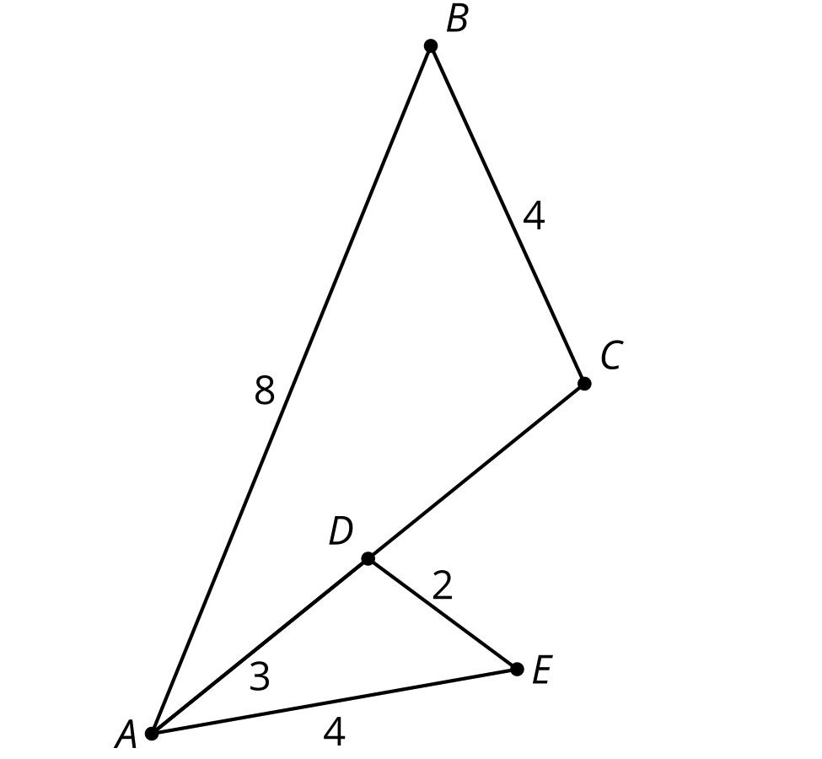
  - Dilate from center $A$ by a scale factor of $2$, then reflect over line $AC$.
  - Dilate from center $A$ by a scale factor of $2$, then rotate 60º around angle $A$.
  - Translate by directed line segment $DC$, then reflect over line $AC$.
  - Dilate from center $A$ by a scale factor of $4$, then reflect over line $AC$.
- (From Unit 3, Lesson 7.)
© CC BY 2019 by Illustrative Mathematics®

