Unit 3 Lesson 2: Relative Frequency Tables

1 Notice and Wonder: Teacher Degrees (Warm up)

Student Task Statement
Several adults in a school building were asked about their highest degree completed and whether they were a teacher.
What do you notice? What do you wonder?
 | teacher | not a teacher
associate degree | 4% | 16%
bachelor’s degree | 52% | 64%
master’s degree or higher | 44% | 20%

2 City Cat, Country Cat

Student Task Statement
200 people were asked if they prefer dogs or cats, and whether they live in a rural or urban setting.
The actual values collected from the survey are in the first table.
 | urban | rural | total
cat | 54 | 42 | 96
dog | 80 | 24 | 104
total | 134 | 66 | 200
The next table shows what percentage of the 200 total people included are represented by each combination of categories. The segmented bar graph represents the same information graphically.
 | urban | rural
cat | 27% | 21%
dog | 40% | 12%
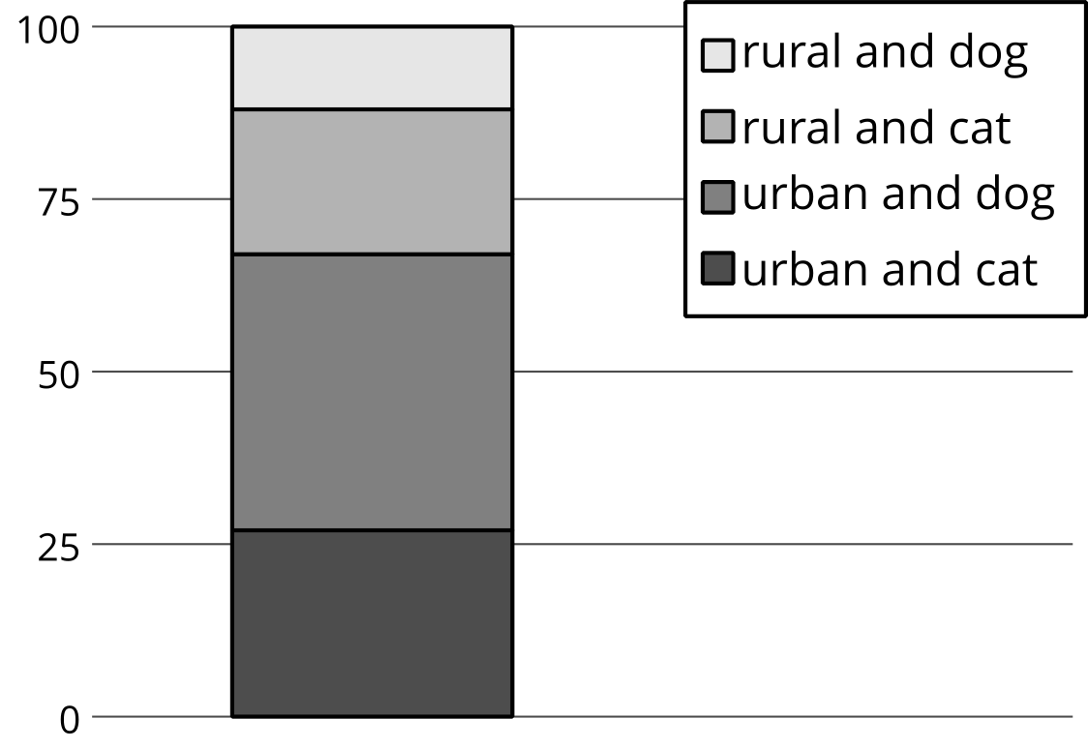
The next table shows the percentage of each column that had a certain pet preference in a column relative frequency table. The segmented bar graph represents the same information graphically.
 | urban | rural
cat | 40% | 64%
dog | 60% | 36%
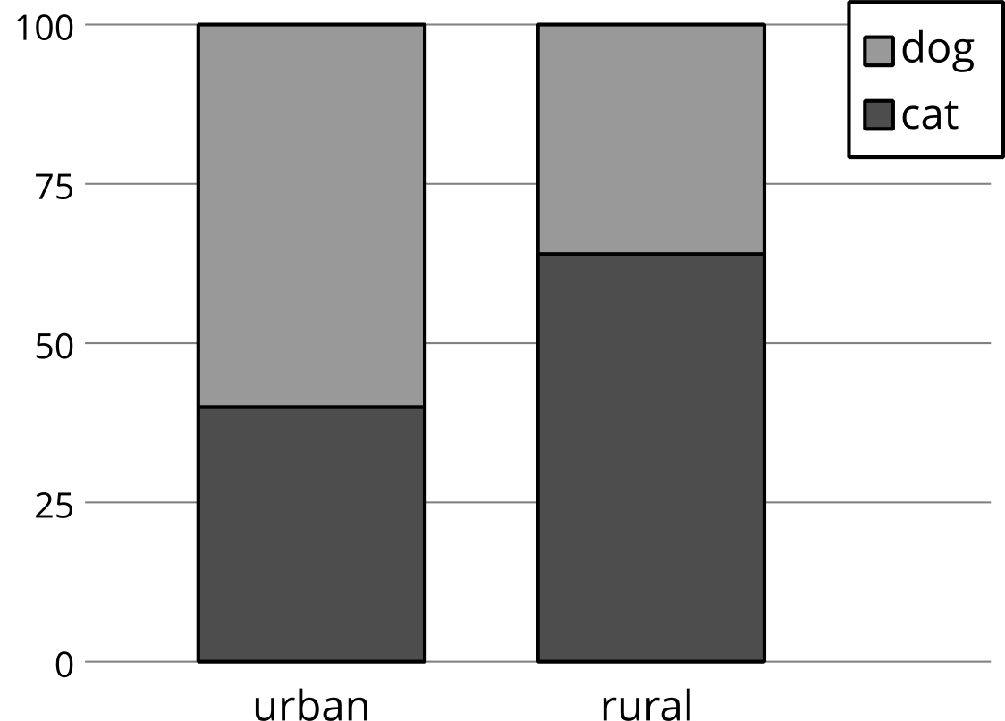
The last table shows the percentage of each row that live in a certain area in a row relative frequency table. The segmented bar graph represents the same information graphically.
 | urban | rural
cat | 56% | 44%
dog | 77% | 23%
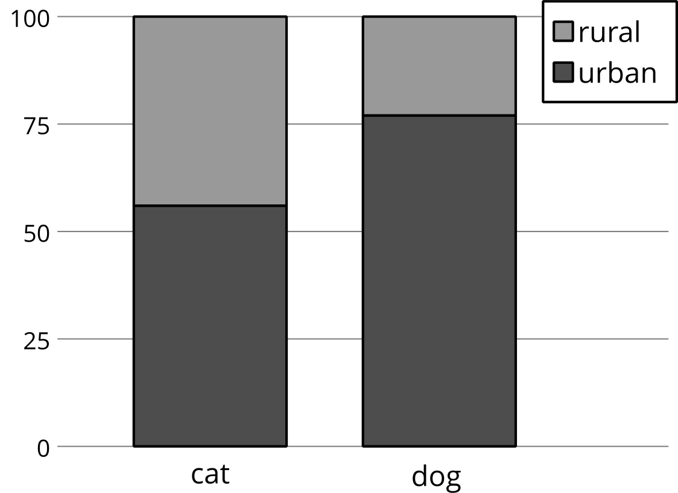
- For each relative frequency table, select a percentage and explain how numbers from the original table were used to get the percentage.
- What percentage of those surveyed live in an urban area and prefer dogs?
- Among the people surveyed who prefer dogs, what percentage of them live in an urban setting?
- What percentage of people surveyed who live in an urban setting prefer dogs?
- How many of the people responded that they prefer dogs and live in an urban setting?
- Among the people surveyed, are there more people who prefer dogs or cats?
- Your pet food company has access to a billboard in a rural setting. Would you recommend advertising dog food or cat food on this billboard? Which table did you use to make this decision? Explain your reasoning.

3 Analyzing a Study With Two Treatments

Student Task Statement
In an experiment to test the effectiveness of vitamin C on the length of colds, two groups of people with colds are given a pill to take once a day. The pill for one of the groups contains 1,000 mg of vitamin C, while the other group takes a placebo pill. The researchers record the results in a table.
 | group A | group B
cold lasts less than a week | 16 | 27
cold lasts a week or more | 17 | 53
- First, the researchers want to know what percentage (to the nearest whole percent) of people are in each combination of categories. Fourteen percent of all the participants had a cold that lasted less than a week and were in group A. What percentage of all the participants had a cold that lasted less than a week and were in group B? Complete the rest of the relative frequency table with the corresponding percentages.
 | - group A | - group B
- cold lasts less than a week | - 14% ($\frac{16}{16+27+17+53}≈0.14$)
- cold lasts a week or more
- Next, the researchers notice that, among participants who had colds that lasted less than a week, 37% were in group A. Among participants who had colds that lasted a week or more, what percentage were in group B? Complete the table with the corresponding percentages.
 | - group A | - group B
- cold lasts less than a week | - 37% ($\frac{16}{16+27}≈0.37$)
- cold lasts a week or more
- Finally, the researchers notice that, among the participants in group A, 48% had colds that lasted less than one week. Among the participants in group B, how many had colds that lasted a week or more? Complete the table with the corresponding percentages.
 | - group A | - group B
- cold lasts less than a week | - 48% ($\frac{16}{16+17}≈0.48$)
- cold lasts a week or more
- To understand the results, the researchers want to know: Among people whose colds lasted less than a week, what percentage are in group B? Explain your reasoning.
- If the researchers believe that vitamin C has a small effect on the length of a cold, which group most likely got the pills containing vitamin C? Explain your reasoning.
© CC BY 2019 by Illustrative Mathematics®

