Lesson 8: Encontremos el perímetro

Standards Alignments
Addressing | 3.MD.D.8, 3.OA.C.7

Teacher-facing Learning Goals
- Find the perimeter of two-dimensional shapes given all or some of the side lengths.

Student-facing Learning Goals
- Encontremos el perímetro de más figuras.

Lesson Purpose
The purpose of this lesson is for students to find perimeters of shapes given all or some of the side lengths.
In previous lessons, students learned about attributes of two-dimensional shapes. They also learned about perimeter and drew shapes with specific perimeters. In this lesson, students find perimeters of shapes given side lengths and use the attributes of shapes to find the perimeter given only some of the side lengths.

Access for:

Students with Disabilities
- Representation (Activity 2)

English Learners
- MLR8 (Activity 1)

Instructional Routines
5 Practices (Activity 1), MLR7 Compare and Connect (Activity 2), Number Talk (Warm-up)

Materials to Gather
- Tools for creating a visual display: Activity 2

Lesson Timeline
Warm-up | 10 min
Activity 1 | 20 min
Activity 2 | 15 min
Lesson Synthesis | 10 min
Cool-down | 5 min

Teacher Reflection Question
How did students leverage their geometry knowledge about attributes of shapes to reason about perimeter in today’s lesson?

Cool-down
(to be completed at the end of the lesson) 5min
Un triángulo y un cuadrado

Standards Alignments
Addressing | 3.MD.D.8

Student-facing Task Statement
Encuentra el perímetro de cada figura. Explica o muestra tu razonamiento.
A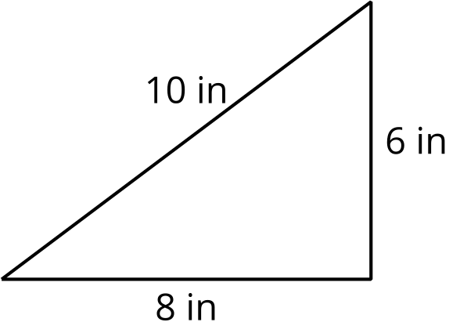
B

Student Responses
A: 24 in. Sample response: $6+8+10=24$
B: 32 in. Sample response: I multiplied $4×8$ since there are 4 sides that are the same length.

