Lesson 14: Transforming Trigonometric Functions
- Let’s make lots of changes to the graphs of trigonometric functions.

14.1: Translated Parabolas
Match each equation with its graph. Be prepared to explain your reasoning.
- $y=x^{2}$
- $y={\left(x−1\right)}^{2}$
- $y={\left(x+3\right)}^{2}$

A
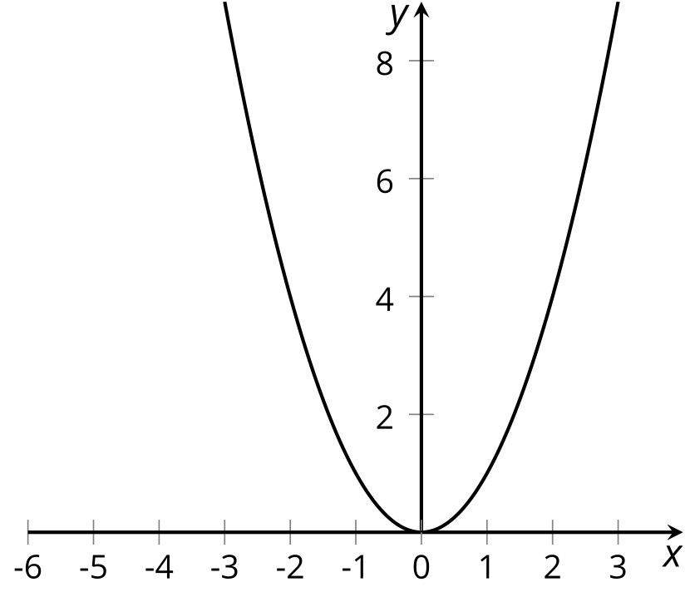

B
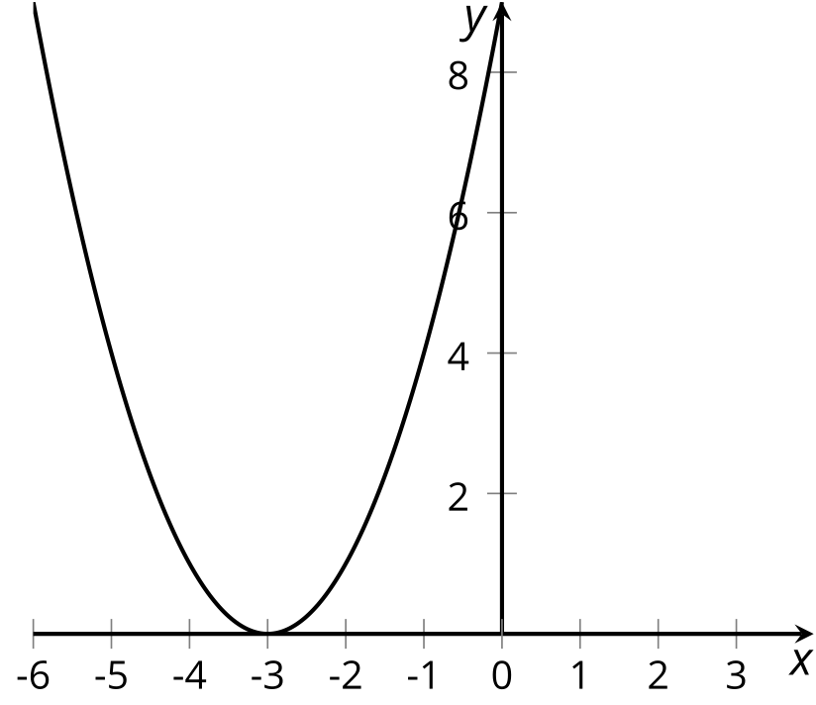

C
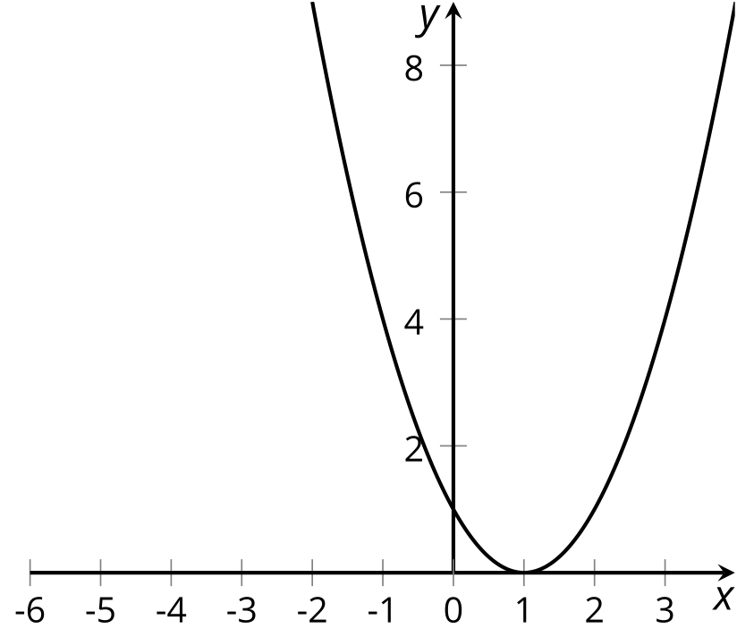

14.2: Windmills Everywhere
Here are three equations for three different windmills. Each equation describes the height $h$, in feet above the ground, of a point at the tip of a blade of a different windmill. The point is at the far right when the angle $θ$ takes the value 0. Describe each windmill and how it is spinning.
- $h=2.5sin\left(θ\right)+10$
- $h=\frac{4}{5}sin\left(θ\right)+3$
- $h=\text{-}1.5sin\left(θ\right)+5$

14.3: Spinning Fan
A fan has radius 1 foot. A point $P$ starts in the position shown in the picture. The center of the fan is at $\left(0,0\right)$ and the point $P$ is at the $\frac{π}{6}$ position on the circle. The fan turns in a counterclockwise direction.
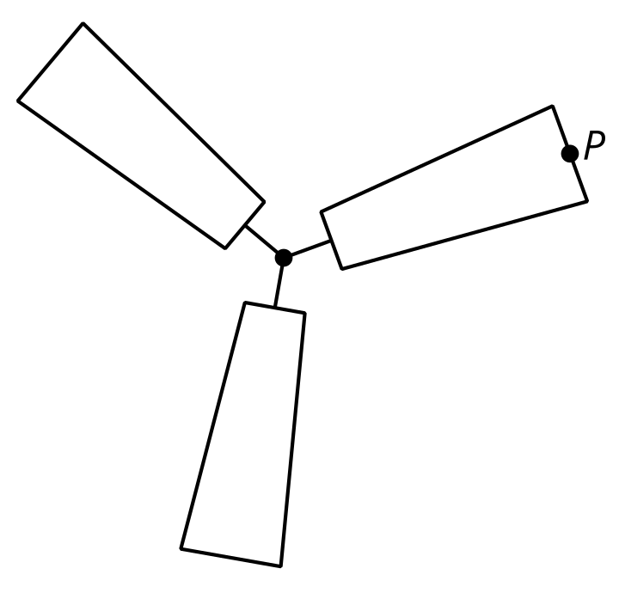
- Sketch a graph of the horizontal position $h$, in feet, of $P$ as a function of the angle of rotation $θ$ of the fan from its starting position.
- 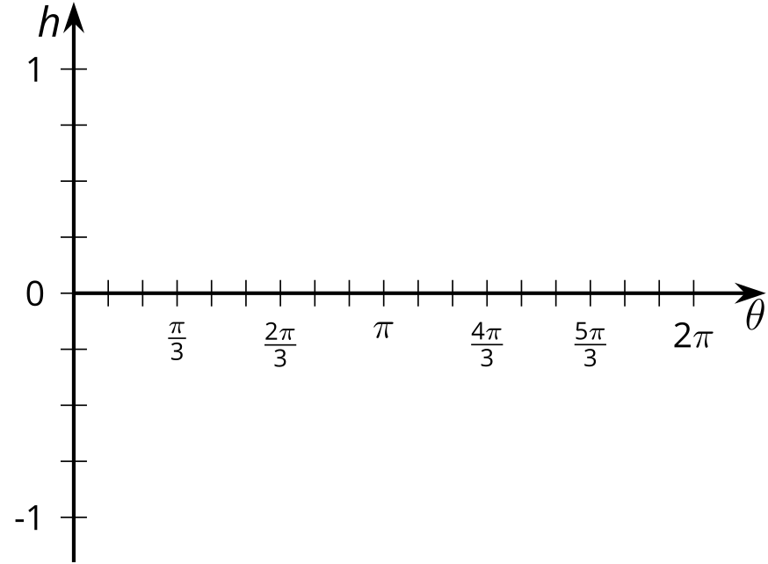
- How does this graph compare to the graph of $h=cos\left(θ\right)$?
- Sketch a graph of the vertical position $v$, in feet, of $P$ as a function of the angle of rotation $θ$ of the fan.
- 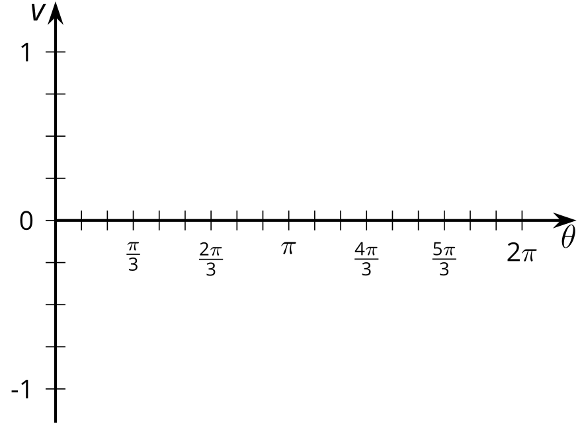
- How does this graph compare to the graph of $v=sin\left(θ\right)$?

Are you ready for more?
I attach a laser beam to the fan at the same point $P$ at position $\frac{π}{6}$ so that the laser points away from the center of the fan. At the starting position the laser beam hits the right wall near the ceiling and does so until position $\frac{π}{4}$. It then moves along the ceiling followed by moving down the left wall of the room, then onto the floor, and finally back up the right wall. We move from the floor to the right wall at the position $\frac{7π}{4}$.
- At what angles of rotation between $0$ and $4π$ from the fan's starting position will the beam hit the right wall?
- Measure the position of the beam on the right wall by marking evenly spaced points from -10 at the floor to 10 at the ceiling so that we hit the 0 mark when the beam is at position 0 on the circle. Write a function which gives the position $y$ on the wall at angle of rotation $θ$ where $θ$ is in the domain you found in the first part.

Lesson 14 Summary
The graphs of cosine and sine functions can be translated vertically or horizontally and the size or height of their graphs can also be modified similar to how we transformed other types of functions in an earlier unit. Let’s look at the graphs of $y=sin\left(θ\right)$ and $y=2sin\left(θ\right)+3$.
The coefficient 2 stretches the graph vertically, doubling the amplitude of the sine graph. This means that the distance from the midline to the maximum or minimum value is now 2 instead of 1. Adding 3 to the equation translates the midline up by 3 units.
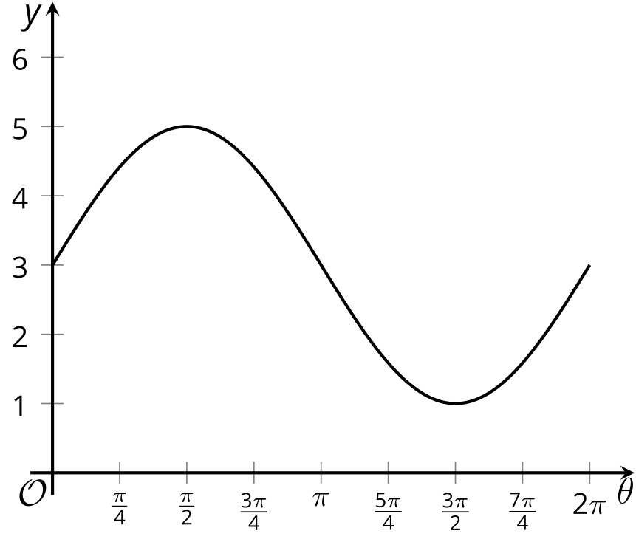
What if we want to translate the graph of $y=sin\left(θ\right)$ to the left? We can do this by adding an angle to the input $θ$. Let’s look at the graph of $y=sin\left(θ+\frac{π}{2}\right)$. The graph of this function looks just like the graph of $y=sin\left(θ\right)$ translated to the left by $\frac{π}{2}$. (It also looks a lot like $y=cos\left(θ\right)$!)
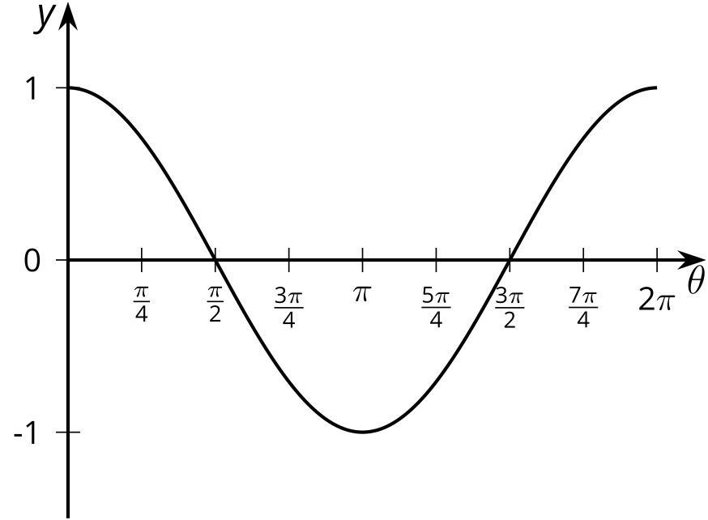
© CC BY 2019 by Illustrative Mathematics®

