Lesson 16 Practice Problems
- Are these two triangles identical? Explain how you know.
- 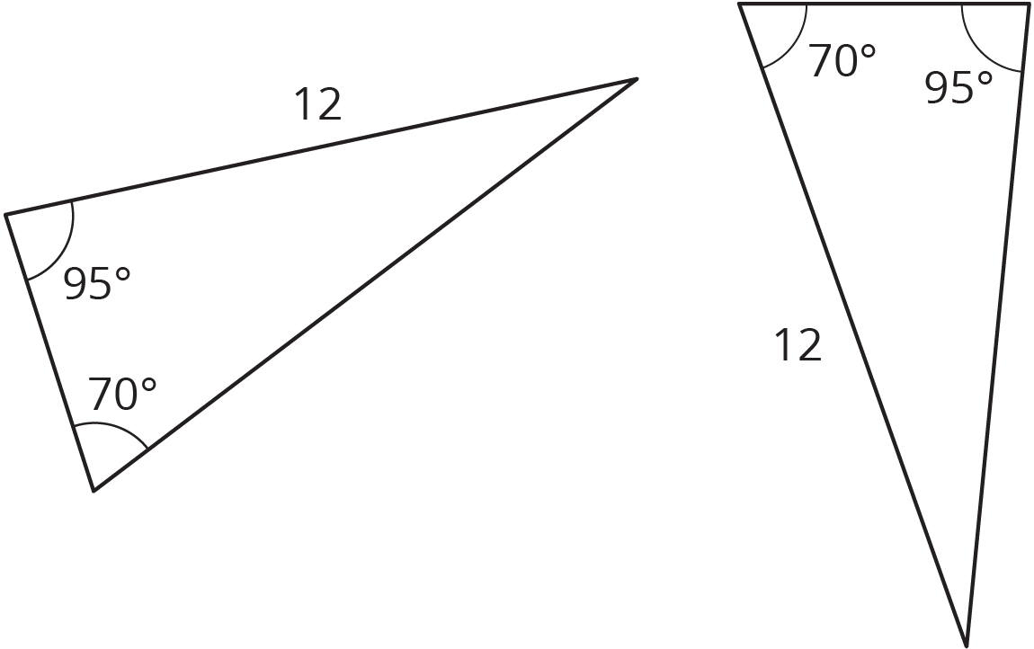
- Are these triangles identical? Explain your reasoning.
- 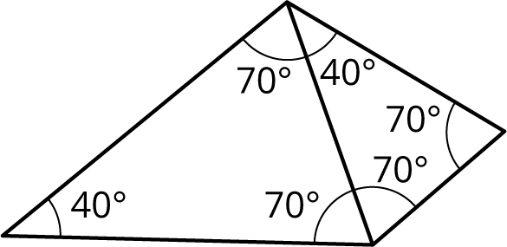

- Tyler claims that if two triangles each have a side length of 11 units and a side length of 8 units, and also an angle measuring ${100}^{∘}$, they must be identical to each other. Do you agree? Explain your reasoning.

  - Draw segment $PQ$.
  - When $PQ$ is rotated ${180}^{∘}$ around point $R$, the resulting segment is the same as $PQ$. Where could point $R$ be located?
- (From Unit 1, Lesson 7.)
- Here is trapezoid $ABCD$.
- 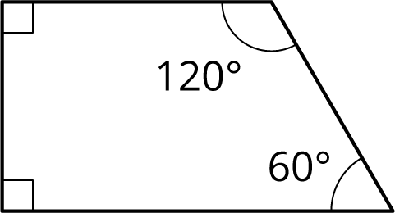

- Using rigid transformations on the trapezoid, build a pattern. Describe some of the rigid transformations you used.
- (From Unit 1, Lesson 9.)
© CC BY Open Up Resources. Adaptations CC BY IM.

