Unit 7 Lesson 8: Arcs and Sectors

1 Math Talk: Fractions of a Circle (Warm up)

Student Task Statement
Evaluate each problem mentally.
- Find the area of the shaded portion of the circle.
- 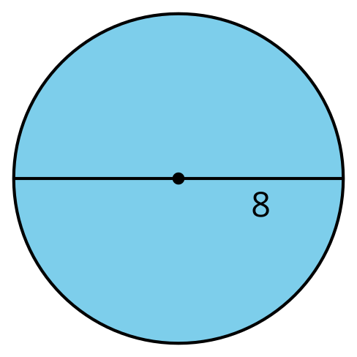
- Find the length of the highlighted portion of the circle’s circumference.
- 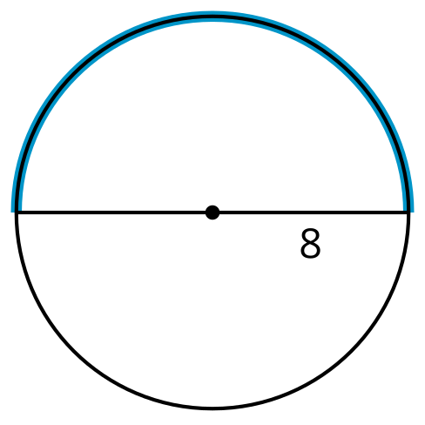
- Find the area of the shaded portion of the circle.
- 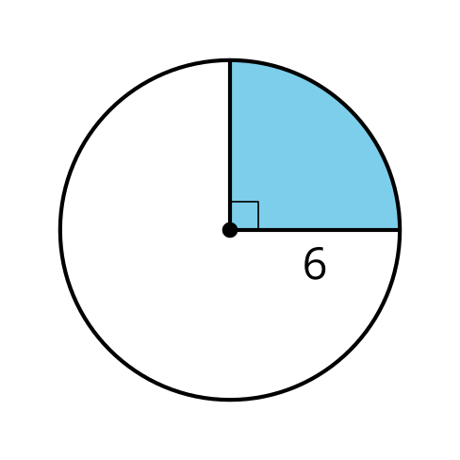
- Find the length of the highlighted portion of the circle’s circumference.
- 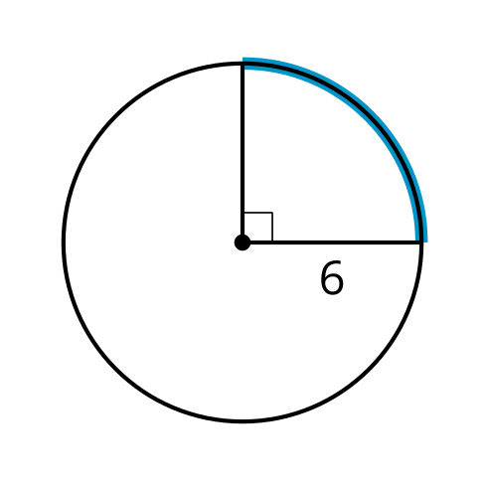

2 Sector Areas and Arc Lengths

Student Task Statement
A sector of a circle is the region enclosed by 2 radii.

A
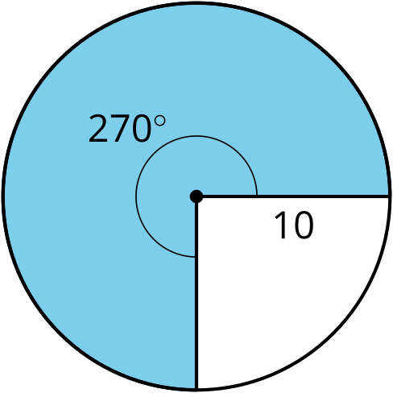

B
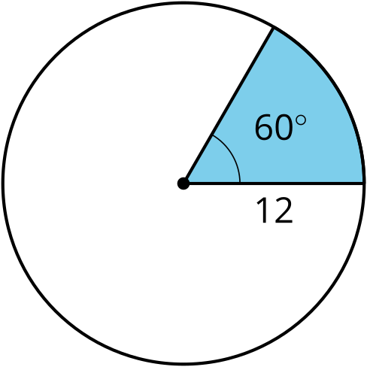

C
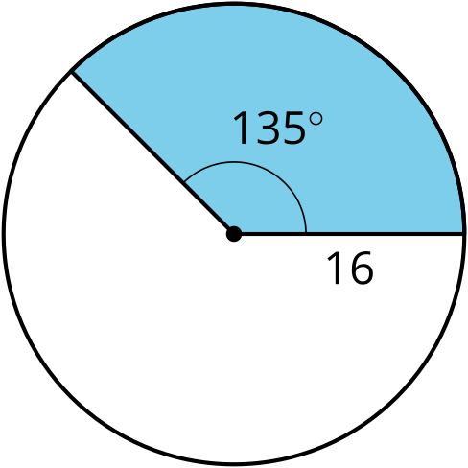
For each circle, find the area of the shaded sector and the length of the arc that outlines the sector. All units are centimeters. Give your answers in terms of $π$.

Activity Synthesis
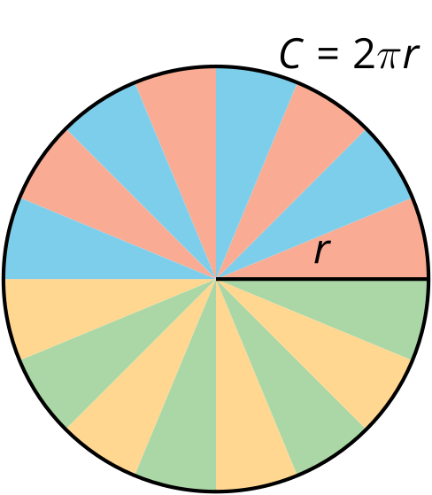
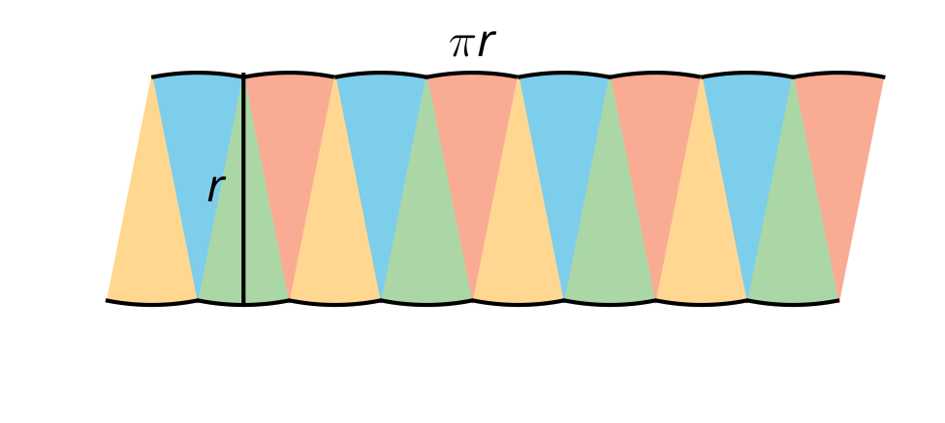

3 Build a Method

Student Task Statement
Mai says, “I know how to find the area of a sector or the length of an arc for central angles like 180 degrees or 90 degrees. But I don’t know how to do it for central angles that make up more complicated fractions of the circle.”
- In the diagram, the sector’s central angle measures $θ$ degrees and the circle’s radius is $r$ units. Use the diagram to tell Mai how to find the area of a sector and the length of an arc for any angle and radius measure.

- 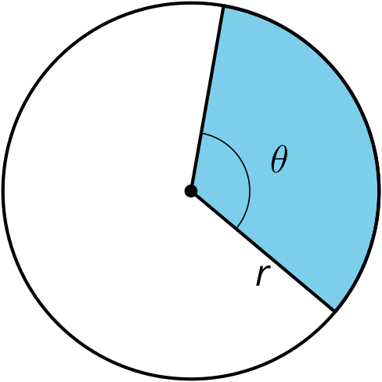
- This image shows a circle with radius and central angle measurements. Find the area of the shaded sector, and the length of the arc defined by the sector.

- 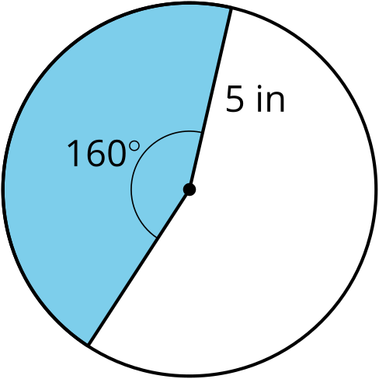

Images for Activity Synthesis
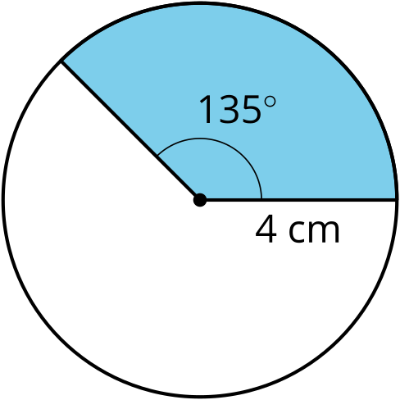
© CC BY 2019 by Illustrative Mathematics®

