Lesson 12: Tangent
- Let’s learn more about tangent.

12.1: Notice and Wonder: An Unusual Function
What do you notice? What do you wonder?
$θ$ | $cos\left(θ\right)$ | $sin\left(θ\right)$ | $tan\left(θ\right)$
$\text{-}\frac{π}{2}$ | 0 | -1
$\text{-}\frac{π}{3}$ | 0.5 | -0.87
$\text{-}\frac{π}{6}$ | 0.87 | -0.5
0 | 1 | 0
$\frac{π}{6}$ | 0.87 | 0.5
$\frac{π}{3}$ | 0.5 | 0.87
$\frac{π}{2}$ | 0 | 1

12.2: A Tangent Ratio
- Complete the table. For each positive angle in the table, add the corresponding point and the segment between it and the origin to the unit circle.
- 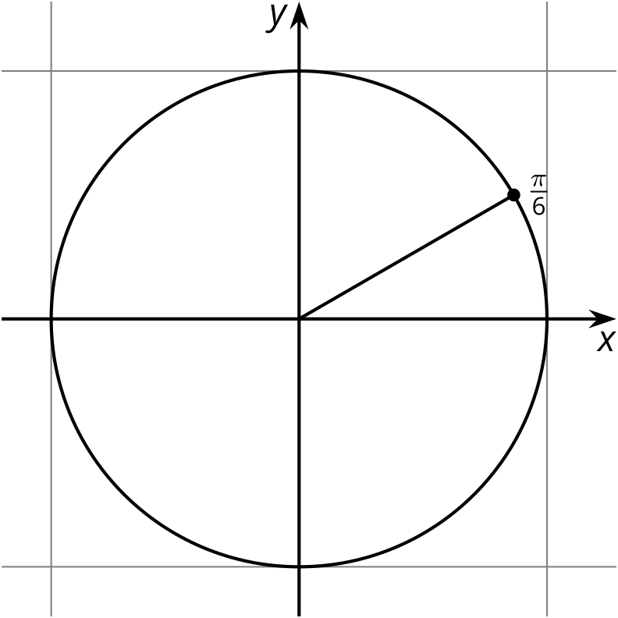
- $θ$ | - $cos\left(θ\right)$ | - $sin\left(θ\right)$ | - $tan\left(θ\right)$
- $\text{-}\frac{π}{2}$ | - 0 | - -1
- $\text{-}\frac{π}{3}$ | - 0.5 | - -0.87
- $\text{-}\frac{π}{6}$ | - 0.87 | - -0.5
- 0 | - 1 | - 0
- $\frac{π}{6}$ | - 0.87 | - 0.5
- $\frac{π}{3}$ | - 0.5 | - 0.87
- $\frac{π}{2}$ | - 0 | - 1
- $\frac{2π}{3}$
- $\frac{5π}{6}$
- $π$
- $\frac{7π}{6}$
- $\frac{4π}{3}$
- $\frac{3π}{2}$
- $\frac{5π}{3}$
- $\frac{11π}{6}$
- $2π$
- How are the values of $tan\left(θ\right)$ like the values of $cos\left(θ\right)$ and $sin\left(θ\right)$? How are they different?

Are you ready for more?
- Where does the line $x=1$ intersect the line that passes through the origin and the point corresponding to the angle $\frac{π}{6}$?
- Where does the line $x=1$ intersect the line that passes through the origin and the point corresponding to the angle $θ$?
- Where do you think the name “tangent” of an angle comes from?
- 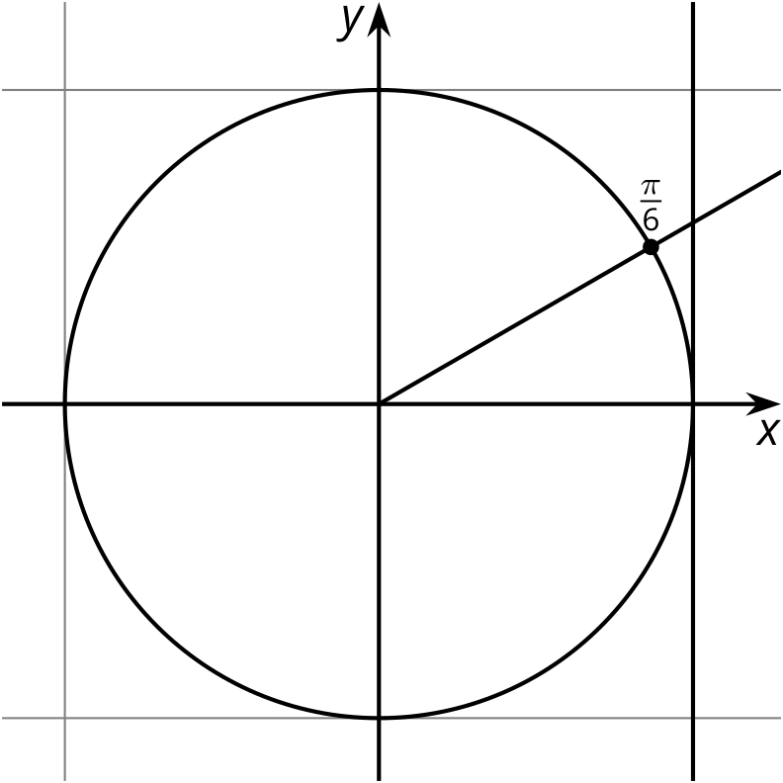

12.3: The Tangent Function
Before we graph $y=tan\left(θ\right)$, let’s figure out some things that must be true.
- Explain why the graph of $tan\left(θ\right)$ has a vertical asymptote at $x=\frac{π}{2}$.
- Does the graph of $tan\left(θ\right)$ have other vertical asymptotes? Explain how you know.
- For which values of $θ$ is $tan\left(θ\right)$ zero? For which values of $θ$ is $tan\left(θ\right)$ one? Explain how you know.
- Is the graph of $tan\left(θ\right)$ periodic? Explain how you know.

Lesson 12 Summary
The tangent of an angle $θ$, $tan\left(θ\right)$, is the quotient of the sine and cosine: $tan\left(θ\right)=\frac{sin\left(θ\right)}{cos\left(θ\right)}$. Here is a graph of $y=tan\left(θ\right)$.
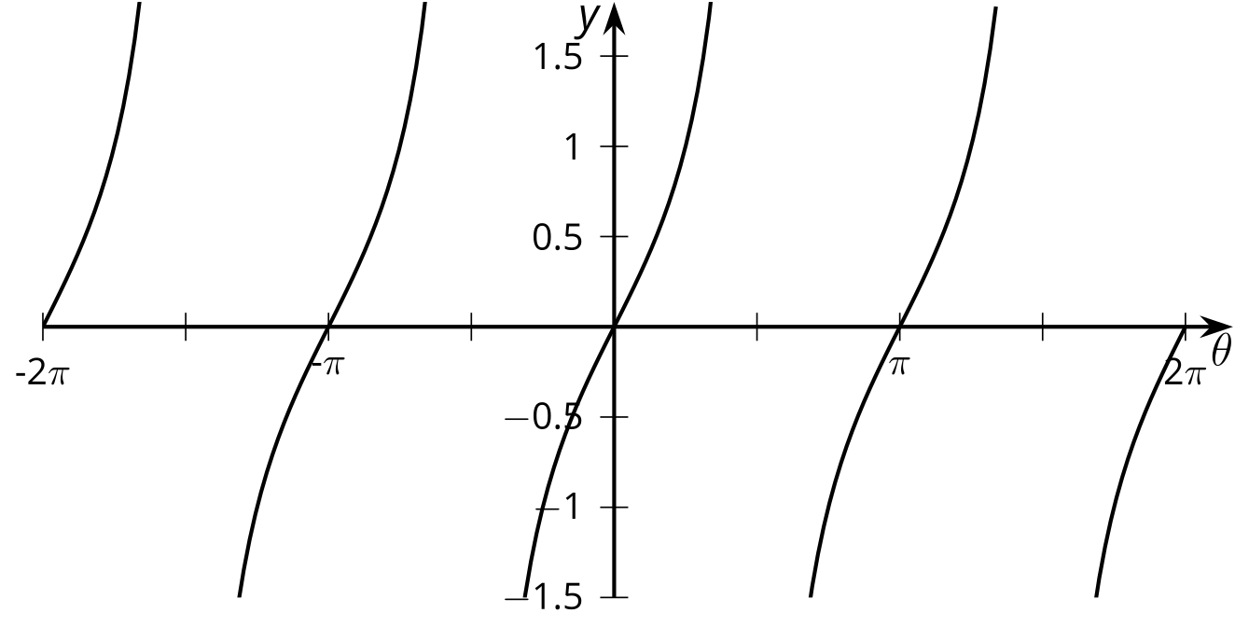
We can see from the graph that $tan\left(θ\right)=0$ when $θ$ is $\text{-}2π,\text{-}π,0,π,\text{or }2π$. This makes sense because the sine is 0 for these values of $θ$. Since sine and cosine are never 0 at the same $θ$, we can say that tangent has a value of 0 whenever sine has a value of 0.
We can also see the asymptotes of tangent $\text{-}\frac{3π}{2},\text{-}\frac{π}{2},\frac{π}{2},\text{and }\frac{3π}{2}$. Let’s look more closely at what happens when $θ=\frac{π}{2}$. We have $sin\frac{π}{2}=1$ and $cos\frac{π}{2}=0$. This means $tan\left(\frac{π}{2}\right)=\frac{1}{0}$, which is not defined. Whenever $cos\left(θ\right)=0$, the tangent is not defined and has a vertical asymptote.
Like the sine and cosine functions, the tangent function is periodic. This makes sense because it is defined using sine and cosine. The period of tangent is only $π$ while the period of sine and cosine is $2π$.
© CC BY 2019 by Illustrative Mathematics®

