Unit 4 Lesson 12: Finding the Percentage

1 Tax, Tip, and Discount (Warm up)

Student Task Statement
What percentage of the car price is the tax?
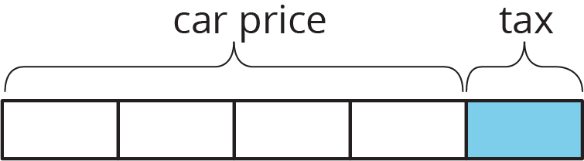
What percentage of the food cost is the tip?
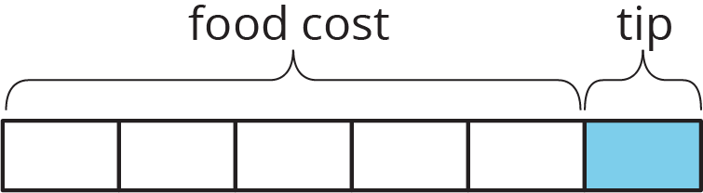
What percentage of the shirt cost is the discount?
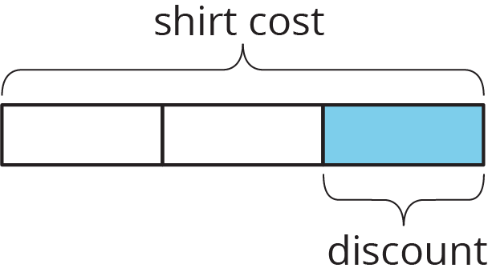

2 What Is the Percentage?

Student Task Statement
- A salesperson sold a car for $18,250 and their commission is $693.50. What percentage of the sale price is their commission?
- The bill for a meal was $33.75. The customer left $40.00. What percentage of the bill was the tip?
- The original price of a bicycle was $375. Now it is on sale for $295. What percentage of the original price was the markdown?

3 Info Gap: Sporting Goods

Student Task Statement
Your teacher will give you either a problem card or a data card. Do not show or read your card to your partner.
If your teacher gives you the problem card:
- Silently read your card and think about what information you need to be able to answer the question.
- Ask your partner for the specific information that you need.
- Explain how you are using the information to solve the problem.
- Continue to ask questions until you have enough information to solve the problem.
- Share the problem card and solve the problem independently.
- Read the data card and discuss your reasoning.
If your teacher gives you the data card:
- Silently read your card.
- Ask your partner “What specific information do you need?” and wait for them to ask for information.
- If your partner asks for information that is not on the card, do not do the calculations for them. Tell them you don’t have that information.
- Before sharing the information, ask “Why do you need that information?” Listen to your partner’s reasoning and ask clarifying questions.
- Read the problem card and solve the problem independently.
- Share the data card and discuss your reasoning.
Pause here so your teacher can review your work. Ask your teacher for a new set of cards and repeat the activity, trading roles with your partner.
© CC BY Open Up Resources. Adaptations CC BY IM.

