Unit 6 Lesson 2: Reasoning about Contexts with Tape Diagrams

1 Notice and Wonder: Remembering Tape Diagrams (Warm up)

Student Task Statement
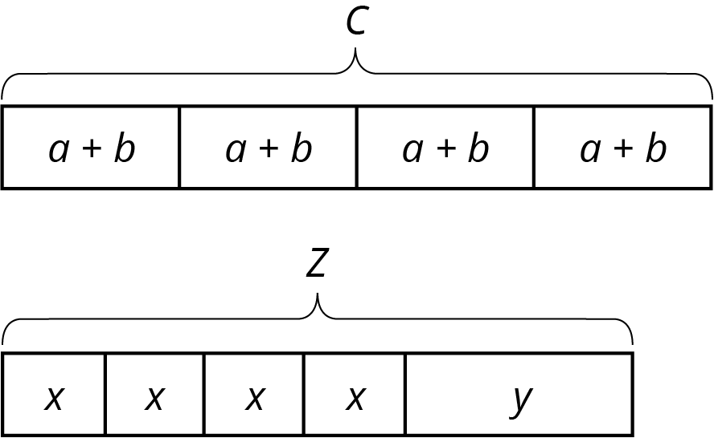
- What do you notice? What do you wonder?
- What are some possible values for $a$, $b$, and $c$ in the first diagram?
- For $x$, $y$, and $z$ in the second diagram? How did you decide on those values?

2 Every Picture Tells a Story

Student Task Statement
Here are three stories with a diagram that represents it. With your group, decide who will go first. That person explains why the diagram represents the story. Work together to find any unknown amounts in the story. Then, switch roles for the second diagram and switch again for the third.
- Mai made 50 flyers for five volunteers in her club to hang up around school. She gave 5 flyers to the first volunteer, 18 flyers to the second volunteer, and divided the remaining flyers equally among the three remaining volunteers.
- 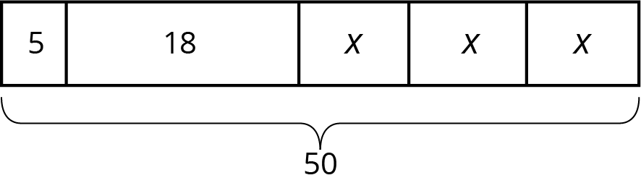

- To thank her five volunteers, Mai gave each of them the same number of stickers. Then she gave them each two more stickers. Altogether, she gave them a total of 30 stickers.
- 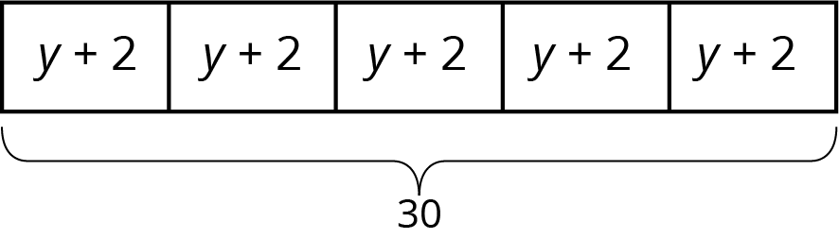

- Mai distributed another group of flyers equally among the five volunteers. Then she remembered that she needed some flyers to give to teachers, so she took 2 flyers from each volunteer. Then, the volunteers had a total of 40 flyers to hang up.
- 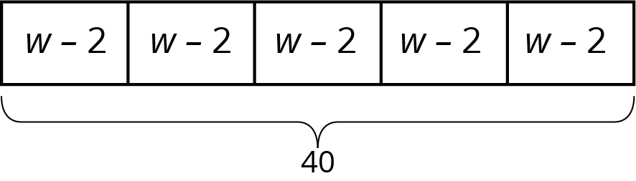

3 Every Story Needs a Picture

Student Task Statement
Here are three more stories. Draw a tape diagram to represent each story. Then describe how you would find any unknown amounts in the stories.
- Noah and his sister are making gift bags for a birthday party. Noah puts 3 pencil erasers in each bag. His sister puts $x$ stickers in each bag. After filling 4 bags, they have used a total of 44 items.
- Noah’s family also wants to blow up a total of 60 balloons for the party. Yesterday they blew up 24 balloons. Today they want to split the remaining balloons equally between four family members.
- Noah’s family bought some fruit bars to put in the gift bags. They bought one box each of four flavors: apple, strawberry, blueberry, and peach. The boxes all had the same number of bars. Noah wanted to taste the flavors and ate one bar from each box. There were 28 bars left for the gift bags.
© CC BY Open Up Resources. Adaptations CC BY IM.

