Lesson 12: ¿Cuántos?

Standards Alignments
Building On | K.CC.A.1
Addressing | 1.MD.C.4
Building Towards | 1.NBT.A.1

Teacher-facing Learning Goals
- Answer “how many in each category” and “how many in all” questions about data represented in different ways.

Student-facing Learning Goals
- Respondamos preguntas sobre datos.

Lesson Purpose
The purpose of this lesson is for students to answer “how many in each category” and “how many in all” questions about data and explain their thinking.
In previous lessons students made statements about categorical data based on representations of the data. In this lesson they answer questions about data using two different representations, tally marks and numbers. The different representations provide students with different entry points into solving Put Together problems based on data. Students discuss how different representations can be helpful in different ways to answer questions about categorical data. Since students only added within 10 in kindergarten, connecting cubes should be made available as students solve Put Together problems within 20.
In this lesson, students collect data from a survey question. In order to keep the total number of data points within 20, break the class into two groups, Group A and Group B. In Activity 1, collect data from Group A and in Activity 2, collect data from Group B.
Blackline masters with survey data are provided for those classes who are unable to collect their own data.

Access for:

Students with Disabilities
- Representation (Activity 1)

English Learners
- MLR2 (Activity 2)

Instructional Routines
Choral Count (Warm-up)

Materials to Gather
- Connecting cubes: Activity 2

Materials to Copy
- Data Represented with Tally Marks, Spanish (groups of 2): Activity 1
- Data Represented with Numbers, Spanish (groups of 2): Activity 2

Lesson Timeline
Warm-up | 10 min
Activity 1 | 20 min
Activity 2 | 15 min
Lesson Synthesis | 10 min
Cool-down | 5 min

Teacher Reflection Question
Identify ways the math community you are working to foster is going well. What aspects would you like to work on? What actions can you take to improve those areas?

Cool-down
(to be completed at the end of the lesson) 5min
Datos sobre deportes favoritos

Standards Alignments
Addressing | 1.MD.C.4

Student-facing Task Statement
Ambas representaciones muestran los mismos datos.
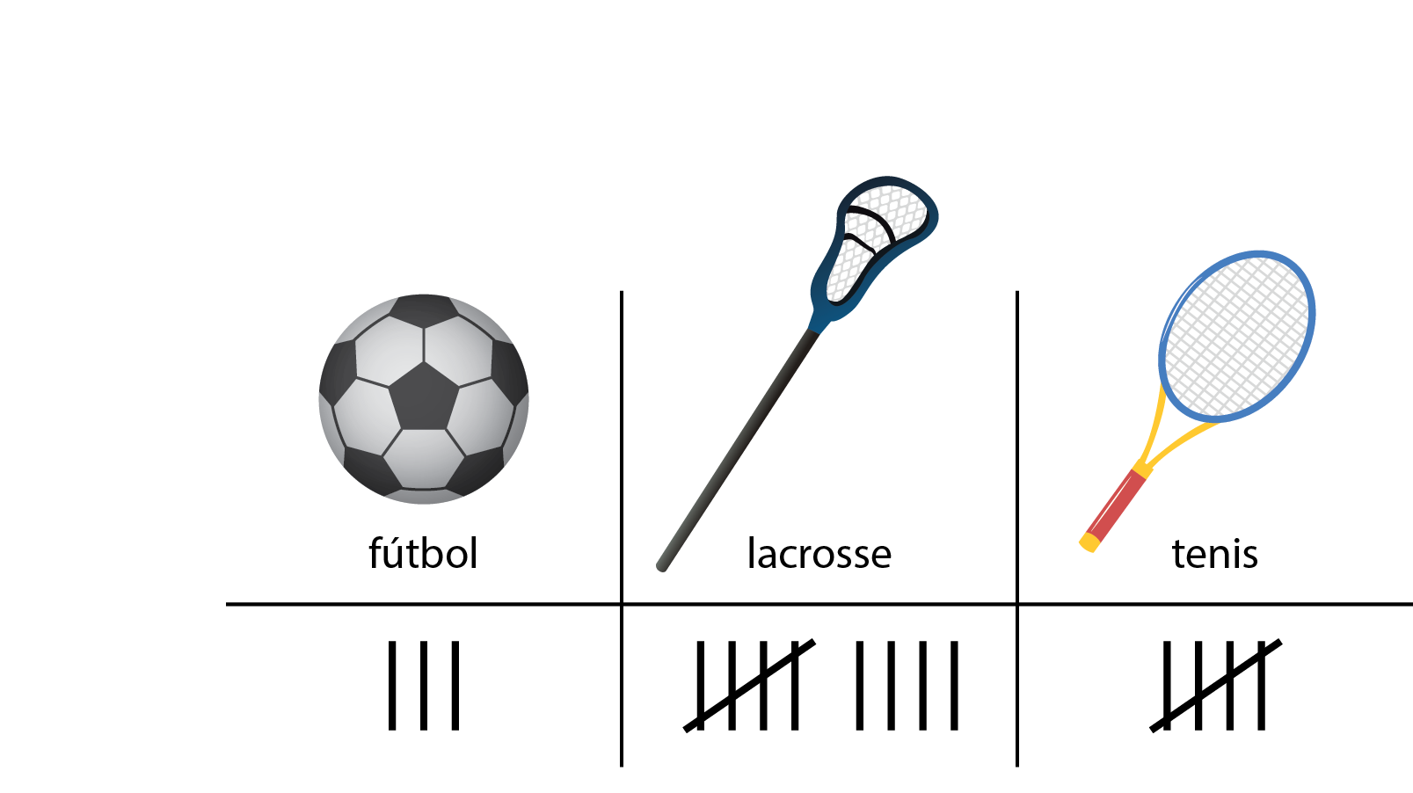
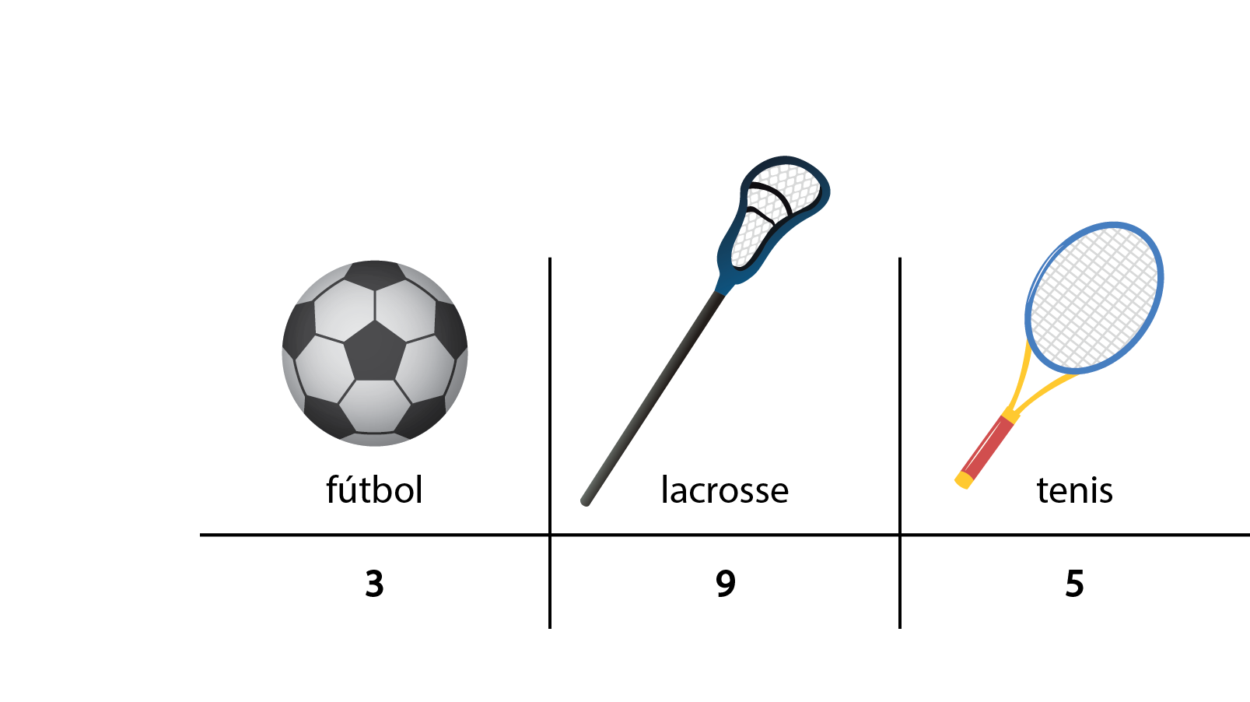
Usa cualquiera de las dos representaciones para responder las preguntas.
- ¿Cuántos estudiantes escogieron lacrosse? ____________
- ¿Cuántos estudiantes respondieron la encuesta? ____________

Student Responses
- 9
- 17

