Lesson 8 Practice Problems
- A kangaroo hops 2 kilometers in 3 minutes. At this rate:
  - How long does it take the kangaroo to travel 5 kilometers?
  - How far does the kangaroo travel in 2 minutes?
- Mai runs around a 400-meter track at a constant speed of 250 meters per minute. How many minutes does it take Mai to complete 4 laps of the track? Explain or show your reasoning.
- At 10:00 a.m., Han and Tyler both started running toward each other from opposite ends of a 10-mile path along a river. Han runs at a pace of 12 minutes per mile. Tyler runs at a pace of 15 minutes per mile.
  - How far does Han run after a half hour? After an hour?
  - Do Han and Tyler meet on the path within 1 hour? Explain or show your reasoning.
- Two skateboarders start a race at the same time. Skateboarder A travels at a steady rate of 15 feet per second. Skateboarder B travels at a steady rate of 22 feet per second. After 4 minutes, how much farther will Skateboarder B have traveled? Explain your reasoning.
- (From Unit 2, Lesson 16.)
- There are 4 tablespoons in $\frac{1}{4}$ cup. There are 2 cups in 1 pint. How many tablespoons are there in 1 pint? If you get stuck, consider drawing a double number line or making a table.
- (From Unit 3, Lesson 4.)
- Two larger cubes are made out of unit cubes. Cube A is 2 by 2 by 2. Cube B is 4 by 4 by 4. The side length of Cube B is twice that of Cube A.
  - Is the surface area of Cube B also twice that of Cube A? Explain or show your reasoning.
  - Is the volume of Cube B also twice that of Cube A? Explain or show your reasoning.
- 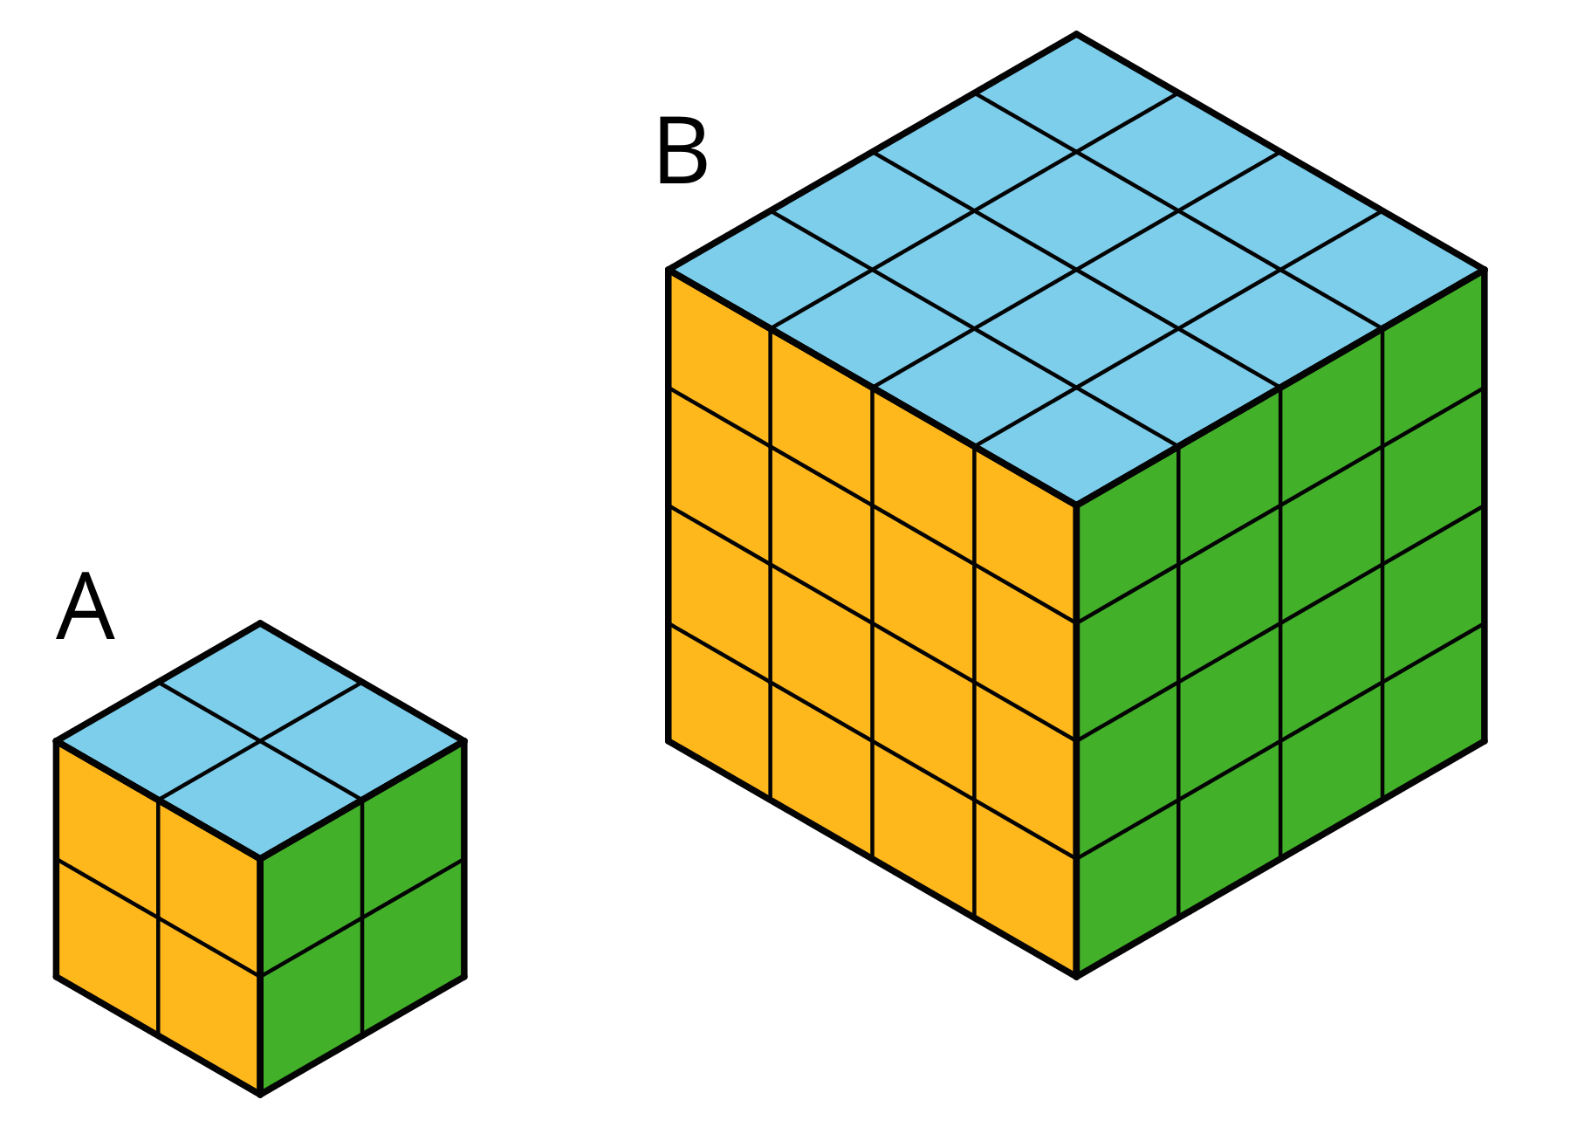
- (From Unit 1, Lesson 12.)
© CC BY Open Up Resources. Adaptations CC BY IM.

