Lesson 9: Introduction to Trigonometric Functions
- Let’s graph cosine and sine.

9.1: An Angle and a Circle
Suppose there is a point $P$ on the unit circle at $\left(1,0\right)$.
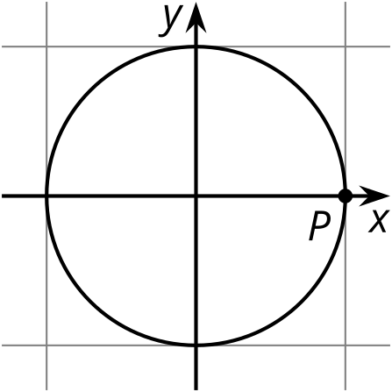
- Describe how the $x$-coordinate of $P$ changes as it rotates once counterclockwise around the circle.
- Describe how the $y$-coordinate of $P$ changes as it rotates once counterclockwise around the circle.

9.2: Do the Wave
- For each tick mark on the horizontal axis, plot the value of $y=cos\left(θ\right)$, where $θ$ is the measure of an angle in radians. Use the class display of the unit circle, the unit circle from an earlier lesson, or technology to estimate the value of $cos\left(θ\right)$.
- 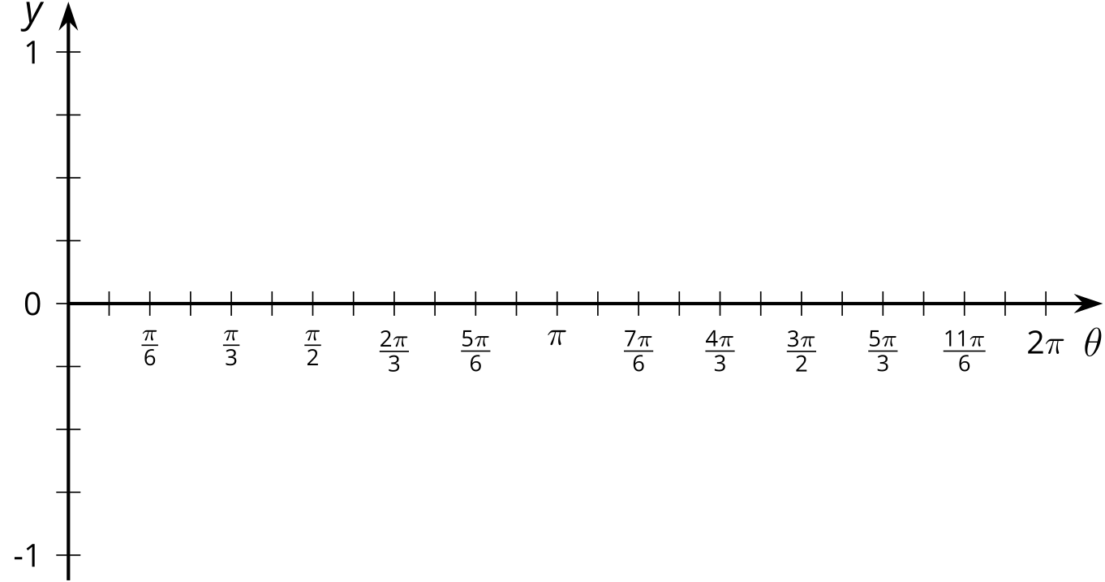
- For each tick mark on the horizontal axis, plot the value of $y=sin\left(θ\right)$. Use the class display of the unit circle, the unit circle from an earlier lesson, or technology to estimate the value of $sin\left(θ\right)$.
- What do you notice about the two graphs?
- Explain why any angle measure between 0 and $2π$ gives a point on each graph.
- Could these graphs represent functions? Explain your reasoning.

9.3: Graphs of Cosine and Sine
- Looking at the graphs of $y=cos\left(θ\right)$ and $y=sin\left(θ\right)$, at what values of $θ$ do $cos\left(θ\right)=sin\left(θ\right)$? Where on the unit circle do these points correspond to?
- For each of these equations, first predict what the graph looks like, and then check your prediction using technology.
  - $y=cos\left(θ\right)+sin\left(θ\right)$
  - $y=\cos^{2}\left(θ\right)$
  - $y=\sin^{2}\left(θ\right)$
  - $y=\cos^{2}\left(θ\right)+\sin^{2}\left(θ\right)$

Are you ready for more?
For the equation given, predict what the graph looks like, and then check your prediction using technology: $y=θ+cos\left(θ\right)$.

Lesson 9 Summary
Using the unit circle, we can make sense of $cos\left(θ\right)$ and $sin\left(θ\right)$ for any angle measure $θ$ between 0 and $2π$ radians. For an angle $θ$ starting at the positive $x$-axis, there is a point $C$ where the terminal ray of the angle intersects the unit circle. The coordinates of that point are $\left(cos\left(θ\right),sin\left(θ\right)\right)$.
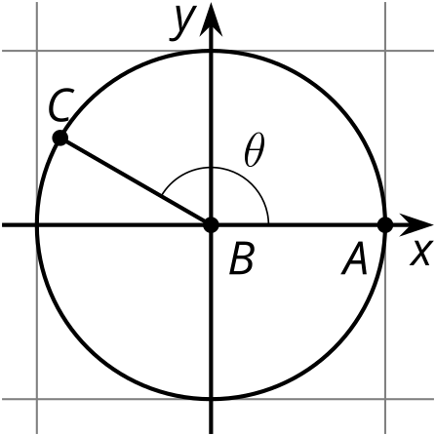
But what if we wanted to think about just the horizontal position of point $C$ as $θ$ goes from 0 to $2π$? The horizontal location is defined by the $x$-coordinate, which is $cos\left(θ\right)$. If we graph $y=cos\left(θ\right)$, we get:
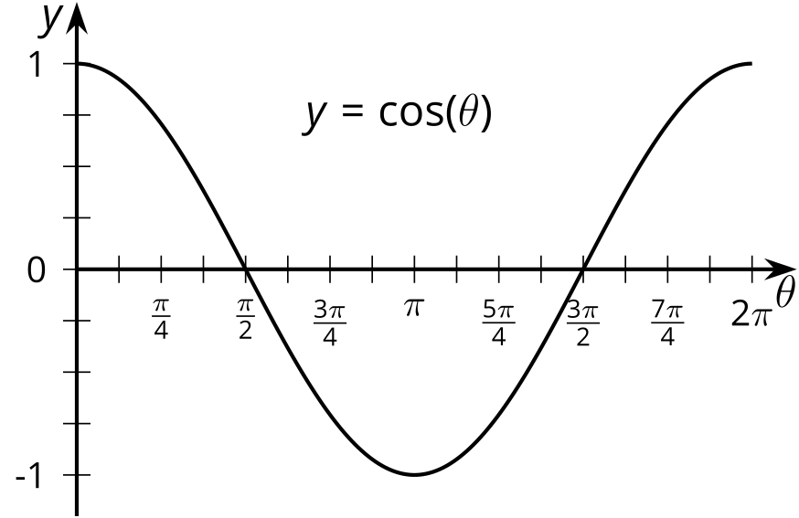
This graph is 1 when $θ$ is 0 because the $x$-coordinate of the point at 0 radians on the unit circle is $\left(1,0\right)$. The graph then decreases to -1 (the smallest $x$-value on the unit circle) before increasing back to 1.
We can do the same for the $y$-coordinate of a point on the unit circle by graphing $y=sin\left(θ\right)$:
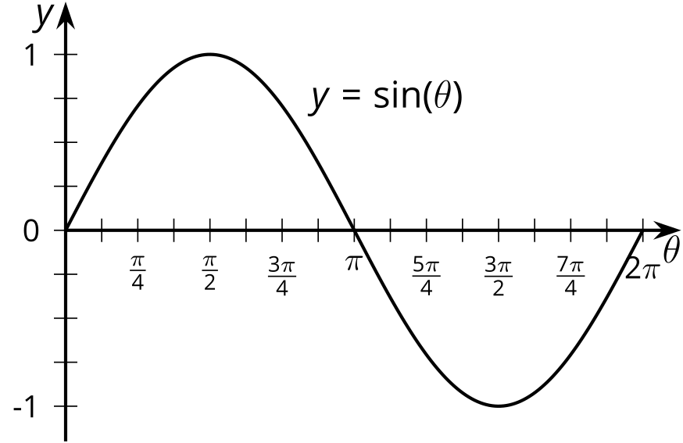
This graph is 0 when $θ$ is 0, increases to 1 (the greatest $y$-value on the unit circle), then decreases to -1 before returning to 0.
© CC BY 2019 by Illustrative Mathematics®

