Lesson 12 Practice Problems
- Segments $AB$, $EF$, and $CD$ intersect at point $C$, and angle $ACD$ is a right angle. Find the value of $g$.
- 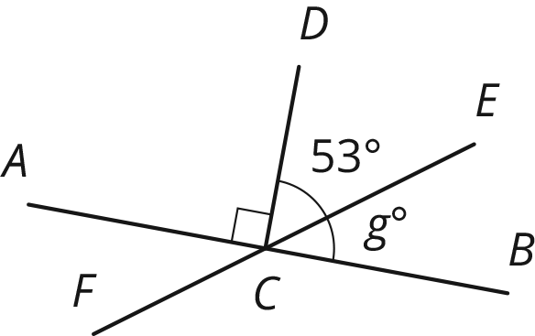
- $M$ is a point on line segment $KL$. $NM$ is a line segment. Select all the equations that represent the relationship between the measures of the angles in the figure.
- 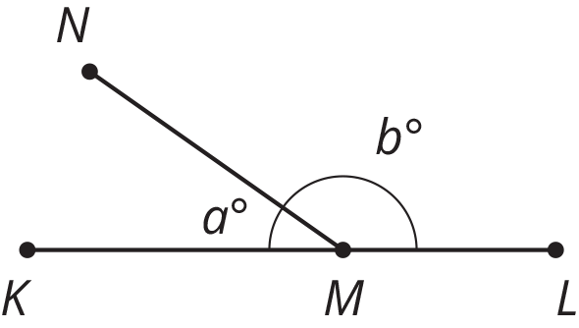
  - $a=b$
  - $a+b=90$
  - $b=90−a$
  - $a+b=180$
  - $180−a=b$
  - $180=b−a$
- Use the diagram to find the measure of each angle.
  - $m∠ABC$
  - $m∠EBD$
  - $m∠ABE$
- 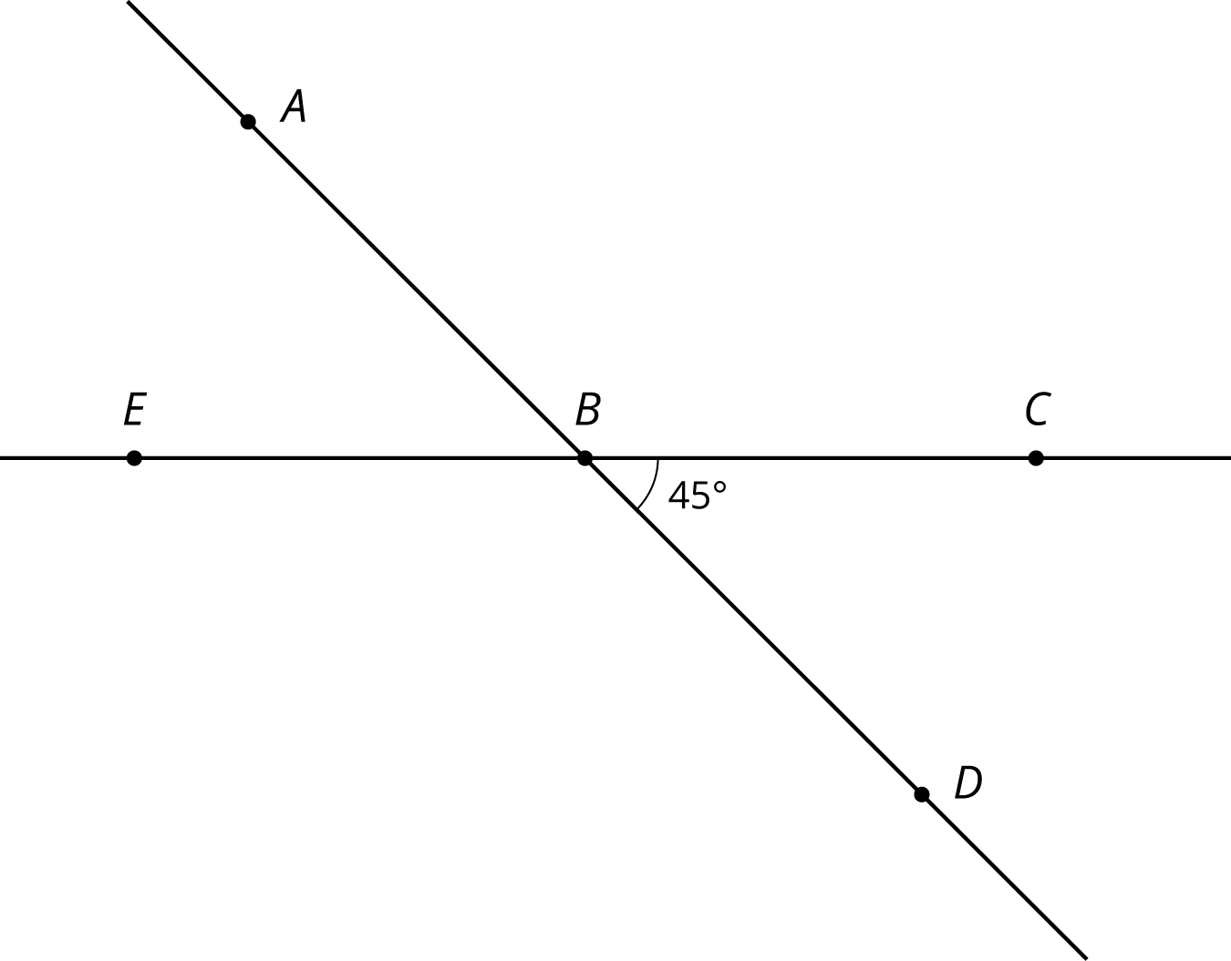
- (From Unit 1, Lesson 8.)
- Lines $k$ and $ℓ$ are parallel, and the measure of angle $ABC$ is 19 degrees.
- 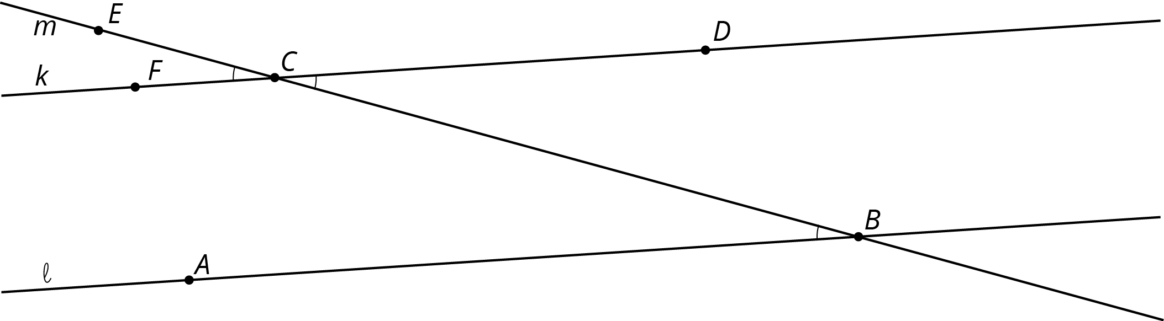
  - Explain why the measure of angle $ECF$ is 19 degrees. If you get stuck, consider translating line $ℓ$ by moving $B$ to $C$.
  - What is the measure of angle $BCD$? Explain.
- The diagram shows three lines with some marked angle measures.
- 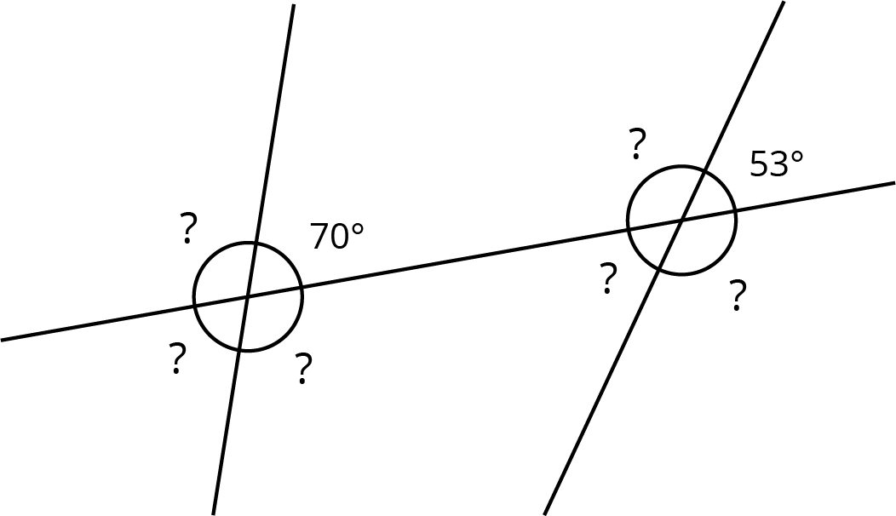
- Find the missing angle measures marked with question marks.
- Lines $s$ and $t$ are parallel. Find the value of $x$.
- 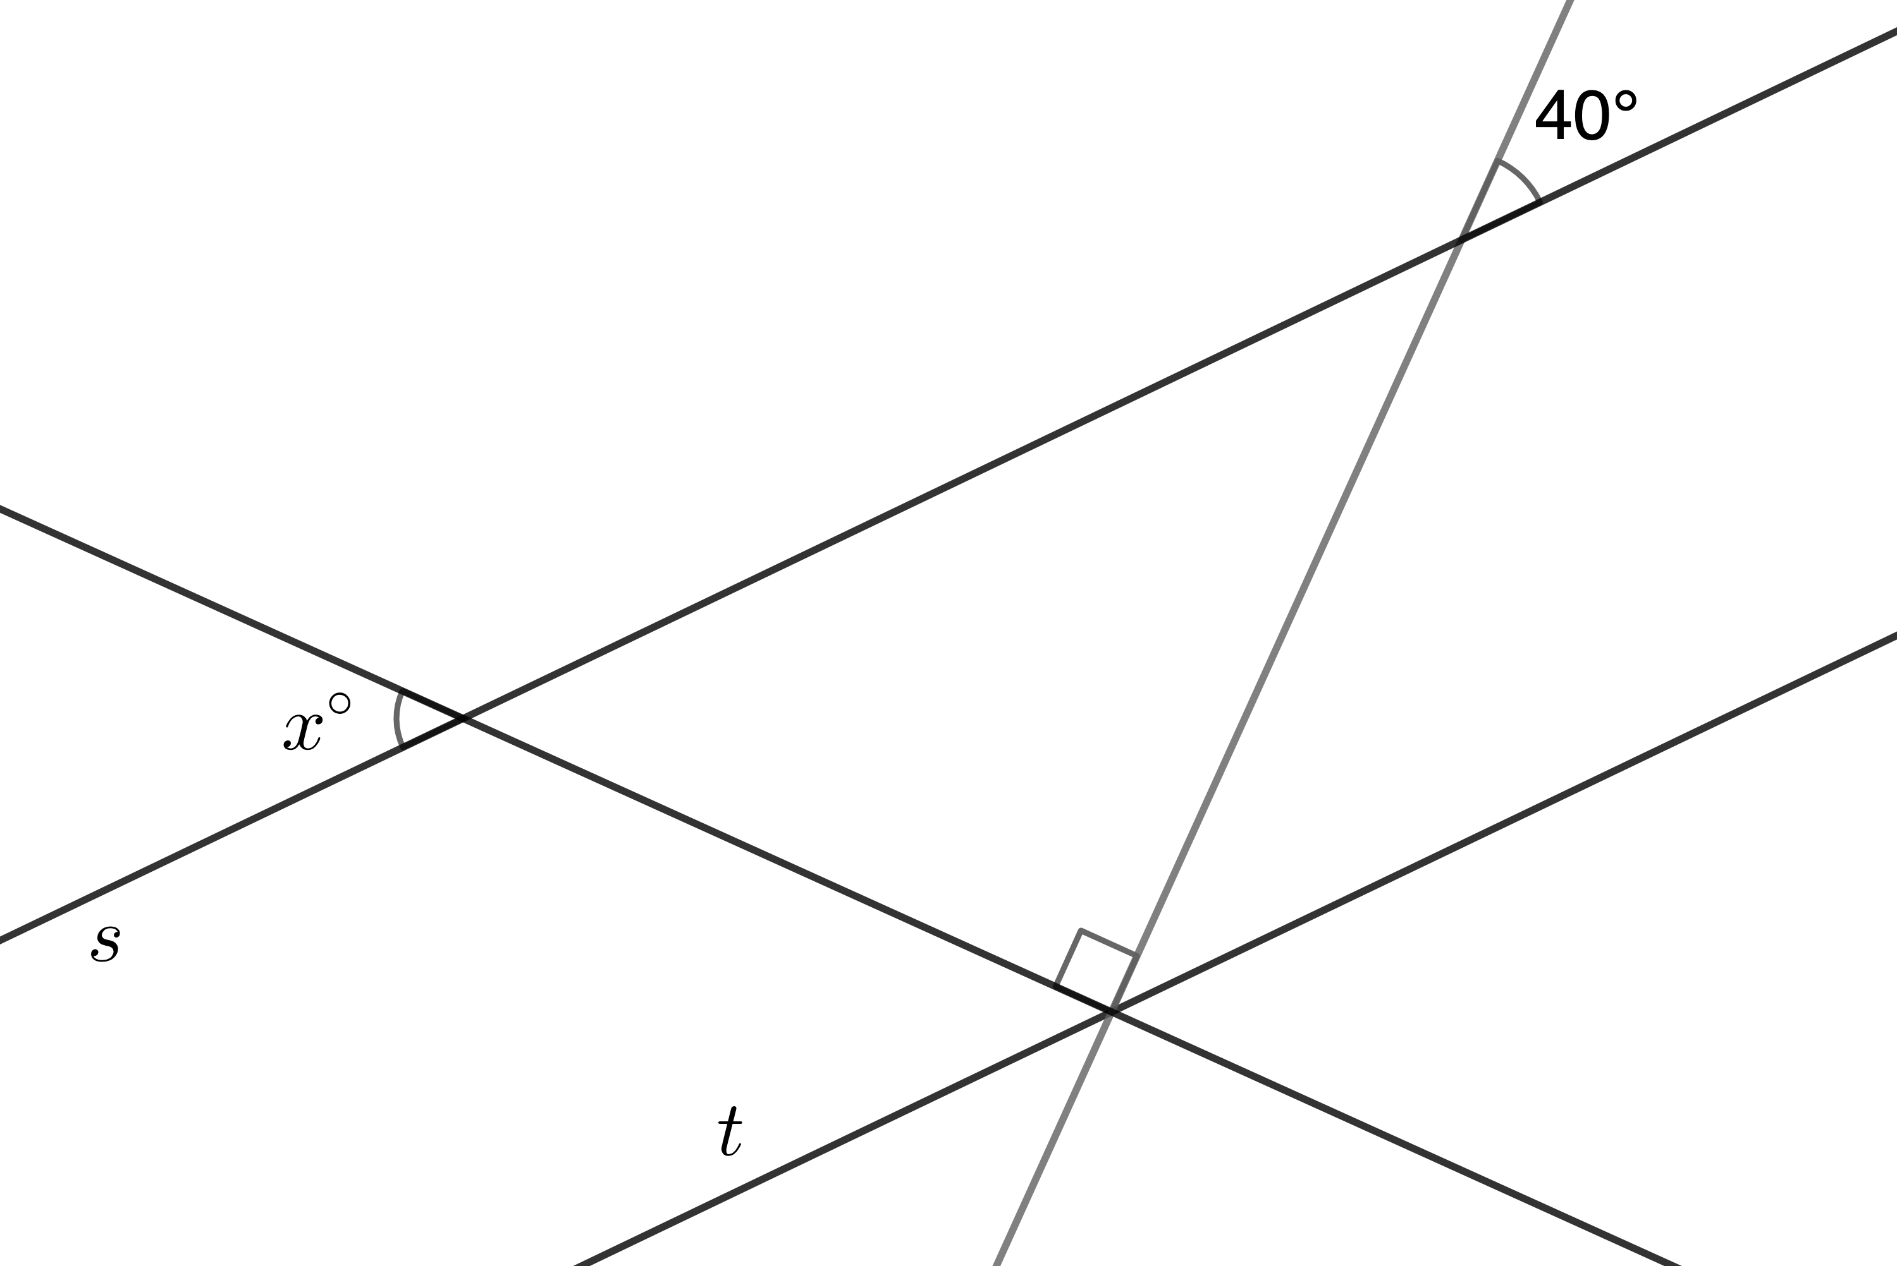
© CC BY Open Up Resources. Adaptations CC BY IM.

